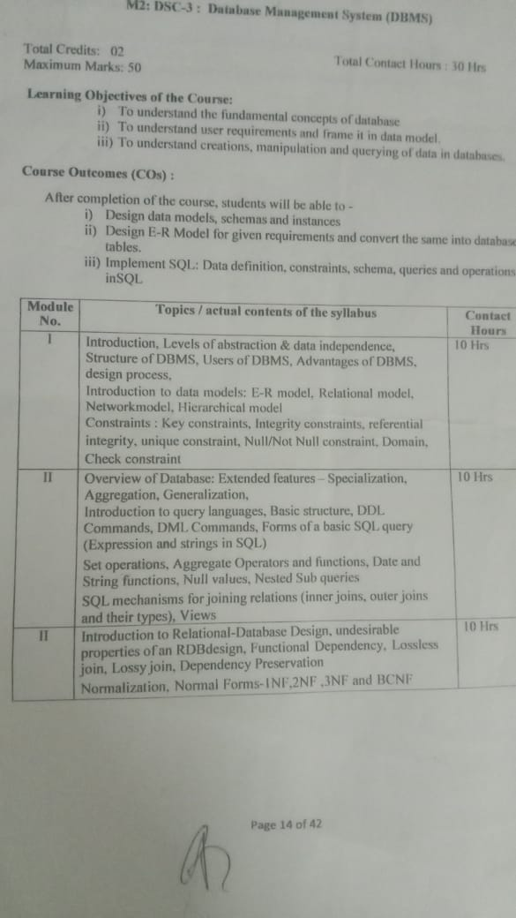

4

UNIT-1

Introduction to Database Management System
As the name suggests, the database management system consists of two parts. They are:
- Database and
- Management System

What is a Database?
To find out what database is, we have to start from data, which is the basic building block of any DBMS.

Data: Facts, figures, statistics etc. having no particular meaning (e.g. 1, ABC, 19 etc).
Record: Collection of related data items, e.g. in the above example the three data items had no meaning. But if we organize them in the following way, then they collectively represent meaningful information.
Roll | Name | Age
1 | ABC | 19
Table or Relation: Collection of related records.

Roll | Name | Age
1 | ABC | 19
2 | DEF | 22
3 | XYZ | 28
The columns of this relation are called Fields, Attributes or Domains. The rows are called Tuples
or Records.
Database: Collection of related relations. Consider the following collection of tables:

T1 T2
 | Roll | Name | Age
 | 1 | ABC | 19
 | 2 | DEF | 22
 | 3 | XYZ | 28

Roll | Address
1 | KOL
2 | DEL
3 | MUM

T3 T4
Roll | Year
1 | I
2 | II
3 | I

Year | Hostel
I | H1
II | H2

We now have a collection of 4 tables. They can be called a “related collection” because we can clearly find out that there are some common attributes existing in a selected pair of tables. Because of these common attributes we may combine the data of two or more tables together to find out the complete details of a

Age and Hostel attributes are in different tables.

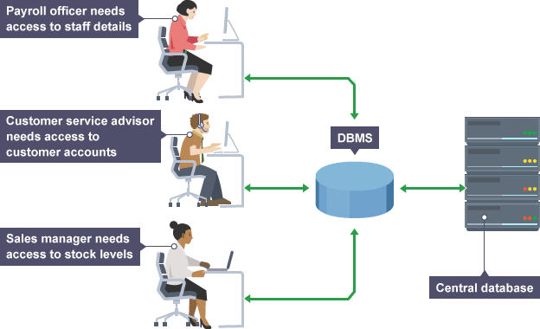
A database in a DBMS could be viewed by lots of different people with different responsibilities.

Figure 1.1: Empolyees are accessing Data through DBMS

For example, within a company there are different departments, as well as customers, who each need to see different kinds of data. Each employee in the company will have different levels of access to the database with their own customized front-end application.

In a database, data is organized strictly in row and column format. The rows are called Tuple or Record. The data items within one row may belong to different data types. On the other hand, the columns are often called Domain or Attribute. All the data items within a single attribute are of the same data type.

What is Management System?
A database-management system (DBMS) is a collection of interrelated data and a set of programs to access those data. This is a collection of related data with an implicit meaning and hence is a database. The collection of data, usually referred to as the database, contains information relevant to an enterprise. The primary goal of a DBMS is to provide a way to store and retrieve database information that is both convenient and efficient. By data, we mean known facts that can be recorded and that have implicit meaning.

The management system is important because without the existence of some kind of rules and regulations it is not possible to maintain the database. We have to select the particular attributes which should be included in a particular table; the common attributes to create relationship between two tables; if a new record has to be inserted or deleted then which tables should have to be handled etc. These issues must be resolved by having some kind of rules to follow in order to maintain the integrity of the database.

Database systems are designed to manage large bodies of information. Management of data involves both defining structures for storage of information and providing mechanisms for the manipulation of information. In addition, the database system must ensure the safety of the information stored, despite system crashes or attempts at unauthorizeaccess. If data are to be shared among several users, the system must avoid possible anomalous results.
Because information is so important in most organizations, computer scientists have developed a large body of concepts and techniques for managing data. These concepts and technique form the focus of this book. This

6
chapter briefly introduces the principles of database systems.

Database Management System (DBMS) and Its Applications:
A Database management system is a computerized record-keeping system. It is a repository or a container for collection of computerized data files. The overall purpose of DBMS is to allow he users to define, store, retrieve and update the information contained in the database on demand. Information can be anything that is of significance to an individual or organization.

Databases touch all aspects of our lives. Some of the major areas of application are as follows:
- Banking
- Airlines
- Universities
- Manufacturing and selling
- Human resources

Enterprise Information
  - Sales: For customer, product, and purchase information.
  - Accounting: For payments, receipts, account balances, assets and other accounting information.
  - Human resources: For information about employees, salaries, payroll taxes, and benefits, and for generation of paychecks.
  - Manufacturing: For management of the supply chain and for tracking production of items in factories, inventories of items inwarehouses and stores, and orders for items.
Online retailers: For sales data noted above plus online order tracking,generation of recommendation lists, and
maintenance of online product evaluations.

Banking and Finance
  - Banking: For customer information, accounts, loans, and banking transactions.
  - Credit card transactions: For purchases on credit cards and generation of monthly statements.
  - Finance: For storing information about holdings, sales, and purchases of financial instruments such as stocks and bonds; also for storing real-time market data to enable online trading by customers and automated trading by the firm.
- Universities: For student information, course registrations, and grades (in addition to standard enterprise information such as human resources and accounting).
- Airlines: For reservations and schedule information. Airlines were among the first to use databases in a geographically distributed manner.
- Telecommunication: For keeping records of calls made, generating monthly bills, maintaining balances on prepaid calling cards, and storing information about the communication networks.

Purpose of Database Systems
Database systems arose in response to early methods of computerized management of commercial data. As an example of such methods, typical of the 1960s, consider part of a university organization that, among other data, keeps information about all instructors, students, departments, and course offerings. One way to keep the information on a computer is to store it in operating system files. To allow users to manipulate the information, the system has a number of application programs that manipulate the files, including programs to:
  - Add new students, instructors, and courses
  - Register students for courses and generate class rosters
  - Assign grades to students, compute grade point averages (GPA), and generate transcripts

7

System programmers wrote these application programs to meet the needs of the university.
New application programs are added to the system as the need arises. For example, suppose that a university decides to create a new major (say, computer science).As a result, the university creates a new department and creates new permanent files (or adds information to existing files) to record information about all the instructors in the department, students in that major, course offerings, degree requirements, etc. The university may have to write new application programs to deal with rules specific to the new major. New application programs may also have to be written to handle new rules in the university. Thus, as time goes by, the system acquires more files and more application programs.

This typical file-processing system is supported by a conventional operating system. The system stores permanent records in various files, and it needs different application programs to extract records from, and add records to, the appropriate files. Before database management systems (DBMSs) were introduced, organizations usually stored information in such systems. Keeping organizational information in a file- processing system has a number of major disadvantages:

Data redundancy and inconsistency. Since different programmers create the files and application programs over a long period, the various files are likely to have different structures and the programs may be written in several programming languages. Moreover, the same information may be duplicated in several places (files). For example, if a student has a double major (say, music and mathematics) the address and telephone number of that student may appear in a file that consists of student records of students in the Music department and in a file that consists of student records of students in the Mathematics department. This redundancy leads to higher storage and access cost. In addition, it may lead to data inconsistency; that is, the various copies of the same data may no longer agree. For example, a changed student address may be reflected in the Music department records but not elsewhere in the system.

Difficulty in accessing data. Suppose that one of the university clerks needs to find out the names of all students who live within a particular postal-code area. The clerk asks the data-processing department to generate such a list. Because the designers of the original system did not anticipate this request, there is no application program on hand to meet it. There is, however, an application program to generate the list of all students.

The university clerk has now two choices: either obtain the list of all students and extract the needed information manually or ask a programmer to write the necessary application program. Both alternatives are obviously unsatisfactory. Suppose that such a program is written, and that, several days later, the same clerk needs to trim that list to include only those students who have taken at least 60 credit hours. As expected, a program to generate such a list does not exist. Again, the clerk has the preceding two options, neither of which is satisfactory. The point here is that conventional file-processing environments do not allow needed data to be retrieved in a convenient and efficient manner. More responsive data-retrieval systems are required for general use.

Data isolation. Because data are scattered in various files, and files may be in different formats, writing new application programs to retrieve the appropriate data is difficult.

Integrity problems. The data values stored in the database must satisfy certain types of consistency constraints. Suppose the university maintains an account for each department, and records the balance amount in each account. Suppose also that the university requires that the account balance of a department may never fall below zero. Developers enforce these constraints in the system by adding appropriate code in the various application programs.

8
Atomicity problems. A computer system, like any other device, is subject to failure. In many applications, it is crucial that, if a failure occurs, the data be restored to the consistent state that existed prior to the failure.

Consider a program to transfer $500 from the account balance of department A to the account balance of department B. If a system failure occurs during the execution of the program, it is possible that the $500 was removed from the balance of department A but was not credited to the balance of department B, resulting in an inconsistent database state. Clearly, it is essential to database consistency that either both the credit and debit occur, or that neither occur.
That is, the funds transfer must be atomic—it must happen in its entirety or not at all. It is difficult to ensure atomicity in a conventional file-processing system.

Concurrent-access anomalies. For the sake of overall performance of the system and faster response, many systems allow multiple users to update the data simultaneously. Indeed, today, the largest Internet retailers may have millions of accesses per day to their data by shoppers. In such an environment, interaction of concurrent updates is possible and may result in inconsistent data. Consider department A, with an account balance of $10,000. If two department clerks debit the account balance (by say $500 and $100, respectively) of department A at almost exactly the same time, the result of the concurrent executions may leave the budget in an incorrect (or inconsistent) state. Suppose that the programs executing on behalf of each withdrawal read the old balance, reduce that value by the amount being withdrawn, and write the result back. If the two programs run concurrently, they may both read the value $10,000, and write back $9500 and $9900, respectively. Depending on which one writes the value last, the account balance of department A may contain either $9500 or $9900, rather than the correct value of $9400. To guard against this possibility, the system must maintain some form of supervision.
But supervision is difficult to provide because data may be accessed by many different application programs that have not been coordinated previously.

As another example, suppose a registration program maintains a count of students registered for a course, in order to enforce limits on the number of students registered. When a student registers, the program reads the current count for the courses, verifies that the count is not already at the limit, adds one to the count, and stores the count back in the database. Suppose two students register concurrently, with the count at (say) 39. The two program executions may both read the value 39, and both would then write back 40, leading to an incorrect increase of only 1, even though two students successfully registered for the course and the count should be 41. Furthermore, suppose the course registration limit was 40; in the above case both students would be able to register, leading to a violation of the limit of 40 students.

Security problems. Not every user of the database system should be able to access all the data. For example, in a university, payroll personnel need to see only that part of the database that has financial information. They do not need access to information about academic records. But, since application programs are added to the file-processing system in an ad hoc manner, enforcing such security constraints is difficult.
These difficulties, among others, prompted the development of database systems. In what follows, we shall see the concepts and algorithms that enable database systems to solve the problems with file-processing systems.

Advantages of DBMS:
Controlling of Redundancy: Data redundancy refers to the duplication of data (i.e storing same data multiple times). In a database system, by having a centralized database and centralized control of data by the DBA the unnecessary duplication of

9
Improved Data Sharing : DBMS allows a user to share the data in any number of application programs.

Data Integrity : Integrity means that the data in the database is accurate. Centralized control of the data helps in permitting the administrator to define integrity constraints to the data in the database. For example: in customer database we can can enforce an integrity that it must accept the customer only from Noida and Meerut city.

Security : Having complete authority over the operational data, enables the DBA in ensuring that the only mean of access to the database is through proper channels. The DBA can define authorization checks to be carried out whenever access to sensitive data is attempted.

Data Consistency : By eliminating data redundancy, we greatly reduce the opportunities for inconsistency. For example: is a customer address is stored only once, we cannot have disagreement on the stored values. Also updating data values is greatly simplified when each value is stored in one place only. Finally, we avoid the wasted storage that results from redundant data storage.

Efficient Data Access : In a database system, the data is managed by the DBMS and all access to the data is through the DBMS providing a key to effective data processing

Enforcements of Standards : With the centralized of data, DBA can establish and enforce the data standards which may include the naming conventions, data quality standards etc.

Data Independence : Ina database system, the database management system provides the interface between the application programs and the data. When changes are made to the data representation, the meta data obtained by the DBMS is changed but the DBMS is continues to provide the data to application program in the previously used way. The DBMs handles the task of transformation of data wherever necessary.

Reduced Application Development and Maintenance Time : DBMS supports many important functions that are common to many applications, accessing data stored in the DBMS, which facilitates the quick development of application.

Disadvantages of DBMS
- It is bit complex. Since it supports multiple functionality to give the user the best, the underlying software has become complex. The designers and developers should have thorough knowledge about the software to get the most out of it.
- Because of its complexity and functionality, it uses large amount of memory. It also needs large memory to run efficiently.
- DBMS system works on the centralized system, i.e.; all the users from all over the world access this database. Hence any failure of the DBMS, will impact all the users.
- DBMS is generalized software, i.e.; it is written work on the entire systems rather specific one. Hence some of the application will run slow.

View of Data
A database system is a collection of interrelated data and a set of programs that allow users to access and modify these

10

Data Abstraction
For the system to be usable, it must retrieve data efficiently. The need for efficiency has led designers to use complex data structures to represent data in the database. Since many database-system users are not computer trained, developers hide the complexity from users through several levels of abstraction, to simplify users’ interactions with the system:

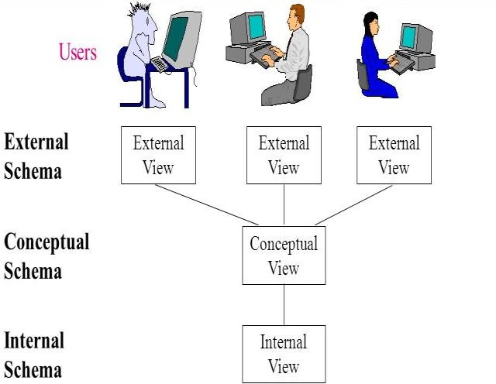
Database DISK

Figure 1.2 : Levels of Abstraction in a DBMS

- Physical level (or Internal View / Schema): The lowest level of abstraction describes how the data are actually stored. The physical level describes complex low-level data structures in detail.

- Logical level (or Conceptual View / Schema): The next-higher level of abstraction describes what data are stored in the database, and what relationships exist among those data. The logical level thus describes the entire database in terms of a small number of relatively simple structures. Although implementation of the simple structures at the logical level may involve complex physical-level structures, the user of the logical level does not need to be aware of this complexity. This is referred to as physical data independence. Database administrators, who must decide what information to keep in the database, use the logical level of abstraction.

- View level (or External View / Schema): The highest level of abstraction describes only part of the entire database. Even though the logical level uses simpler structures, complexity remains because of the variety of information stored in a large database. Many users of the database system do not need all this information; instead, they need to access only a part of the database. The view level of abstraction exists to simplify their interaction with the system. The system may provide many views for the same database. Figure 1.2 shows the relationship among the three levels of abstraction.
An analogy to the concept of data types in programming languages may clarify the distinction among levels of abstraction. Many high-level programming languages support the notion of a structured type. For example, we may describe a record as follows:
type instructor = record
ID : char (5);
name : char (20);
dept name : char (20);
salary : numeric (8,2);
end;

This code defines a new record type called instructor with four fields. Each field has a name and a type associated with it. A university organization may have several such record types, including

11
  - department, with fields dept_name, building, and budget
  - course, with fields course_id, title, dept_name, and credits
  - student, with fields ID, name, dept_name, and tot_cred
At the physical level, an instructor, department, or student record can be described as a block of consecutive storage locations. The compiler hides this level of detail from programmers. Similarly, the database system hides many of the lowest-level storage details from database programmers. Database administrators, on the other hand, may be aware of certain details of the physical organization of the data.
At the logical level, each such record is described by a type definition, as in the previous code segment, and the interrelationship of these record types is defined as well. Programmers using a programming language work at this level of abstraction. Similarly, database administrators usually work at this level of abstraction.
Finally, at the view level, computer users see a set of application programs that hide details of the data types. At the view level, several views of the database are defined, and a database user sees some or all of these views. In addition
to hiding details of the logical level of the database, the views also provide a security mechanism to prevent users from accessing certain parts of the database. For example, clerks in the university registrar office can see only that part of the database that has information about students; they cannot access information about salaries of instructors.

Instances and Schemas
Databases change over time as information is inserted and deleted. The collection of information stored in the database at a particular moment is called an instance of the database. The overall design of the database is called the database schema. Schemas are changed infrequently, if at all. The concept of database schemas and instances can be understood by analogy to a program written in a programming language. A database schema corresponds to the variable declarations (along with associated type definitions) in a program.
Each variable has a particular value at a given instant. The values of the variables in a program at a point in time correspond to an instance of a database schema. Database systems have several schemas, partitioned according to the levels of abstraction. The physical schema describes the database design at the physical level, while the logical schema describes the database design at the logical level. A database may also have several schemas at the view level, sometimes called subschemas, which describe different views of the database. Of these, the logical schema is by far the most important, in terms of its effect on application programs, since programmers construct applications by using the logical schema. The physical schema is hidden beneath the logical schema, and can usually be changed easily without affecting application programs. Application programs are said to exhibit physical data independence if they do not depend on the physical schema, and thus need not be rewritten if the physical schema changes.

Data Models
Underlying the structure of a database is the data model: a collection of conceptual tools for describing data, data relationships, data semantics, and consistency constraints. A data model provides a way to describe the design of a database at the physical, logical, and view levels.

The data models can be classified into four different categories:

12
- Relational Model. The relational model uses a collection of tables to represent both data and the relationships among those data. Each table has multiple columns, and each column has a unique name. Tables are also known as relations. The relational model is an example of a record-based model.
Record-based models are so named because the database is structured in fixed-format records of several types. Each table contains records of a particular type. Each record type defines a fixed number of fields, or attributes. The columns of the table correspond to the attributes of the record type. The relational data model is the most widely used data model, and a vast majority of current database systems are based on the relational model.

Entity-Relationship Model. The entity-relationship (E-R) data model uses a collection of basic objects, called
entities, and relationships among these objects.
An entity is a “thing” or “object” in the real world that is distinguishable from other objects. The entity- relationship model is widely used in database design.

Object-Based Data Model. Object-oriented programming (especially in Java, C++, or C#) has become the dominant software-development methodology. This led to the development of an object-oriented data model that can be seen as extending the E-R model with notions of encapsulation, methods (functions), and object identity. The object-relational data model combines features of the object-oriented data model and relational data model.

Semi-structured Data Model. The semi-structured data model permits the specification of data where individual data items of the same type may have different sets of attributes. This is in contrast to the data models mentioned earlier, where every data item of a particular type must have the same set of attributes. The Extensible Markup Language (XML) is widely used to represent semi-structured data.
Historically, the network data model and the hierarchical data model preceded the relational data model. These models were tied closely to the underlying implementation, and complicated the task of modeling data. As a result they are used little now, except in old database code that is still in service in some places.

Database Languages
A database system provides a data-definition language to specify the database
schema and a data-manipulation language to express database queries and updates. In practice, the data- definition and data-manipulation languages are not
two separate languages; instead they simply form parts of a single database language, such as the widely used SQL language.
Data-Manipulation Language
A data-manipulation language (DML) is a language that enables users to access or manipulate data as organized by the appropriate data model. The types of access are:
- Retrieval of information stored in the database
- Insertion of new information into the database
- Deletion of information from the database
- Modification of information stored in the database

There are basically two types:
- Procedural DMLs require a user to specify what data are needed and how to get those data.
- Declarative DMLs (also referred to as nonprocedural DMLs) require a user to specify what data are needed
without specifying how to get those data.
Declarative DMLs are usually easier to learn and use than are procedural DMLs. However, since a user does not have to specify how to get the data, the database system has to figure out an efficient means of accessing

13
data. A query is a statement requesting the retrieval of information. The portion of a DML that involves information retrieval is called a query language. Although technically incorrect, it is common practice to use the terms query language and data-manipulation language synonymously.

Data-Definition Language (DDL)
We specify a database schema by a set of definitions expressed by a special language called a data-definition language (DDL). The DDL is also used to specify additional properties of the data.

We specify the storage structure and access methods used by the database system by a set of statements in a special type of DDL called a data storage and definition language. These statements define the implementation details of the database schemas, which are usually hidden from the users.
The data values stored in the database must satisfy certain consistency constraints.
For example, suppose the university requires that the account balance of a department must never be negative. The DDL provides facilities to specify such constraints. The database system checks these constraints every time the database is updated. In general, a constraint can be an arbitrary predicate pertaining to the database. However, arbitrary predicates may be costly to test. Thus, database systems implement integrity constraints that can be tested with minimal overhead.

- Domain Constraints. A domain of possible values must be associated with every attribute (for example, integer types, character types, date/time types). Declaring an attribute to be of a particular domain acts as a constraint on the values that it can take. Domain constraints are the most elementary form of integrity constraint. They are tested easily by the system whenever a new data item is entered into the database.

- Referential Integrity. There are cases where we wish to ensure that a value that appears in one relation for a given set of attributes also appears in a certain set of attributes in another relation (referential integrity). For example, the department listed for each course must be one that actually exists. More precisely, the dept name value in a course record must appear in the dept name attribute of some record of the department relation.
Database modifications can cause violations of referential integrity. When a referential-integrity constraint is violated, the normal procedure is to reject the action that caused the violation.

- Assertions. An assertion is any condition that the database must always satisfy. Domain constraints and referential-integrity constraints are special forms of assertions. However, there are many constraints that we cannot express by using only these special forms. For example, “Every department must have at least five courses offered every semester” must be expressed as an assertion. When an assertion is created, the system tests it for validity. If the assertion is valid, then any future modification to the database is allowed only if it does not cause that assertion to be violated.

- Authorization. We may want to differentiate among the users as far as the type of access they are permitted on various data values in the database. These differentiations are expressed in terms of authorization, the most common being: read authorization, which allows reading, but not modification, of data; insert authorization, which allows insertion of new data, but not modification of existing data; update authorization, which allows modification, but not deletion, of data; and delete authorization, which allows deletion of data. We may assign the user all, none, or a combination of these types of authorization.

The DDL, just like any other programming language, gets as input some instructions (statements) and generates some output. The output of the DDL is placed in the data dictionary,which contains metadata—that is, data about data. The data dictionary is considered to be a special type of table that can only be accesssystem itself (not a regular user).

14

Data Dictionary

We can define a data dictionary as a DBMS component that stores the definition of data characteristics and relationships. You may recall that such “data about data” were labeled metadata. The DBMS data dictionary provides the DBMS with its self describing characteristic. In effect, the data dictionary resembles and X-ray of the company’s entire data set, and is a crucial element in the data administration function.
The two main types of data dictionary exist, integrated and stand alone. An integrated data dictionary is included with the DBMS. For example, all relational DBMSs include a built in data dictionary or system catalog that is frequently accessed and updated by the RDBMS. Other DBMSs especially older types, do not have a built in data dictionary instead the DBA may use third party stand alone data dictionary systems.
Data dictionaries can also be classified as active or passive. An active data dictionary is automatically updated by the DBMS with every database access, thereby keeping its access information up-to-date. A passive data dictionary is not updated automatically and usually requires a batch process to be run. Data dictionary access information is normally used by the DBMS for query optimization purpose.
The data dictionary’s main function is to store the description of all objects that interact with the database. Integrated data dictionaries tend to limit their metadata to the data managed by the DBMS. Stand alone data dictionary systems are more usually more flexible and allow the DBA to describe and manage all the organization’s data, whether or not they are computerized. Whatever the data dictionary’s format, its existence provides database designers and end users with a much improved ability to communicate. In addition, the data dictionary is the tool that helps the DBA to resolve data conflicts.
Although, there is no standard format for the information stored in the data dictionary several features are common. For example, the data dictionary typically stores descriptions of all:
- Data elements that are define in all tables of all databases. Specifically the data dictionary stores the name, datatypes, display formats, internal storage formats, and validation rules. The data dictionary tells where an element is used, by whom it is used and so on.
- Tables define in all databases. For example, the data dictionary is likely to store the name of the table creator, the date of creation access authorizations, the number of columns, and so on.
- Indexes define for each database tables. For each index the DBMS stores at least the index name the attributes used, the location, specific index characteristics and the creation date.
- Define databases: who created each database, the date of creation where the database is located, who the DBA is and so on.
- End users and The Administrators of the data base
- Programs that access the database including screen formats, report formats application formats, SQL queries and so on.
- Access authorization for all users of all databases.
- Relationships among data elements which elements are involved: whether the relationship are mandatory or optional, the connectivity and cardinality and so on.

Database Administrators and Database Users

A primary goal of a database system is to retrieve information from and store new information in the database. People who work with a database can be categorized as database users or database administrators.

Database Users and User Interfaces

There are four different types of database-system users, differentiated by the way they expect to interact with the system. Different types of user interfaces have been designed for the different types of users.
Naive users are unsophisticated users who interact with the system by invoking one of the application programs that have been written previously. For example, a bank teller who needs to transfer $50 from account A to account B invokes a program called transfer. This program asks the teller for the amount of money to be transferred, the account from which the money is to be transferred, and the account to which the money is to be transferred.

15
As another example, consider a user who wishes to find her account balance over the World Wide Web. Such a user may access a form, where she enters her account number. An application program at the Web server then retrieves the account balance, using the given account number, and passes this information back to the user. The typical user interface for naive users is a forms interface, where the user can fill in appropriate fields of the form. Naive users may also simply read reports generated from the database.
Application programmers are computer professionals who write application programs. Application programmers can choose from many tools to develop user interfaces. Rapid application development (RAD) tools are tools that enable an application programmer to construct forms and reports without writing a program. There are also special types of programming languages that combine imperative control structures (for example, for loops, while loops and if-then-else statements) with statements of the data manipulation language. These languages, sometimes called fourth-generation languages, often include special features to facilitate the generation of forms and the display of data on the screen. Most major commercial database systems include a fourth generation language.
Sophisticated users interact with the system without writing programs. Instead, they form their requests in a database query language. They submit each such query to a query processor, whose function is to break down DML statements into instructions that the storage manager understands. Analysts who submit queries to explore data in the database fall in this category.
Online analytical processing (OLAP) tools simplify analysts’ tasks by letting them view summaries of data in different ways. For instance, an analyst can see total sales by region (for example, North, South, East, and West), or by product, or by a combination of region and product (that is, total sales of each product in each region). The tools also permit the analyst to select specific regions, look at data in more detail (for example, sales by city within a region) or look at the data in less detail (for example, aggregate products together by category).
Another class of tools for analysts is data mining tools, which help them find certain kinds of patterns in data. Specialized users are sophisticated users who write specialized database applications that do not fit into the traditional data-processing framework.
Among these applications are computer-aided design systems, knowledge base and expert systems, systems that store data with complex data types (for example, graphics data and audio data), and environment-modeling systems.

16
Database Architecture:
We are now in a position to provide a single picture (Figure 1.3) of the various components of a database system and the connections among them.

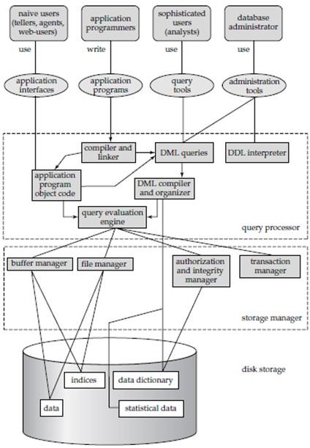
The architecture of a database system is greatly influenced by the underlying computer system on which the database system runs. Database systems can be centralized, or client-server, where one server machine executes work on behalf of multiple client machines. Database systems can also be designed to exploit parallel computer architectures. Distributed databases span multiple geographically separated machines.

Figure 1.3: Database System Architecture

A database system is partitioned into modules that deal with each of the responsibilities of the overall system. The functional components of a database system can be broadly divided into the storage manager and the query processor components. The storage manager is important because databases typically require a large amount of storage space. The query processor is important because it helps the database system simplify and facilitate access to data.

It is the job of the database system to translate updates and queries written in a nonprocedural language, at the logical level, into an efficient sequence of operations at the physical level.
Database applications are usually partitioned into two or three parts, as in Figure 1.4. In a two-tier architecture, the application resides at the client machine, where it invokes database system functionality at the server machine through query language statements. Application program interface standards like ODBC and JDBC are used for interaction between the client and the server. In contrast, in a three-tier architecture, the client machine acts as merely a front end and does not contain any direct database calls. Instead, the client end communicates with an application server, usually through a forms interface.
17
The application server in turn communicates with a database system to access data. The business logic of the application, which says what actions to carry out under what conditions, is embedded in the application server, instead of being distributed across multiple clients. Three-tier applications are more appropriate for large applications, and for applications that run on the WorldWideWeb.

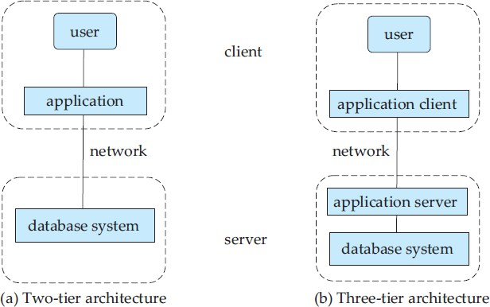
Figure 1.4: Two-tier and three-tier architectures.

Query Processor:
The query processor components include
- DDL interpreter, which interprets DDL statements and records the definitions in the data dictionary.
- DML compiler, which translates DML statements in a query language into an evaluation plan consisting of low-level instructions that the query evaluation engine understands.
A query can usually be translated into any of a number of alternative evaluation plans that all give the same result. The DML compiler also performs query optimization, that is, it picks the lowest cost evaluation plan from among the alternatives.
Query evaluation engine, which executes low-level instructions generated by the DML compiler.

Storage Manager:
A storage manager is a program module that provides the interface between the lowlevel data stored in the database and the application programs and queries submitted to the system. The storage manager is responsible for the interaction with the file manager. The raw data are stored on the disk using the file system, which is usually provided by a conventional operating system. The storage manager translates the various DML statements into low-level file-system commands. Thus, the storage manager is responsible for storing, retrieving, and updating data in the database.
The storage manager components include:

18
- Authorization and integrity manager, which tests for the satisfaction of integrity constraints and checks the authority of users to access data.
- Transaction manager, which ensures that the database remains in a consistent (correct) state despite system failures, and that concurrent transaction executions proceed without conflicting.
- File manager, which manages the allocation of space on disk storage and the data structures used to represent information stored on disk.
- Buffer manager, which is responsible for fetching data from disk storage into main memory, and deciding what data to cache in main memory. The buffer manager is a critical part of the database system, since it enables the database to handle data sizes that are much larger than the size of main memory.

Transaction Manager:
A transaction is a collection of operations that performs a single logical function in a database application. Each transaction is a unit of both atomicity and consistency. Thus, we require that transactions do not violate any database-consistency constraints. That is, if the database was consistent when a transaction started, the database must be consistent when the transaction successfully terminates. Transaction - manager ensures that the database remains in a consistent (correct) state despite system failures (e.g., power failures and operating system crashes) and transaction failures.

Conceptual Database Design - Entity Relationship(ER) Modeling:

Database Design Techniques
- ER Modeling (Top down Approach)
- Normalization (Bottom Up approach)

What is ER Modeling?
A graphical technique for understanding and organizing the data independent of the actual database implementation
We need to be familiar with the following terms to go further.

Entity
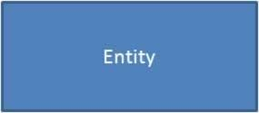
Any thing that has an independent existence and about which we collect data. It is also known as entity type. In ER modeling, notation for entity is given below.

Entity instance
Entity instance is a particular member of the entity type. Example for entity instance : A particular employee Regular Entity
An entity which has its own key attribute is a regular entity. Example for regular entity : Employee.

Weak entity

19
entity.
Example for a weak entity : In a parent/child relationship, a parent is considered as a strong entity and the child is a weak entity.
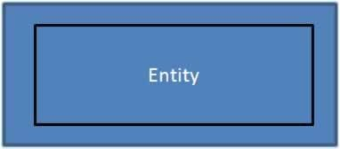
In ER modeling, notation for weak entity is given below.

Attributes
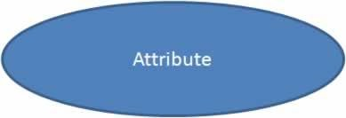
Properties/characteristics which describe entities are called attributes. In ER modeling, notation for attribute is given below.

Domain of Attributes
The set of possible values that an attribute can take is called the domain of the attribute. For example, the attribute day may take any value from the set {Monday, Tuesday ... Friday}. Hence this set can be termed as the domain of the attribute day.

Key attribute
The attribute (or combination of attributes) which is unique for every entity instance is called key attribute.
E.g the employee_id of an employee, pan_card_number of a person etc.If the key attribute consists of two or more attributes in combination, it is called a composite key.
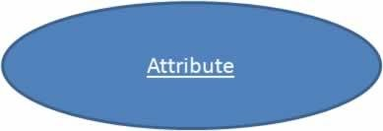
In ER modeling, notation for key attribute is given below.

Simple attribute
If an attribute cannot be divided into simpler components, it is a simple attribute. Example for simple attribute : employee_id of an employee.

Composite attribute
If an attribute can be split into components, it is called a composite attrExample for composite attribute : Name of the employee which can be split into First_name, Middle_name, and Last_name.

Single valued Attributes

20
If an attribute can take only a single value for each entity instance, it is a single valued attribute. example for single valued attribute : age of a student. It can take only one value for a particular student. Multi-valued Attributes
If an attribute can take more than one value for each entity instance, it is a multi-valued attribute. Multi-valued
example for multi valued attribute : telephone number of an employee, a particular employee may have multiple telephone numbers.
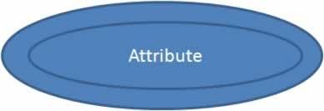
In ER modeling, notation for multi-valued attribute is given below.

Stored Attribute
An attribute which need to be stored permanently is a stored attribute Example for stored attribute : name of a student

Derived Attribute
An attribute which can be calculated or derived based on other attributes is a derived attribute.
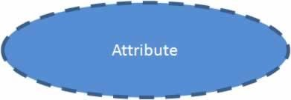
Example for derived attribute : age of employee which can be calculated from date of birth and current date. In ER modeling, notation for derived attribute is given below.

Relationships
Associations between entities are called relationships
Example : An employee works for an organization. Here "works for" is a relation between the entities employee and organization.
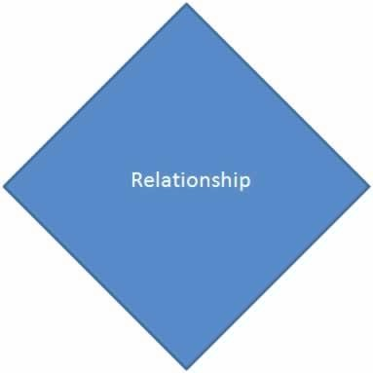
In ER modeling, notation for relationship is given below.

However in ER Modeling, To connect a weak Entity with others, you should use a weak relationship notation as given below

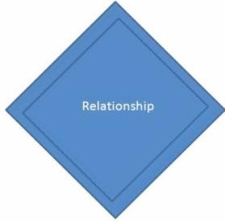
21

Degree of a Relationship
Degree of a relationship is the number of entity types involved. The n-ary relationship is the general form for degree n. Special cases are unary, binary, and ternary ,where the degree is 1, 2, and 3, respectively.
Example for unary relationship : An employee ia a manager of another employee Example for binary relationship : An employee works-for department.
Example for ternary relationship : customer purchase item from a shop keeper

Cardinality of a Relationship
Relationship cardinalities specify how many of each entity type is allowed. Relationships can have four possible connectivities as given below.
- One to one (1:1) relationship
- One to many (1:N) relationship
- Many to one (M:1) relationship
- Many to many (M:N) relationship
The minimum and maximum values of this connectivity is called the cardinality of the relationship

Example for Cardinality – One-to-One (1:1)
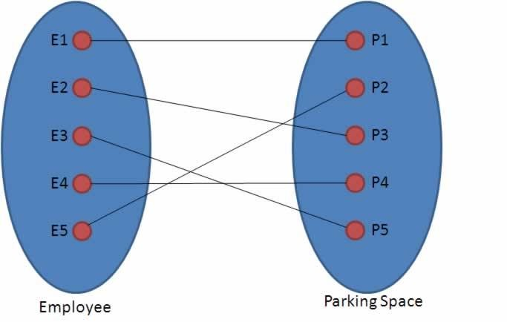
Employee is assigned with a parking space.

One employee is assigned with only one parking space and one parking space is assigned to only one employee. Hence it is a 1:1 relationship and cardinality is One-To-One (1:1)
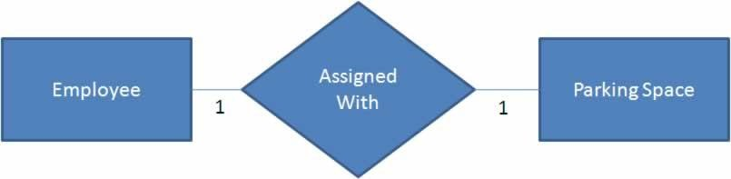

Example for Cardinality – One-to-Many (1:N)
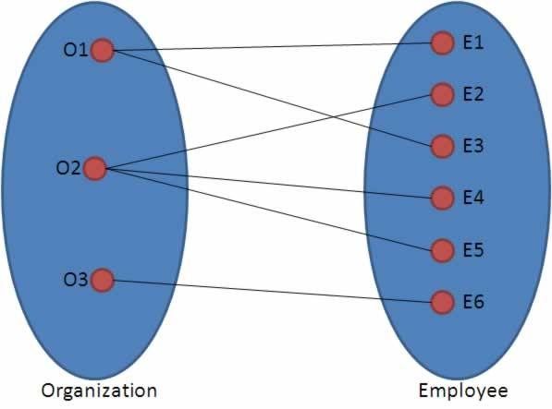
Organization has employees

One organization can have many employees , but one employee works in only one organization. Hence it is a 1:N relationship and cardinality is One-To-Many (1:N)
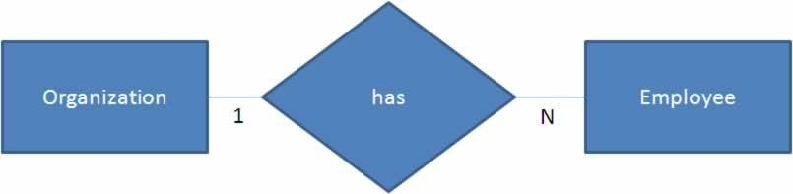
In ER modeling, this can be mentioned using notations as given below

Example for Cardinality – Many-to-One (M :1)
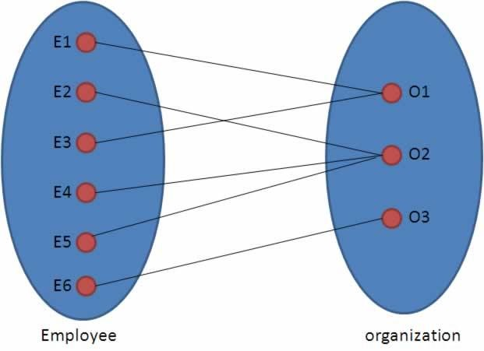
It is the reverse of the One to Many relationship. employee works in organization

One employee works in only one organization But one organization can have many employees. Hence it is a M:1 relationship and cardinality is Many-to-One (M :1)

23
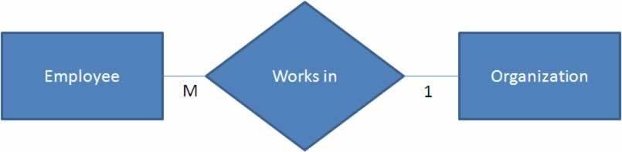
In ER modeling, this can be mentioned using notations as given below.

Cardinality – Many-to-Many (M:N)
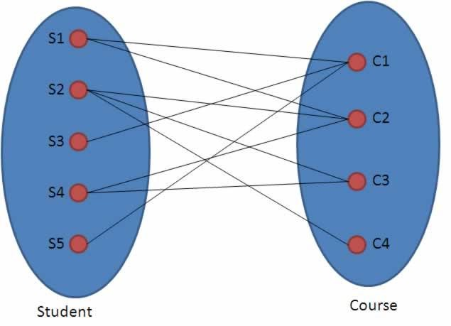
Students enrolls for courses

One student can enroll for many courses and one course can be enrolled by many students. Hence it is a M:N relationship and cardinality is Many-to-Many (M:N)
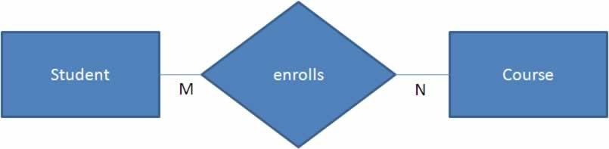
In ER modeling, this can be mentioned using notations as given below

Relationship Participation
- Total
In total participation, every entity instance will be connected through the relationship to another instance of the other participating entity types

Partial
Example for relationship participation
Consider the relationship - Employee is head of the department.
Here all employees will not be the head of the department. Only one employee will be the head of the department. In other words, only few instances of employee entity participate in the above relationship. So employee entity's participation is partial in the said relationship.
However each department will be headed by some employee. So department entity's participation is total in the said relationship.

24
Advantages and Disadvantages of ER Modeling ( Merits and Demerits of ER Modeling ) Advantages
- ER Modeling is simple and easily understandable. It is represented in business users language and it can be understood by non-technical specialist.
- Intuitive and helps in Physical Database creation.
- Can be generalized and specialized based on needs.
- Can help in database design.
- Gives a higher level description of the system.
Disadvantages
- Physical design derived from E-R Model may have some amount of ambiguities or inconsistency.
- Sometime diagrams may lead to misinterpretations

Relational Model

The relational model is today the primary data model for commercial data processing applications. It attained its primary position because of its simplicity, which eases the job of the programmer, compared to earlier data models such as the network model or the hierarchical model. In this, we first study the fundamentals of the relational model. A substantial theory exists for relational databases.

Structure of Relational Databases:

A relational database consists of a collection of tables, each of which is assigned a unique name. For example, consider the instructor table of Figure:1.5, which stores information about instructors. The table has four column headers: ID, name, dept name, and salary. Each row of this table records information about an instructor, consisting of the instructor’s ID, name, dept name, and salary. Similarly, the course table of Figure 1.6 stores information about courses, consisting of a course id, title, dept name, and credits, for each course. Note that each instructor is identified by the value of the column ID, while each course is identified by the value of the column course id.

Figure 1.7 shows a third table, prereq, which stores the prerequisite courses for each course. The table has two columns, course id and prereq id. Each row consists of a pair of course identifiers such that the second course is a prerequisite for the first course.

Thus, a row in the prereq table indicates that two courses are related in the sense that one course is a prerequisite for the other. As another example, we consider the table instructor, a row in the table can be thought of as representing the.

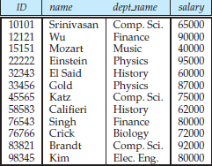
25

Figure 1.5: The instructor relation (2.1)

In general, a row in a table represents a relationship among a set of values. Since a table is a collection of such relationships, there is a close correspondence between the concept of table and the mathematical concept of relation, from which the relational data model takes its name. In mathematical terminology, a tuple is simply a sequence (or list) of values. A relationship between n values is represented mathematically by an n-tuple of values, i.e., a tuple with n values, which corresponds to a row in a table.

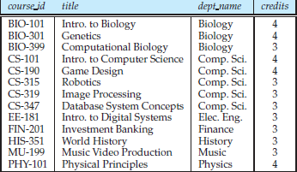
Figure: 1.6: The course relation (2.2)

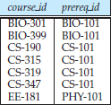
Figure: 1.7: The prereq relation. (2.3)

Thus, in the relational model the term relation is used to refer to a table, while the term tuple is used to refer to a row. Similarly, the term attribute refers to a column of a table.

Examining Figure 1.5, we can see that the relation instructor has four attributes:

ID, name, dept name, and salary.

We use the term relation instance to refer to a specific instance of a relation, i.e., containing a specific set of rows. The instance of instructor shown in Figure 1.5 has 12 tuples, corresponding to 12 instructors.

26

In this topic, we shall be using a number of different relations to illustrate the various concepts underlying the relational data model. These relations represent part of a university. They do not include all the data an actual university database would contain, in order to simplify our presentation.
The order in which tuples appear in a relation is irrelevant, since a relation is a set of tuples. Thus, whether the tuples of a relation are listed in sorted order, as in Figure 1.5, or are unsorted, as in Figure 1.8, does not matter; the relations in the two figures are the same, since both contain the same set of tuples. For ease of exposition, we will mostly show the relations sorted by their first attribute. For each attribute of a relation, there is a set of permitted values, called the domain of that attribute. Thus, the domain of the salary attribute of the instructor relation is the set of all possible salary values, while the domain of the name attribute is the set of all possible instructor names.
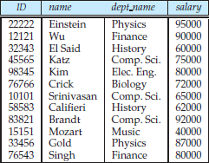
We require that, for all relations r, the domains of all attributes of r be atomic. A domain is atomic if elements of the domain are considered to be indivisible units.

Figure: 1.8: Unsorted display of the instructor relation. (2-4)

For example, suppose the table instructor had an attribute phone number, which can store a set of phone numbers corresponding to the instructor. Then the domain of phone number would not be atomic, since an element of the domain is a set of phone numbers, and it has subparts, namely the individual phone numbers
in the set.

The important issue is not what the domain itself is, but rather how we use domain elements in our database. Suppose now that the phone number attribute stores a single phone number. Even then, if we split the value from the phone number attribute into a country code, an area code and a local number, we would be treating it as a nonatomic value. If we treat each phone number as a single indivisible unit, then the attribute phone number would have an atomic domain.

The null value is a special value that signifies that the value is unknown or does not exist. For example, suppose as before that we include the attribute phone number in the instructor relation. It may be that an instructor does not have a phone number at all, or that the telephone number is unlisted. We would then have to use the null value to signify that the value is unknown or does not exist. We shall see later that null values cause a number of difficulties when we access or update the database, and thus should be eliminated if at all possible. We shall assume null values are absent initially.

Database Schema
When we talk about a database, we must differentiate between the database schema, which is the logical design of the database, and the database instance, which is a snapshot of the data in the database at a given

27
instant in time. The concept of a relation corresponds to the programming-language notion of a variable, while the concept of a relation schema corresponds to the programming-language notion of type definition.

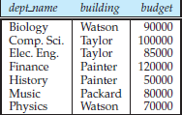
In general, a relation schema consists of a list of attributes and their corresponding domains. The concept of a relation instance corresponds to the programming-language notion of a value of a variable. The value of a given variable may change with time;

Figure 1.9: The department relation.(2-5)

similarly the contents of a relation instance may change with time as the relation is updated. In contrast, the schema of a relation does not generally change. Although it is important to know the difference between a relation schema and a relation instance, we often use the same name, such as instructor, to refer to both the schema and the instance. Where required, we explicitly refer to the schema or to the instance, for example “the instructor schema,” or “an instance of the instructor relation.” However, where it is clear whether we mean the schema or the instance, we simply use the relation name.
Consider the department relation of Figure 1.9. The schema for that relation is

department (dept name, building, budget)

Note that the attribute dept name appears in both the instructor schema and the department schema. This duplication is not a coincidence. Rather, using common attributes in relation schemas is one way of relating tuples of distinct relations.

For example, suppose we wish to find the information about all the instructors who work in the Watson building. We look first at the department relation to find the dept name of all the departments housed in Watson. Then, for each such department, we look in the instructor relation to find the information about the instructor associated with the corresponding dept name.

Let us continue with our university database example. Each course in a university may be offered multiple times, across different semesters, or even within a semester.We need a relation to describe each individual
offering, or section, of the class. The schema is

section (course id, sec id, semester, year, building, room number, time slot id)
Figure 1.10 shows a sample instance of the section relation. We need a relation to describe the association between instructors and the class sections that they teach. The relation schema to describe this association is
teaches (ID, course id, sec id, semester, year)

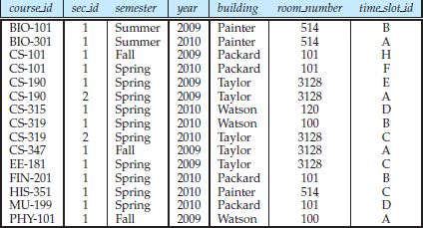
28

Figure 1.10: The section relation.(2-6)

Figure 1.11 shows a sample instance of the teaches relation. As you can imagine, there are many more relations maintained in a real university database. In addition to those relations we have listed already, instructor, department, course, section, prereq, and teaches,we use the following relations in this text:

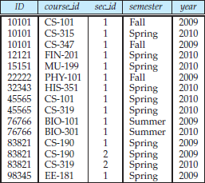
Figure: 1.11: The teaches relation.(2-7)

- student (ID, name, dept name, tot cred)
- advisor (s id, i id)
- takes (ID, course id, sec id, semester, year, grade)
- classroom (building, room number, capacity)
- time slot (time slot id, day, start time, end time)

Keys

We must have a way to specify how tuples within a given relation are distinguished. This is expressed in terms of their attributes. That is, the values of the attribute values of a tuple must be such that they can uniquely identify the tuple. In other words, no two tuples in a relation are allowed to have exactly the same value for all attributes.

A superkey is a set of one or more attributes that, taken collectively, allow us to identify uniquely a tuple in the relation. For example, the ID attribute of the relation instructor is sufficient to distinguish one instructor tuple from

29
another. Thus, ID is a superkey. The name attribute of instructor, on the other hand, is not a superkey, because several instructors might have the same name. Formally, let R denote the set of attributes in the schema of relation r. If we say that a subset K of R is a superkey for r , we are restricting consideration to instances of relations r in which no two distinct tuples have the same values on all attributes in K. That is, if t1 and t2 are in r and t1 = t2, then t1.K = t2.K.

A superkey may contain extraneous attributes. For example, the combination of ID and name is a superkey for the relation instructor. If K is a superkey, then so is any superset of K. We are often interested in superkeys for which no proper subset is a superkey. Such minimal superkeys are called candidate keys.

It is possible that several distinct sets of attributes could serve as a candidate key. Suppose that a combination of name and dept name is sufficient to distinguish among members of the instructor relation. Then, both {ID} and
{name, dept name} are candidate keys. Although the attributes ID and name together can distinguish instructor tuples, their combination, {ID, name}, does not form a candidate key, since the attribute ID alone is a candidate key.
We shall use the term primary key to denote a candidate key that is chosen by the database designer as the principal means of identifying tuples within a relation. A key (whether primary, candidate, or super) is a property of the entire relation, rather than of the individual tuples. Any two individual tuples in the relation are prohibited from having the same value on the key attributes at the same time. The designation of a key represents a constraint in the real-world enterprise being modeled.

Primary keys must be chosen with care. As we noted, the name of a person is obviously not sufficient, because there may be many people with the same name. In the United States, the social-security number attribute of a person would be a candidate key. Since non-U.S. residents usually do not have social-security numbers, international enterprises must generate their own unique identifiers.

An alternative is to use some unique combination of other attributes as a key. The primary key should be chosen such that its attribute values are never, or very rarely, changed. For instance, the address field of a person should not be part of the primary key, since it is likely to change. Social-security numbers, on the other hand, are guaranteed never to change. Unique identifiers generated by enterprises generally do not change, except if two enterprises merge; in such a case the same identifier may have been issued by both enterprises, and a reallocation of identifiers may be required to make sure they are unique.

It is customary to list the primary key attributes of a relation schema before the other attributes; for example, the dept name attribute of department is listed first, since it is the primary key. Primary key attributes are also underlined. A relation, say r1, may include among its attributes the primary key of another relation, say r2. This attribute is called a foreign key from r1, referencing r2.

The relation r1 is also called the referencing relation of the foreign key dependency, and r2 is called the referenced relation of the foreign key. For example, the attribute dept name in instructor is a foreign key from instructor, referencing department, since dept name is the primary key of department. In any database instance, given any tuple, say ta, from the instructor relation, there must be some tuple, say tb, in the department relation such that the value of the dept name attribute of ta is the same as the value of the primary key, dept name, of tb.

Now consider the section and teaches relations. It would be reasonable to require that if a section exists for a course, it must be taught by at least one instructor; however, it could possibly be taught by more than one instructor. To enforce this constraint, we would require that if a particular (course id, sec id, semester, year) combination appears in section, then the same combination must appear in teaches. However, this set of values does not form a primary key for teaches, since more than one instructor may teach one such section. As a result, we cannot declare a foreign key constraint from section to teaches (although we can define a foreign key constraint in the other direction, from teaches to section).

30

The constraint from section to teaches is an example of a referential integrity constraint; a referential integrity constraint requires that the values appearing in specified attributes of any tuple in the referencing relation also appear in specified attributes of at least one tuple in the referenced relation.

Schema Diagrams
A database schema, along with primary key and foreign key dependencies, can be depicted by schema diagrams. Figure 1.12 shows the schema diagram for our university organization. Each relation appears as a box, with the relation name at the top in blue, and the attributes listed inside the box. Primary key attributes are shown underlined. Foreign key dependencies appear as arrows from the foreign key attributes of the referencing relation to the primary key of the referenced relation.

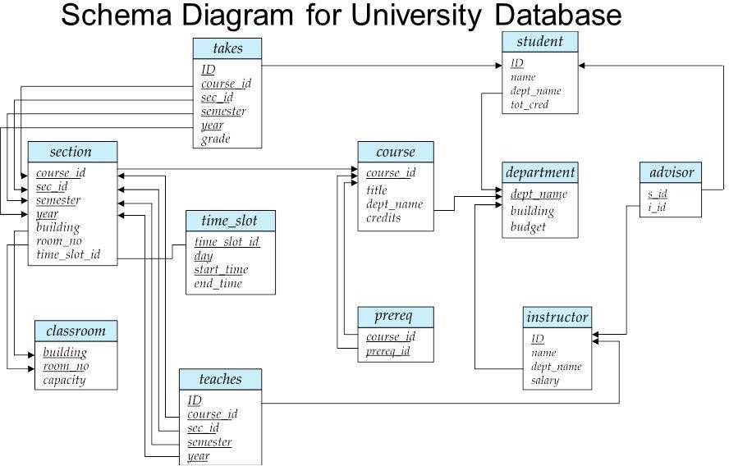

Figure 1.12 : Schema diagram for the university database.

Referential integrity constraints other than foreign key constraints are not shown explicitly in schema diagrams. We will study a different diagrammatic representation called the entity-relationship diagram.

UNIT-2
Relational Algebra and Calculus

PRELIMINARIES

In defining relational algebra and calculus, the alternative of referring to fields by position is more convenient than referring to fields by name: Queries often involve the computation of intermediate results, which are themselves relation instances, and if we use field names to refer to fields, the definition of query language constructs must specify the names of fields for all intermediate relation instances. This can be tedious and is really a secondary issue because we can refer to fields by position anyway. On the other hand, field names make queries more readable.
Due to these considerations, we use the positional notation to formally define relational algebra and calculus. We also introduce simple conventions that allow intermediate relations to ‘inherit’ field names, for convenience.

We present a number of sample queries using the following schema:

Sailors (sid: integer, sname: string, rating: integer, age: real) Boats (bid: integer, bname: string, color: string)
Reserves (sid: integer, bid: integer, day: date)

The key fields are underlined, and the domain of each field is listed after the field name. Thus sid is the key for Sailors, bid is the key for Boats, and all three fields together form the key for Reserves. Fields in an instance of one of these relations will be referred to by name, or positionally, using the order in which they are listed above.
In several examples illustrating the relational algebra operators, we will use the in-stances S1 and S2 (of Sailors) and R1 (of Reserves) shown in

RELATIONAL ALGEBRA
Relational algebra is one of the two formal query languages associated with the re- lational model. Queries in algebra are composed using a collection of operators. A fundamental property is that every operator in the algebra accepts (one or two) rela- tion instances as arguments and returns a relation instance as the result. This property makes it easy to compose operators to form a complex query—a relational algebra expression is recursively defined to be a relation, a unary algebra operator applied to a single expression, or a binary algebra operator applied to two expressions. We describe the basic operators of the algebra (selection, projection, union, cross-product, and difference), as well as some additional operators that can be defined in terms of the basic operators but arise frequently enough to warrant special attention, in the following sections.Each relational query describes a step-by-step procedure for computing the desired answer, based on the order in which operators are applied in the query. The procedural nature of the algebra allows us to think of an algebra expression as a recipe, or a plan, for evaluating a query, and relational systems in fact use algebra expressions to represent query evaluation plans.

Selection and Projection

Relational algebra includes operators to select rows from a relation (σ) and to project columns (π). These operations allow us to manipulate data in a single relation. Con- sider the instance of the Sailors relation shown in Figure 4.2, denoted as S2. We can retrieve rows corresponding to expert sailors by using the σ operator. The expression,
σrating>8(S2)
evaluates to the relation shown in Figure 4.4. The subscript rating>8 specifies the selection criterion to be applied while retrieving tuples.
 |  |  |  | sname | rating
 |  |  |  | yuppy | 9
 |  |  |  | Lubber | 8
 |  |  |  | Guppy | 5
 |  |  |  | Rusty | 10
sid | sname | rating | age
28 | Yuppy | 9 | 35.0
58 | Rusty | 10 | 35.0
Figure 4.4 σrating>8(S2) Figure 4.5πsname,rating(S2)

The selection operator σ specifies the tuples to retain through a selection condition. In general, the selection condition is a boolean combination (i.e., an expression using the logical connectives ∧ and ∨) of terms that have the form attribute op constant or attribute1 op attribute2, where op is one of the comparison operators <, <=, =, =, >=, or >. The reference to an attribute can be by position (of the form .i or i) or by name (of the form .name or name). The schema of the result of a selection is the schema of the input relation instance
The projection operator π allows us to extract columns from a relation; for example, we can find out all sailor names and ratings by using π. The expression πsname,rating(S2)
Suppose that we wanted to find out only the ages of sailors. The expression
πage(S2)
a single tuple with age=35.0 appears in the result of the projection. This follows from the definition of a relation as a set of tuples. In practice, real systems often omit the expensive step of eliminating duplicate tuples, leading to relations that are multisets. However, our discussion of relational algebra and calculus assumes that duplicate elimination is always done so that relations are always sets of tuples.
We can compute the names and ratings of highly rated sailors by combining two of the preceding queries. The expression
πsname,rating(σrating>8(S2))

age |  | sname | rating
35.0 |  | yuppy | 9
55.5 |  | Rusty | 10
Figure 4.6 πage(S2) Figure 4.7 πsname,rating(σrating>8(S2))

Set Operations

The following standard operations on sets are also available in relational algebra: union (U),
intersection (∩), set-difference (−), and cross-product (×).

- Union: R u S returns a relation instance containing all tuples that occur in either relation instance R or relation instance S (or both). R and S must be union- compatible, and the schema of the result is defined to be identical to the schema of R.
- Intersection: R ∩ S returns a relation instance containing all tuples that occur in both R and S. The relations R and S must be union-compatible, and the schema of the result is defined to be identical to the schema of R.
- Set-difference: R − S returns a relation instance containing all tuples that occur in R but not in S. The relations R and S must be union-compatible, and the schema of the result is defined to be identical to the schema of R.
- Cross-product: R × S returns a relation instance whose schema contains all the fields of R (in the same order as they appear in R) followed by all the fields of S (in the same order as they appear in S). The result of R × S contains one tuple
〈r, s〉 (the concatenation of tuples r and s) for each pair of tuples r ∈ R, s ∈ S. The cross-product opertion is sometimes called Cartesian product.
We now illustrate these definitions through several examples. The union of S1 and S2 is shown in Figure 4.8. Fields are listed in order; field names are also inherited from S1. S2 has the same field names, of course, since it is also an instance of Sailors.In general, fields of S2 may have different names; recall that we require only domains to match. Note that the result is a set of tuples. Tuples that appear in both S1 and S2 appear only once in S1 ∪ S2. Also, S1 ∪ R1 is not a valid operation because the two relations are not union-compatible. The intersection of S1 and S2 is shown in Figure 4.9, and the set-difference S1 − S2 is shown in Figure 4.10.
sid | sname | rating | age
22 | Dustin | 7 | 45.0
31 | Lubber | 8 | 55.5
58 | Rusty | 10 | 35.0
28 | Yuppy | 9 | 35.0
44 | Guppy | 5 | 35.0
Figure 4.8 S1 ∪ S2

sid | sname | rating | age
31 | Lubbe | 8 | 55.5
58 | Rusty | 10 | 35.0

sid | sname | rating | age
22 | Dustin | 7 | 45.0

Figure 4.9 S1 ∩ S2 Figure 4.10 S1 − S2

The result of the cross-product S1 × R1 is shown in Figure 4.11 The fields in S1
× R1 have the same domains as the corresponding fields in R1 and S1. In Figure 4.11 sid is listed in parentheses to
emphasize that it is not an inherited field name; only the corresponding domain is inherited.

(sid) | sname | rating | age | (sid) | bid | day
22 | Dustin | 7 | 45.0 | 22 | 101 | 10/10/96
22 | Dustin | 7 | 45.0 | 58 | 103 | 11/12/96
31 | Lubber | 8 | 55.5 | 22 | 101 | 10/10/96
31 | Lubber | 8 | 55.5 | 58 | 103 | 11/12/96
58 | Rusty | 10 | 35.0 | 22 | 101 | 10/10/96
58 | Rusty | 10 | 35.0 | 58 | 103 | 11/12/96
Figure 4.11 S1 × R1

Renaming
We introduce a renaming operator ρ for this purpose. The expression ρ(R(F ), E) takes an arbitrary relational algebra expression E and returns an instance of a (new) relation called R. R contains the same tuples as the result of E, and has the same schema as E, but some fields are renamed. The field names in relation R are the same as in E, except for fields renamed in the renaming list F.
For example, the expression ρ(C(1 → sid1, 5 → sid2), S1 × R1) returns a relation that contains the tuples shown in Figure 4.11 and has the following schema: C(sid1: integer, sname: string, rating: integer, age: real, sid2: integer, bid: integer,day: dates).
It is customary to include some additional operators in the algebra, but they can all be defined in terms of the operators that we have defined thus far. (In fact, the renaming operator is only needed for syntactic convenience, and even the ∩ operator is redundant; R
∩ S can be defined as R − (R − S).) We will consider these additional operators,and their definition in terms of the basic operators, in the next two subsections.

Joins

The join operation is one of the most useful operations in relational algebra and is the most commonly used way to combine information from two or more relations. Although a join can be defined as a cross-product followed by selections and projections, joins arise much more frequently in practice than plain cross-products.
joins have received a lot of attention, and there are several variants of the join operation.

Condition Joins
The most general version of the join operation accepts a join condition c and a pair of relation instances as arguments, and returns a relation instance. The join condition is identical to a selection condition in form. The operation is defined as follows:
R 𝝰⊳c S = σc(R × S)

Thus 𝝰⊳ is defined to be a cross-product followed by a selection. Note that the condition
c can (and typically does) refer to attributes of both R and S. The reference to an

attribute of a relation, say R, can be by position (of the form R.i) or by name (of the form R.name).As an example, the result of S1 𝝰⊳S1.sid<R1.sid R1 is shown in Figure 4.12. Because sid appears in both S1 and R1, the corresponding fields in the result of the cross-product S1 × R1 (and therefore in the result of S1 𝝰⊳S1.sid<R1.sid R1) are unnamed. Domains are inherited from the corresponding fields of S1 and R1.

(sid) | sname | rating | age | (sid) | bid | day
22 | Dustin | 7 | 45.0 | 58 | 103 | 11/12/96
31 | Lubber | 8 | 55.5 | 58 | 103 | 11/12/96
Figure 4.12 S1 𝝰⊳S1.sid<R1.sid R1

Equijoin

common special case of the join operation R 𝝰⊳ S is when the join condition con- sists solely of equalities (connected by ∧) of the form R.name1 = S.name2, that is, equalities between two fields in R and S. In this case, obviously, there is some redun- dancy in retaining both attributes in the result. For join conditions that contain only such equalities, the join operation is refined by doing an additional projection in which S.name2 is dropped. The join operation with this refinement is called equijoin.
The schema of the result of an equijoin contains the fields of R (with the same names and domains as in R) followed by the fields of S that do not appear in the join conditions. If this set of fields in the result relation includes two fields that inherit the same name from R and S, they are unnamed in the result relation.
We illustrate S1 𝝰⊳R.sid=S.sid R1 in Figure 4.13. Notice that only one field called sid
appears in the result.

sid | sname | rating | age | bid | day
22 | Dustin | 7 | 45.0 | 101 | 10/10/96
58 | Rusty | 10 | 35.0 | 103 | 11/12/96
Figure 4.13 S1 𝝰⊳R.sid=S.sid R1

Natural Join
A further special case of the join operation R 𝝰⊳ S is an equijoin in which equalities are specified on all fields having the same name in R and S. In this case, we can simply omit the join condition; the default is that the join condition is a collection of equalities on all common fields. We call this special case a natural join, and it has the nice property that the result is guaranteed not to have two fields with the same name.
The equijoin expression S1 𝝰⊳R.sid=S.sid R1 is actually a natural join and can simply be denoted as S1 𝝰⊳ R1, since the only common field is sid. If the two relations have no attributes in common, S1 𝝰⊳ R1 is simply the cross-product.

Division
The division operator is useful for expressing certain kinds of queries, for example: “Find the names of sailors who have reserved all boats.” Understanding how to use the basic operators of the algebra to define division is a useful exercise. However,

the division operator does not have the same importance as the other operators—it is not needed as often, and database systems do not try to exploit the semantics of division by implementing it as a distinct operator (as, for example, is done with the join operator).
We discuss division through an example. Consider two relation instances A and B in which A has (exactly) two fields x and y and B has just one field y, with the same domain as in A. We define the division operation A/B as the set of all x values (in the form of unary tuples) such that for every y value in (a tuple of) B, there is a tuple
〈x,y〉in A.

Another way to understand division is as follows. For each x value in (the first column of) A, consider the set of y values that appear in (the second field of) tuples of A with that x value. If this set contains (all y values in) B, the x value is in the result of A/B.
An analogy with integer division may also help to understand division. For integers A and B, A/B is the largest integer Q such that Q ∗ B ≤ A. For relation instances A and B, A/B is the largest relation instance Q such that Q × B ⊆ A.
Division is illustrated in Figure 4.14. It helps to think of A as a relation listing the parts supplied by suppliers, and of the B relations as listing parts. A/Bi computes suppliers who supply all parts listed in relation instance Bi.
Expressing A/B in terms of the basic algebra operators is an interesting exercise, and the reader should try to do this before reading further. The basic idea is to compute all x values in A that are not disqualified. An x value is disqualified if by attaching a
y value from B, we obtain a tuple 〈x,y〉 that is not in A. We can compute disqualified tuples using the algebra expression

Thus we can define A/B as
πx((πx(A) × B) − A)

πx(A) − πx((πx(A) × B) − A)

To understand the division operation in full generality, we have to consider the case when both x and y are replaced by a set of attributes.

More Examples of Relational Algebra Queries
We illustrate queries using thei nstances S3 of Sailors, R2 of Reserves, and B1 of Boats, shown in Figures 4.15,4.16,and4.17, respectively.

sid | sname | rating | age |  | sid | bid | day
22 | Dustin | 7 | 45.0 |  | 22 | 101 | 10/10/98
29 | Brutus | 1 | 33.0 |  | 22 | 102 | 10/10/98
31 | Lubber | 8 | 55.5 |  | 22 | 103 | 10/8/98
32 | Andy | 8 | 25.5 |  | 22 | 104 | 10/7/98
58 | Rusty | 10 | 35.0 |  | 31 | 102 | 11/10/98
64 | Horatio | 7 | 35.0 |  | 31 | 103 | 11/6/98
71 | Zorba | 10 | 16.0 |  | 31 | 104 | 11/12/98
74 | Horatio | 9 | 35.0 |  | 64 | 101 | 9/5/98
85 | Art | 3 | 25.5 |  | 64 | 102 | 9/8/98
95 | Bob | 3 | 63.5 |  | 74 | 103 | 9/8/98

Figure 4.15An Instance S3 of Sailors Figure 4.16An Instance R2 of Reserves

bid | bname | color
101 | Interlak | blue
102 | Interlak | red
103 | Clipper | green
104 | Marine | red
Figure 4.17 An Instance B1 of Boats

(Q1) Find the names of sailors who have reserved boat 103.

This query can be written as follows:
πsname((σbid=103Reserves) 𝝰⊳Sailors)
We first compute the set of tuples in Reserves with bid = 103 and then take the natural join of this set with Sailors. This expression can be evaluated on instances of Reserves and Sailors. Evaluated on the instances R2 and S3, it yields a relation that contains just one field, called sname, and three tuples 〈Dustin〉, 〈Horatio〉,and

Lubber〉. (Observe that there are two sailors called Horatio, and only one of them has reserved a red boat.)
We can break this query into smaller pieces using the renaming operator ρ:
ρ(T emp1, σbid=103Reserves) ρ(T emp2, T emp1 𝝰⊳ Sailors) πsname(Temp2)
T emp1 denotes an intermediate relation that identifies reservations of boat 103. T emp2 is another intermediate relation, and it denotes sailors who have made a reservation in the set T emp1. The instances of these relations when evaluating this query on the instances R2 and S3 are illustrated in Figures 4.18 and 4.19. Finally, we extract the sname column from T emp2.
sid | bid | day |  | sid | sname | rating | age | bid | day
22 | 103 | 10/8/98 |  | 22 | Dustin | 7 | 45.0 | 103 | 10/8/98
31 | 103 | 11/6/98 |  | 31 | Lubber | 8 | 55.5 | 103 | 11/6/98
74 | 103 | 9/8/98 |  | 74 | Horatio | 9 | 35.0 | 103 | 9/8/98
Figure 4.18Instance of T emp1 Figure 4.19 Instance of T emp2

πsname(σbid=103(Reserves𝝰⊳Sailors))
The DBMS translates an SQL query into (an extended form of) relational algebra, and then looks for other algebra expressions that will produce the same answers but are cheaper to evaluate. If the user’s query is first translated into the expression
πsname(σbid=103(Reserves𝝰⊳Sailors)) a good query optimizer will find the equivalent expression
πsname((σbid=103Reserves) 𝝰⊳ Sailors)

(Q2) Find the names of sailors who have reserved a red boat.

πsname((σcolor=′red′ Boats) 𝝰⊳ Reserves 𝝰⊳ Sailors
This query involves a series of two joins. First we choose (tuples describing) red boats. Then we join this set with Reserves (natural join, with equality specified on the bid column) to identify reservations of red boats. Next we join the resulting intermediate

relation with Sailors (natural join, with equality specified on the sid column) to retrieve the names of sailors who have made reservations of red boats. Finally, we project the sailors’ names. The answer, when evaluated on the instances B1, R2 and S3, contains the names Dustin, Horatio, and Lubber.An equivalent expression is:
πsname(πsid((πbidσcolor=′red′ Boats) 𝝰⊳ Reserves) 𝝰⊳ Sailors)
The reader is invited to rewrite both of these queries by using ρ to make the interme- diate relations explicit and to compare the schemas of the intermediate relations. The second expression generates intermediate relations with fewer fields (and is therefore likely to result in intermediate relation instances with fewer tuples, as well). A rela- tional query optimizer would try to arrive at the second expression if it is given the first.
(Q3) Find the colors of boats reserved by Lubber.
πcolor((σsname=′Lubber′ Sailors) 𝝰⊳ Reserves 𝝰⊳ Boats)
This query is very similar to the query we used to compute sailors who reserved red boats. On instances B1, R2, and S3, the query will return the colors gren and red.
(Q4) Find the names of sailors who have reserved at least one boat.
πsname(Sailors 𝝰⊳ Reserves)

(Q5) Find the names of sailors who have reserved a red or a green boat.
ρ(T empboats, (σcolor=′red′ Boats) U (σcolor=′green′ Boats)) πsname(Tempboats 𝝰⊳Reserves 𝝰⊳Sailors)
We identify the set of all boats that are either red or green (Tempboats, which contains boats with the bids 102, 103, and 104 on instances B1, R2, and S3). Then we join with Reserves to identify sids of sailors who have reserved one of these boats; this gives us sids 22, 31, 64, and 74 over our example instances. Finally, we join (an intermediate relation containing this set of sids) with Sailors to find the names of Sailors with these sids. This gives us the names Dustin, Horatio, and Lubber on the instances B1, R2, and S3. Another equivalent definition is the following:
ρ(T empboats, (σcolor=′red′∨ color=′green′ Boats)) πsname(Tempboats 𝝰⊳Reserves 𝝰⊳ Sailors)

(Q6) Find the names of sailors who have reserved a red and a green boat
ρ(T empboats2, (σcolor=′red′ Boats) ∩ (σcolor=′green′
Boats)) πsname(Tempboats2 𝝰⊳ Reserves 𝝰⊳ Sailors)
However, this solution is incorrect—it instead tries to compute sailors who have re- served a boat that is both red and green. (Since bid is a key for Boats, a boat can be only one color; this query will always return an empty answer set.) The correct approach is to find sailors who have reserved a red boat, then sailors who have reserved a green boat, and then take the intersection of these two sets:
ρ(T empred, πsid((σcolor=′red′ Boats) 𝝰⊳ Reserves))
ρ(T empgreen, πsid((σcolor=′green′ Boats) 𝝰⊳ Reserves)) πsname((Tempred ∩ Tempgreen) 𝝰⊳ Sailors)
The two temporary relations compute the sids of sailors, and their intersection identifies sailors who have reserved both red and green boats. On instances B1, R2, and S3, the sids of sailors who have reserved a red boat are 22, 31, and 64. The sids of sailors who have reserved a green boat are 22, 31, and 74. Thus, sailors 22 and 31 have reserved both a red boat and a green boat; their names are Dustin and Lubber.
This formulation of Query Q6 can easily be adapted to find sailors who have reserved red or green boats (Query Q5); just replace ∩ by ∪ :
ρ(T empred, πsid((σcolor=′red′ Boats) 𝝰⊳ Reserves))
ρ(T empgreen, πsid((σcolor=′green′ Boats) 𝝰⊳ Reserves)) πsname((Tempred ∪ Tempgreen) 𝝰⊳Sailors)
In the above formulations of Queries Q5 and Q6, the fact that sid (the field over which we compute union or intersection) is a key for Sailors is very important. Consider the following attempt to answer Query Q6:
ρ(T empred, πsname((σcolor=′red′ Boats) 𝝰⊳Reserves 𝝰⊳ Sailors))
ρ(T empgreen, πsname((σcolor=′green′ Boats) 𝝰⊳Reserves 𝝰⊳
Sailors)) T empred ∩ T empgreen

This attempt is incorrect for a rather subtle reason. Two distinct sailors with the same name, such as Horatio in our example instances, may have reserved red and

green boats, respectively. In this case, the name Horatio will (incorrectly) be included in the answer even though no one individual called Horatio has reserved a red boat and a green boat. The cause of this error is that sname is being used to identify sailors (while doing the intersection) in this version of the query, but sname is not a key.
(Q7) Find the names of sailors who have reserved at least two boats. ρ(Reservations, πsid,sname,bid(Sailors 𝝰⊳ Reserves)) ρ(Reservationpairs(1 → sid1, 2 → sname1, 3 → bid1, 4 → sid2, 5 → sname2,6 → bid2),Reservations × Reservations) πsname1σ(sid1=sid2) ∩ (bid1=bid2)Reservationpairs
First we compute tuples of the form 〈sid,sname,bid〉, where sailor sid has made a reservation for boat bid; this set of tuples is the temporary relation Reservations. Next we find all pairs of Reservations tuples where the same sailor has made both reservations and the boats involved are distinct. Here is the central idea: In order to show that a sailor has reserved two boats, we must find two Reservations tuples involving the same sailor but distinct boats. Over instances B1, R2, and S3, the sailors with sids 22, 31, and 64 have each reserved at least two boats. Finally, we project the names of such sailors to obtain the answer, containing the names Dustin, Horatio, and Lubber.
Notice that we included sid in Reservations because it is the key field identifying sailors, and we need it to check that two Reservations tuples involve the same sailor. As noted in the previous example, we can’t use sname for this purpose.

(Q8) Find the sids of sailors with age over 20 who have not reserved a red boat.
πsid(σage>20Sailors) −πsid((σcolor=′red′ Boats) 𝝰⊳ Reserves 𝝰⊳ Sailors)
This query illustrates the use of the set-difference operator. Again, we use the fact that sid is the key for Sailors. We first identify sailors aged over 20 (over instances B1, R2, and S3, sids 22, 29, 31, 32, 58, 64, 74, 85, and 95) and then discard those who have
reserved a red boat (sids 22, 31, and 64), to obtain the answer (sids 29, 32, 58, 74,

85, and 95). If we want to compute the names of such sailors, we must first compute their sids (as shown above), and then join with Sailors and project the sname values.

(Q9) Find the names of sailors who have reserved all boats.
The use of the word all (or every) is a good indication that the division operation might be applicable:
ρ(T empsids, (πsid,bidReserves)/(πbidBoats))
πsname(Tempsids 𝝰⊳ Sailors)
The intermediate relation Tempsids is defined using division, and computes the set of sids of sailors who have reserved every boat (over instances B1, R2, and S3, this is just sid 22). Notice how we define the two relations that the division operator (/) is applied to—the first relation has the schema (sid,bid) and the second has the schema (bid). Division then returns all sids such that there is a tuple 〈sid,bid〉 in the first relation for each bid in the second. Joining Tempsids with Sailors is necessary to associate names with the selected sids; for sailor 22, the name is Dustin.

(Q10) Find the names of sailors who have reserved all boats called Interlake.
ρ(T empsids, (πsid,bidReserves)/(πbid(σbname=′Interlake′ Boats))) πsname(Tempsids 𝝰⊳
Sailors)

The only difference with respect to the previous query is that now we apply a selection to Boats, to ensure that we compute only bids of boats named Interlake in defining the second argument to the division operator. Over instances B1, R2, and S3, Tempsids evaluates to sids 22 and 64, and the answer contains their names, Dustin and Horatio.

RELATIONAL CALCULUS
Relational calculus is an alternative to relational algebra. In contrast to the algebra, which is procedural, the calculus is nonprocedural, or declarative, in that it allows us to describe the set of answers without being explicit about how they should be computed. Relational calculus has had a big influence on the design of commercial query languages such as SQL and, especially, Query-by-Example (QBE).
The variant of the calculus that we present in detail is called the tuple relational calculus (TRC). Variables in TRC take on tuples as values. In another variant, called

the domain relational calculus (DRC), the variables range over field values. TRC has had more of an influence on SQL, while DRC has strongly influenced QBE.

Tuple Relational Calculus
A tuple variable is a variable that takes on tuples of a particular relation schema as values. That is, every value assigned to a given tuple variable has the same number and type of fields. A tuple relational calculus query has the form { T | p(T) }, where T is a tuple variable and p(T ) denotes a formula that describes T ; we will shortly define formulas and queries rigorously. The result of this query is the set of all tuples t for which the formula p(T ) evaluates to true with T = t. The language for writing formulas p(T ) is thus at the heart of TRC and is essentially a simple subset of first-order logic. As a simple example, consider the following query.

(Q11) Find all sailors with a rating above 7.
{S I S E Sailors ^ S. rating > 7}
When this query is evaluated on an instance of the Sailors relation, the tuple variable S is instantiated successively with each tuple, and the test S.rating>7 is applied. The answer contains those instances of S that pass this test. On instance S3 of Sailors, the answer contains Sailors tuples with sid 31, 32, 58, 71, and 74.

Syntax of TRC Queries
We now define these concepts formally, beginning with the notion of a formula. Let Rel be a relation name, R and S be tuple variables, a an attribute of R, and b an attribute of S. Let op denote an operator in the set {<,>,=,≤, ≥, =}. An atomic formula is one of the following:
- R E Rel
- R.a op S.b
- R.a op constant, or constant op R.a
A formula is recursively defined to be one of the following, where p and q are them- selves formulas, and p(R) denotes a formula in which the variable R appears:
any atomic formula
¬ p, p V q, p ^ q, or p  q
 R(p(R)), where R is a tuple variable

 R(p(R)), where R is a tuple variable

We observe that every variable in a TRC formula appears in a subformula that is atomic, and every relation schema specifies a domain for each field; this observation ensures that each variable in a TRC formula has a well-defined domain from which values for the variable are drawn. That is, each variable has a well-defined type, in the programming language sense. Informally, an atomic formula R ∈ Rel gives R the type of tuples in Rel, and comparisons such as R.a op S.b and R.a op constant induce type restrictions on the field R.a. If a variable R does not appear in an atomic formula of the form R E Rel (i.e., it appears only in atomic formulas that are comparisons), we will follow the convention that the type of R is a tuple whose fields include all (and only) fields of R that appear in the formula.
We will not define types of variables formally, but the type of a variable should be clear in most cases, and the important point to note is that comparisons of values having different types should always fail. (In discussions of relational calculus, the simplifying assumption is often made that there is a single domain of constants and that this is the domain associated with each field of each relation.)
A TRC query is defined to be expression of the form {T | p(T)}, where T is the only free variable in the formula p.

Semantics of TRC Queries
What does a TRC query mean? More precisely, what is the set of answer tuples for a given TRC query? The answer to a TRC query {T | p(T)}, as we noted earlier, is the set of all tuples t for which the formula p(T ) evaluates to true with variable T assigned the tuple value t. To complete this definition, we must state which assignments of tuple values to the free variables in a formula make the formula evaluate to true.
A query is evaluated on a given instance of the database. Let each free variable in a formula F be bound to a tuple value. For the given assignment of tuples to variables,

- and there is some assignment of tuples to the free variables in p(R) that makes the formula p(R) true no matter what tuple is assigned to R.

Examples of TRC Queries
We now illustrate the calculus through several examples, using the instances B1 of Boats, R2 of Reserves, and S3 of Sailors shown in Figures 4.15, 4.16, and 4.17. We will use parentheses as needed to make our formulas unambiguous. Often, a formula p(R) includes a condition RRel, and the meaning of the phrases some tuple R and for all tuples R is intuitive. We will use the notation R  Rel(p(R)) for  R(R  Rel  p(R)). Similarly, we use the notation R  Rel(p(R)) for R(R  Rel  p(R)).

(
A domain variable is a variable that ranges over the values in the domain of some attribute (e.g., the variable can be assigned an integer if it appears in an attribute whose domain is the set of integers). A DRC query has the form {〈x1, x2, . . . , xn〉 | p(〈x1,x2,.. ., xn〉)}, where each xi is either a domain variable or a constant and p(〈x1,x2,.. ., xn〉) denotes a DRC formula whose only free variables are thevari-ables among the xi, 1 ≤ i ≤ n. The result of this query is the set of all tuples 〈x1, x2,..
.,xn〉 for which the formula evaluates to true.

A DRC formula is defined in a manner that is very similar to the definition of a TRC formula. The main difference is that the variables are now domain variables. Let op denote an operator in the set {<, >, =, ≤, ≥, =} and let X and Y be domain variables. An atomic formula in DRC is one of the following:
〈x1,x2,...,xn〉 ∈ Rel, where Rel is a relation with n attributes; each xi, 1 ≤ i ≤ n is either a variable or a constant.
X op Y

X op constant, or constant op X

A formula is recursively defined to be one of the following, where p and q are them- selves formulas, and p(X) denotes a formula in which the variable X appears
(〈Ir, Br, D〉 Reserves(I = Ir  Br = B))))}
This query can be read as follows: “Find all values of N such that there is some tuple
〈I, N,T,A〉 in Sailors satisfying the following condition: for every 〈B, BN,C〉, either this is not a tuple in Boats or there is some tuple 〈Ir, Br, D〉 in Reserves that proves that Sailor I has reserved boat B.” The ∀ quantifier allows the domain variables B, BN, and C to range over all values in their respective attribute domains, and the pattern ‘¬(〈B, BN, C〉  Boats)∨ ’ is necessary to restrict attention to those values that appear in tuples of Boats.

THE FORM OF A BASIC SQL QUERY
This section presents the syntax of a simple SQL query and explains its meaning through a conceptual evaluation strategy. A conceptual evaluation strategy is a way to evaluate the query that is intended to be easy to understand, rather than efficient. A DBMS would typically execute a query in a different and more efficient way.
Sid | sname | rating | age |  | sid | bid | day
22 | Dustin | 7 | 45.0 |  | 22 | 101 | 10/10/98
29 | Brutus | 1 | 33.0 |  | 22 | 102 | 10/10/98
31 | Lubber | 8 | 55.5 |  | 22 | 103 | 10/8/98
32 | Andy | 8 | 25.5 |  | 22 | 104 | 10/7/98
58 | Rusty | 10 | 35.0 |  | 31 | 102 | 11/10/98
64 | Horatio | 7 | 35.0 |  | 31 | 103 | 11/6/98
71 | Zorba | 10 | 16.0 |  | 31 | 104 | 11/12/98
74 | Horatio | 9 | 35.0 |  | 64 | 101 | 9/5/98
85 | Art | 3 | 25.5 |  | 64 | 102 | 9/8/98
95 | Bob | 3 | 63.5 |  | 74 | 103 | 9/8/98
Figure 5.1An Instance S3 of Sailors Figure 5.2 An Instance R2 of Reserves

bid | bname | color
101 | Interlake | blue
102 | Interlake | red
103 | Clipper | green
104 | Marine | red

Figure 5.3 An Instance B1 of Boats

The basic form of an SQL query is as follows:
SELECT[ DISTINCT ] select-list FROM from-list WHERE qualification
Such a query intuitively corresponds to a relational algebra expression involving selec- tions, projections, and cross-products. Every query must have a SELECT clause, which specifies columns to be retained in the result, and a FROM clause, which specifies a cross-product of tables. The optional WHERE clause specifies selection conditions on the tables mentioned in the FROM clause. Let us consider a simple query.
(Q15) Find the names and ages of all sailors.
SELECT DISTINCT S.sname, S.age FROM Sailors S
The answer is a set of rows, each of which is a pair 〈sname, age〉. If two or more sailors have the same name and age, the answer still contains just one pair with that name and age. This query is equivalent to applying the projection operator of relational algebra.
The answer to this query with and without the keyword DISTINCT on instance S3 of Sailors is shown in Figures 5.4 and 5.5. The only difference is that the tuple for Horatio appears twice if DISTINCT is omitted; this is because there are two sailors called Horatio and age 35.

Sname age
sname | age |  | Dustin | 45.0
Dustin | 45.0 |  | Brutus | 33.0
Brutus | 33.0 |  | Lubber | 55.5
Lubber | 55.5 |  | Andy | 25.5
Andy | 25.5 |  | Rusty | 35.0
Rusty | 35.0 |  | Horatio | 35.0
Horatio | 35.0 |  | Zorba | 16.0
Zorba | 16.0 |  | Horatio | 35.0
Art | 25.5 |  | Art | 25.5
Bob | 63.5 |  | Bob | 63.5
Figure 5.4Answer to Q15 Figure 5.5Answer to Q15 without DISTINCT

(Q11) Find all sailors with a rating above 7.

SELECT S.sid, S.sname, S.rating, S.age FROM Sailors AS S WHERE S.rating > 7 We now consider the syntax of a basic SQL query in more detail.
- The from-list in the FROM clause is a list of table names. A table name can be followed by a range variable; a range variable is particularly useful when the same table name appears more than once in the from-list.
- The select-list is a list of (expressions involving) column names of tables named in the from-list. Column names can be prefixed by a range variable.
- The qualification in the WHERE clause is a boolean combination (i.e., an expres- sion using the logical connectives AND, OR, and NOT) of conditions of the form expression op expression, where op is one of the comparison operators {<, <=, =
, <>, >=, >}.² An expression is a column name, a constant, or an (arithmetic or string) expression.
- The DISTINCT keyword is optional. It indicates that the table computed as an answer to this query should not contain duplicates, that is, two copies of the same row. The default is that duplicates are not eliminated.
the syntax of a basic SQL query, they don’t tell us the meaning of a query. The answer to a query is itself a relation which is a multiset of rows in SQL whose contents can be understood by considering the following conceptual evaluation strategy:
  - Compute the cross-product of the tables in the from-list.

  - Delete those rows in the cross-product that fail the qualification conditions.

  - Delete all columns that do not appear in the select-list.

  - If DISTINCT is specified, eliminate duplicate rows.

(Q1) Find the names of sailors who have reserved boat number 103.
It can be expressed in SQL as follows.SELECT S.sname FROM Sailors S, Reserves R WHERE S.sid = R.sid AND R.bid=103Let us compute the answer to this query on the instances R3 of Reserves and S4 of Sailors shown in Figures 5.6 and 5.7, since the

computation on our usual example instances (R2 and S3) would be unnecessarily tedious.
 |  |  | sid | sna | rati | age
 |  |  | 22 | Dus | 7 | 45.0
 |  |  | 31 | Lub | 8 | 55.5
 |  |  | 58 | Rust | 10 | 35.0
sid | bid | day
22 | 101 | 10/10/96
58 | 103 | 11/12/96

Figure 5.6Instance R3 of Reserves Figure 5.7Instance S4 of Sailors
The first step is to construct the cross-product S4 × R3, which is shown in Figure 5.8.

sid | sname | rating | age | sid | bid | day
22 | Dusti | 7 | 45.0 | 22 | 101 | 10/10/96
22 | Dusti | 7 | 45.0 | 58 | 103 | 11/12/96
31 | Lubbe | 8 | 55.5 | 22 | 101 | 10/10/96
31 | Lubbe | 8 | 55.5 | 58 | 103 | 11/12/96
58 | Rusty | 10 | 35.0 | 22 | 101 | 10/10/96
58 | Rusty | 10 | 35.0 | 58 | 103 | 11/12/96
Figure 5.8 S4 × R3
The second step is to apply the qualification S.sid = R.sid AND R.bid=103. (Note that the first part of this qualification requires a join operation.) This step eliminates all but the last row from the instance shown in Figure 5.8. The third step is to eliminate unwanted columns; only sname appears in the SELECT clause. This step leaves us with the result shown in Figure 5.9, which is a table with a single column and, as it happens, just one row.
sname
rusty
Figure 5.9 Answer to Query Q1 on R3 and S4

Examples of Basic SQL Queries
Query Q1, which we discussed in the previous section, can also be expressed as follows:

SELECT sname FROM Sailors S, Reserves R WHERE S.sid = R.sid AND bid=103Only the

SELECT sname FROM Sailors, Reserves WHERE Sailors.sid = Reserves.sid AND bid=103

(Q2) Find the names of sailors who have reserved a red boat.
SELECT S.sname FROM Sailors S, Reserves R, Boats B WHERE S.sid = R.sid
AND R.bid = B.bid AND B.color = ‘red’

This query contains a join of three tables followed by a selection on the color of boats. The join with Sailors allows us to find the name of the sailor who, according to Reserves tuple R, has reserved a red boat described by tuple B.
(Q3) Find the colors of boats reserved by Lubber.
SELECT B.color FROM Sailors S, Reserves R, Boats B WHERE S.sid = R.sid
AND R.bid = B.bid AND S.sname = ‘Lubber’
This query is very similar to the previous one. Notice that in general there may be more than one sailor called Lubber (since sname is not a key for Sailors); this query is still correct in that it will return the colors of boats reserved by some Lubber, if there are several sailors called Lubber

(Q4) Find the names of sailors who have reserved at least one boat.

SELECT S.sname FROM Sailors S, Reserves R WHERE S.sid = R.sid
The join of Sailors and Reserves ensures that for each selected sname, the sailor has made some reservation. (If a sailor has not made a reservation, the second step in the conceptual evaluation strategy would eliminate all rows in the cross-product that involve this sailor.)

Expressions and Strings in the SELECT Command

SQL supports a more general version of the select-list than just a list of columns. Each item in a select-list can be of the form expression AS column name, where expression

..

UNION, INTERSECT, AND EXCEPT
SQL provides three set-manipulation constructs that extend the basic query form pre- sented earlier. Since the answer to a query is a multiset of rows, it is natural to consider the use of operations such as union, intersection, and difference. SQL supports these operations under the names UNION, INTERSECT, and EXCEPT.⁴ SQL also provides other set operations: IN (to check if an element is in a given set),op ANY,op ALL(tocom-pare a value with the elements in a given set, using comparison operator op), and EXISTS (to check if a set is empty). IN and EXISTS can be prefixed by NOT, with the obvious modification to their meaning. We cover UNION, INTERSECT, and EXCEPT in this section.
Consider the following query:

(Q5) Find the names of sailors who have reserved a red or a green boat.

SELECT S.sname FROM Sailors S, Reserves R, Boats B WHERE S.sid = R.sid
AND R.bid = B.bid AND (B.color = ‘red’ OR B.color = ‘green’)

This query is easily expressed using the OR connective in the WHERE clause. However, the following query, which is identical except for the use of ‘and’ rather than ‘or’ in the English version, turns out to be much more difficult:

(Q6) Find the names of sailors who have reserved both a red and a green boat.
If we were to just replace the use of OR in the previous query by AND, in analogy to the English statements of the two queries, we would retrieve the names of sailors who have reserved a boat that is both red and green. The integrity constraint that bid is a key for Boats tells us that the same boat cannot have two colors, and so the variant of the previous query with AND in place of OR will always return an empty answer set. A correct statement of Query Q6 using AND is the following:
SELECT S.sname FROM Sailors S, Reserves R1, Boats B1, Reserves R2, Boats B2 WHERE S.sid = R1.sid AND R1.bid = B1.bid AND S.sid = R2.sid AND R2.bid = B2.bid AND B1.color=‘red’ AND B2.color = ‘green’
We can think of R1 and B1 as rows that prove that sailor S.sid has reserved a red boat. R2 and B2 similarly prove that the same sailor has reserved a green boat. S.sname is not included in the result unless five such rows S, R1, B1, R2, and B2 are found.The OR query (Query Q5) can be rewritten as follows:

SELECT S.sname
FROM Sailors S, Reserves R, Boats B
WHERE S.sid = R.sid AND R.bid = B.bid AND B.color = ‘red’
UNION
SELECT S2.sname
FROM Sailors S2, Boats B2, Reserves R2
WHERE S2.sid = R2.sid AND R2.bid = B2.bid AND B2.color = ‘green’
This query says that we want the union of the set of sailors who have reserved red boats and the set of sailors who have reserved green boats. In complete symmetry, the AND query (Query Q6) can be rewritten as follows:
SELECT S.sname
FROM Sailors S, Reserves R, Boats B
WHERE S.sid = R.sid AND R.bid = B.bid AND B.color = ‘red’
INTERSECT
SELECT S2.sn
number of copies of a row in the result is m − n, where m corresponds to the first relation.

NESTED QUERIES

A nested query is a querythat has another query embedded within it; the embedded query is called a subquery.

Introduction to Nested Queries
As an example, let us rewrite the following query, which we discussed earlier, using a nested subquery:
(Q1) Find the names of sailors who have reserved boat 103.
SELECT S.sname
FROM Sailors S
WHERE S.sid IN ( SELECT R.sid
FROM Reserves R
WHERE R.bid = 103 )
The nested subquery computes the (multi)set of sids for sailors who have reserved boat 103 (the set contains 22, 31, and 74 on instances R2 and S3), and the top-level query retrieves the names of sailors whose sid is in this set. The IN operator allows us to test whether a value is in a given set of elements; an SQL query is used to generate the set to be tested. Notice that it is very easy to modify this query to find all sailors who have not reserved boat 103—we can just replace IN by NOT IN!

(Q2) Find the names of sailors who have reserved a red boat.
SELECT S.sname
FROM Sailors S
WHERE S.sid IN ( SELECT R.sid
FROM Reserves R
WHERE R.bid IN ( SELECT B.bid
FROM Boats B
WHERE B.color = ‘red’ )
The innermost subquery finds the set of bids of red boats (102 and 104 on instance B1). The subquery one level above finds the set of sids of sailors who have reserved one of these boats. On instances B1, R2, and S3, this set of sids contains 22, 31, and64.

The top-level query finds the names of sailors whose sid is in this set of sids. For the example instances, we get Dustin, Lubber, and Horatio.

(Q21) Find the names of sailors who have not reserved a red boat.
SELECT S.sname
FROM Sailors S
WHERE S.sid NOT IN ( SELECT R.sid
FROM Reserves R
WHERE R.bid IN ( SELECT B.bid
FROM Boats B
WHERE B.color = ‘red’ )
This query computes the names of sailors whose sid is not in the set 22, 31, and 64.

Correlated Nested Queries
In the nested queries that we have seen thus far, the inner subquery has been completely independent of the outer query. In general the inner subquery could depend on the row that is currently being examined in the outer query (in terms of our conceptual evaluation strategy). Let us rewrite the following query once more:

(Q1) Find the names of sailors who have reserved boat number 103.
SELECT S.sname
FROM Sailors S
WHERE EXISTS ( SELECT *
FROM Reserves R
WHERE R.bid = 103
AND R.sid = S.sid )
The EXISTS operator is another set comparison operator, such as IN. It allows us to test whether a set is nonempty. Thus, for each Sailor row S, we test whether the set of Reserves rows R such that R.bid = 103 AND S.sid = R.sid is nonempty. If so, sailor S has reserved boat 103, and we retrieve the name. The subquery clearly depends on the current row S and must be re-evaluated for each row in Sailors. The occurrence of S in the subquery (in the form of the literal S.sid) is called a correlation, and such queries are called correlated queries.

Set-Comparison Operators
We have already seen the set-comparison operators EXISTS, IN, and UNIQUE, along with their negated versions. SQL also supports op ANY and op ALL, where op is one of the

arithmetic comparison operators {<, <=, =, <>, >=, >}. (SOME is also available, but it is just a synonym for ANY.)

(Q22) Find sailors whose rating is better than some sailor called Horatio.
SELECT S.sid
FROM Sailors S
WHERE S.rating > ANY ( SELECT S2.rating
FROM Sailors S2
WHERE S2.sname = ‘Horatio’ )
If there are several sailors called Horatio, this query finds all sailors whose rating is better than that of some sailor called Horatio. On instance S3, this computes the sids 31, 32, 58, 71, and 74. What if there were no sailor called Horatio? In this case the comparison S.rating > ANY . . . is defined to return false, and the above query returns an empty answer set. To understand comparisons involving ANY, it is useful to think of the comparison being carried out repeatedly. In the example above, S.rating is successively compared with each rating value that is an answer to the nested query. Intuitively, the subquery must return a row that makes the comparison true, in order for S.rating > ANY . . . to return true.

(Q23) Find sailors whose rating is better than every sailor called Horatio.
We can obtain all such queries with a simple modification to Query Q22: just replace ANY with ALL in the WHERE clause of the outer query. On instance S3, we would get the sids 58 and 71. If there were no sailor called Horatio, the comparison S.rating
- ALL . . . is defined to return true! The query would then return the names of all sailors. Again, it is useful to think of the comparison being carried out repeatedly. Intuitively, the comparison must be true for every returned row in order for S.rating
- ALL . . . to return true.

As another illustration of ALL, consider the following query:

(Q24) Find the sailors with the highest rating .
SELECT S.sid
FROM Sailors S
WHERE S.rating >= ALL ( SELECT S2.rating
FROM Sailors S2 )

The subquery computes the set of all rating values in Sailors. The outer WHERE con- dition is satisfied only when S.rating is greater than or equal to each of these rating values, i.e., when it is the largest rating value. In the instance S3, the condition is only satisfied for rating 10, and the answer includes the sids of sailors with this rating, i.e., 58 and 71.
Note that IN and NOT IN are equivalent to = ANY and <> ALL, respectively.

More Examples of Nested Queries
Let us revisit a query that we considered earlier using the INTERSECT operator.

(Q6) Find the names of sailors who have reserved both a red and a green boat.
SELECT S.sname
FROM Sailors S, Reserves R, Boats B
WHERE S.sid = R.sid AND R.bid = B.bid AND B.color = ‘red’
AND S.sid IN ( SELECT S2.sid
FROM Sailors S2, Boats B2, Reserves R2
WHERE S2.sid = R2.sid AND R2.bid = B2.bid
AND B2.color = ‘green’ )
As it turns out, writing this query (Q6) using INTERSECT is more complicated because we have to use sids to identify sailors (while intersecting) and have to return sailor names:
SELECT S3.sname
FROM Sailors S3
WHERE S3.sid IN (( SELECT R.sid
FROM Boats B, Reserves R
WHERE R.bid = B.bid AND B.color = ‘red’ )
INTERSECT
(SELECT R2.sid
FROM Boats B2, Reserves R2
WHERE R2.bid = B2.bid AND B2.color = ‘green’ ))
Our next example illustrates how the division operation in relational algebra can be expressed in SQL.

(Q9) Find the names of sailors who have reserved all boats.
SELECT S.sname
FROM Sailors S
WHERE NOT EXISTS (( SELECT B.bid
FROM Boats B )
EXCEPT
WHERE R.sid = S.sid ))
Notice that this query is correlated—for each sailor S, we check to see that the set of boats reserved by S includes all boats. An alternative way to do this query without using EXCEPT follows:
SELECT S.sname
FROM Sailors S
WHERE NOT EXISTS ( SELECT B.bid
FROM Boats B
WHERE NOT EXISTS ( SELECT R.bid
FROM Reserves R
WHERE R.bid = B.bid
AND R.sid = S.sid ))
Intuitively, for each sailor we check that there is no boat that has not been reserved by this sailor.

AGGREGATE OPERATORS
We now consider a powerful class of constructs for computing aggregate values such as MIN and SUM. These features represent a significant extension of rela- tional algebra. SQL supports five aggregate operations, which can be applied on any column, say A, of a relation:
- COUNT ([DISTINCT] A): The number of (unique) values in the A column.
- SUM ([DISTINCT] A): The sum of all (unique) values in the A column.
- AVG ([DISTINCT] A): The average of all (unique) values in the A column.
- MAX (A): The maximum value in the A column.
- MIN (A): The minimum value in the A column.
Note that it does not make sense to specify DISTINCT in conjunction with MIN or MAX
(although SQL-92 does not preclude this).

(Q25) Find the average age of all sailors.
SELECT AVG (S.age)
FROM Sailors S
On instance S3, the average age is 37.4. Of course, the WHERE clause can be used to restrict the sailors who are considered in computing the average age

SELECT AVG (S.age)
FROM Sailors S
WHERE S.rating = 10
There are two such sailors, and their average age is 25.5. MIN (or MAX) can be used instead of AVG in the above queries to find the age of the youngest (oldest) sailor.
(Q27) Find the name and age of the oldest sailor. Consider the following attempt to answer this query:
SELECT S.sname, MAX (S.age)
FROM Sailors S
The intent is for this query to return not only the maximum age but also the name of the sailors having that age. However, this query is illegal in SQL—if the SELECT clause uses an aggregate operation, then it must use only aggregate operations unless the query contains a GROUP BY clause! (The intuition behind this restriction should become clear when we discuss the GROUP BY clause in Section 5.5.1.) Thus, we cannot use MAX (S.age) as well as S.sname in the SELECT clause. We have to use a nested query to compute the desired answer to Q27:
SELECT S.sname, S.age
FROM Sailors S
WHERE S.age = ( SELECT MAX (S2.age)
FROM Sailors S2 )
Observe that we have used the result of an aggregate operation in the subquery as an argument to a comparison operation. Strictly speaking, we are comparing an age value with the result of the subquery, which is a relation. However, because of the use of the aggregate operation, the subquery is guaranteed to return a single tuple with a single field, and SQL converts such a relation to a field value for the sake of the comparison. The following equivalent query for Q27 is legal in the SQL-92 standard but is not supported in many systems:
SELECT S.sname, S.age
FROM Sailors S
WHERE ( SELECT MAX (S2.age)
FROM Sailors S2 ) = S.age
We can count the number of sailors using COUNT. This example illustrates the use of * as an argument to COUNT, which is useful when we want to count all rows.

(Q28) Count the number of sailors.
SELECT COUNT (*)
FROM Sailors S
We can think of * as shorthand for all the columns (in the cross-product of the from- list in the FROM clause). Contrast this query with the following query, which computes the number of distinct sailor names. (Remember that sname is not a key!)

(Q30) Find the names of sailors who are older than the oldest sailor with a rating of 10.
SELECT S.sname
FROM Sailors S
WHERE S.age > ( SELECT MAX ( S2.age )
FROM Sailors S2
WHERE S2.rating = 10 )
On instance S3, the oldest sailor with rating 10 is sailor 58, names of older sailors are Bob, Dustin, Horatio, and Lubber. could alternatively be written as follows:
SELECT S.sname FROM Sailors S
WHERE S.age > ALL ( SELECT S2.age
FROM Sailors S2
WHERE S2.rating = 10 )

The GROUP BY and HAVING Clauses

we want to apply aggregate operations to each of a number of groups of rows in a relation, where the number of groups depends on the relation instance (i.e., is not known in advance). For example, consider the following query.

(Q31) Find the age of the youngest sailor for each rating level.
If we know that ratings are integers in the range 1 to 10, we could write 10 queries of the form:
SELECT MIN (S.age)
FROM Sailors S
WHERE S.rating = i
where i = 1, 2, . . . , 10. Writing 10 such queries is tedious. More importantly, we may not know what rating levels exist in advance.
To write such queries, we need a major extension to the basic query form, namely, the GROUP BY clause. In fact, the extension also includes an optional HAVING clause

that can be used to specify qualifications over groups (for example, we may only be interested in rating levels > 6). The general form of an SQL query with these extensions is:

SELECT[ DISTINCT ] select-list
FROM from-list WHERE qualification GROUP BY grouping-list
HAVING group-qualification
Using the GROUP BY clause, we can write Q31 as follows:
SELECT S.rating, MIN (S.age)
FROM Sailors S
GROUP BY S.rating
Let us consider some important points concerning the new clauses:
The select-list in the SELECT clause consists of (1) a list of column names and (2) a list of terms having the form aggop ( column-name ) AS new-name. The optional AS new-name term gives this column a name in the table that is the result of the query. Any of the aggregation operators can be used for aggop.Every column that appears in (1) must also appear in grouping-list. The reason is that each row in the result of the query corresponds to one group, which is a collection of rows that agree on the values of columns in grouping-list. If a column appears in list (1), but not in grouping-list, it is not clear what value should be assigned to it in an answer row.
The expressions appearing in the group-qualification in the HAVING clause must have a single value per group. The intuition is that the HAVING clause determines whether an answer row is to be generated for a given group. Therefore, a col- umn appearing in the group-qualification must appear as the argument to an aggregation operator, or it must also appear in grouping-list.
If the GROUP BY clause is omitted, the entire table is regarded as a single group.
We will explain the semantics of such a query through an example. Consider the query:

Q32) Find the age of the youngest sailor who is eligible to vote (i.e., is at least 18 years old) for each rating level with at least two such sailors.
SELECT S.rating, MIN (S.age) AS minage
FROM Sailors S
WHERE S.age >= 18

GROUP BY S.rating
HAVING COUNT (*) > 1
Extending the conceptual evaluation strategy presented in Section 5.2, we proceed as follows. The first step is to construct the cross-product of tables in the from-list. Because the only relation in the from-list in Query Q32 is Sailors, the result is just the instance shown in Figure 5.10.
sid | sname | rating | age
22 | Dustin | 7 | 45.0
29 | Brutus | 1 | 33.0
31 | Lubber | 8 | 55.5
32 | Andy | 8 | 25.5
58 | Rusty | 10 | 35.0
64 | Horati | 7 | 35.0
71 | Zorba | 10 | 16.0
74 | Horatio | 9 | 35.0
85 | Art | 3 | 25.5
95 | Bob | 3 | 63.5
Figure 5.10 Instance S3 of Sailors
The second step is to apply the qualification in the WHERE clause, S.age >= 18. This step eliminates the row 〈71, zorba, 10, 16〉. The third step is to eliminate unwanted columns. Only columns mentioned in the SELECT clause, the GROUP BY clause, or the HAVING clause are necessary, which means we can eliminate sid and sname in our example. The result is shown in Figure 5.13. The fourth step is to sort the table

Rating | minage
3 | 25.5
7 | 35.0
8 | 25.5

==

More Examples of Aggregate Queries

Q33) For each red boat, find the number of reservations for this boat.
SELECT B.bid, COUNT (*) AS sailorcount FROM Boats B, Reserves R
WHERE R.bid = B.bid AND B.color = ‘red’ GROUP BY B.bid
On instances B1 and R2, the answer to this query contains the two tuples 〈102, 3〉 and
〈104, 2〉.It is interesting to observe that the following version of the above query is illegal:

SELECT B.bid, COUNT (*) AS sailorcount FROM Boats B, Reserves R
WHERE R.bid = B.bid GROUP BY B.bid HAVING B.color = ‘red’

(Q34) Find the average age of sailors for each rating level that has at least two sailors.
SELECT S.rating, AVG (S.age) AS avgage
FROM Sailors S
GROUP BY S.rating
HAVING COUNT (*) > 1
After identifying groups based on rating, we retain only groups with at least two sailors. The answer to this query on instance S3 is shown in Figure 5.14.

rating | avgage |  | rating | avgage |  | rating | avgage
3 | 44.5 |  | 3 | 45.5 |  | 3 | 45.5
7 | 40.0 |  | 7 | 40.0 |  | 7 | 40.0
8 | 40.5 |  | 8 | 40.5 |  | 8 | 40.5
10 | 25.5 |  | 10 | 35.0

Figure 5.14 Q34 Answer Figure 5.15 Q35 Answer Figure 5.16 Q36 Answer

SELECT S.rating, AVG ( S.age ) AS avgage
FROM Sailors S
GROUP BY S.rating
HAVING 1 < ( SELECT COUNT (*)
FROM Sailors S2
WHERE S.rating = S2.rating )

(Q35) Find the average age of sailors who are of voting age (i.e., at least 18 years old) for each rating level that has at least two sailors.
SELECT S.rating, AVG ( S.age ) AS avgage
FROM Sailors S
WHERE S. age >= 18
GROUP BY S.rating
HAVING 1 < ( SELECT COUNT (*)
FROM Sailors S2 WHERE S.rating = S2.rating

(Q36) Find the average age of sailors who are of voting age (i.e., at least 18 years old) for each rating level that has at least two such sailors.
SELECT S.rating, AVG ( S.age ) AS avgage
FROM Sailors S
WHERE S. age > 18
GROUP BY S.rating

HAVING 1 < ( SELECT COUNT (*)
FROM Sailors S2
WHERE S.rating = S2.rating AND S2.age >= 18 )
The above formulation of the query reflects the fact that it is a variant of Q35. The answer to Q36 on instance S3 is shown in Figure 5.16. It differs from the answer to Q35 in that there is no tuple for rating 10, since there is only one tuple with rating 10 and age ≥ 18.
SELECT S.rating, AVG ( S.age ) AS avgage
FROM Sailors S
WHERE S. age > 18
GROUP BY S.rating
HAVING COUNT (*) > 1
This formulation of Q36 takes advantage of the fact that the WHERE clause is applied before grouping is done; thus, only sailors with age > 18 are left when grouping is done. It is instructive to consider yet another way of writing this query:
SELECT Temp.rating, Temp.avgage
FROM ( SELECT S.rating, AVG ( S.age ) AS avgage,
COUNT (*) AS ratingcount
FROM Sailors S WHERE S. age > 18 GROUP BY S.rating ) AS Temp
WHERE Temp.ratingcount > 1
This alternative brings out several interesting points. First, the FROM clause can also contain a nested subquery according to the SQL-92 standard.⁶ Second, the HAVING clause is not needed at all. Any query with a HAVING clause can be rewritten without one, but many queries are simpler to express with the HAVING clause. Finally, when a subquery appears in the FROM clause, using the AS keyword to give it a name is neces- sary (since otherwise we could not express, for instance, the condition Temp.ratingcount
- 1).

(Q37) Find those ratings for which the average age of sailors is the minimum over all ratings.

We use this query to illustrate that aggregate operations cannot be nested. One might consider writing it as follows:
SELECT S.rating
FROM Sailors S
WHERE AVG (S.age) = ( SELECT MIN (AVG (S2.age))

FROM Sailors S2
GROUP BY S2.rating )
A little thought shows that this query will not work even if the expression MIN (AVG (S2.age)), which is illegal, were allowed. In the nested query, Sailors is partitioned into groups by rating, and the average age is computed for each rating value. For each group, applying MIN to this average age value for the group will return the same value
A correct version of the above query follows. It essentially computes a temporary table containing the average age for each rating value and then finds the rating(s) for which this average age is the minimum.

SELECT Temp.rating, Temp.avgage
FROM ( SELECT S.rating, AVG (S.age) AS avgage,
FROM Sailors S
GROUP BY S.rating) AS Temp
WHERE Temp.avgage = ( SELECT MIN (Temp.avgage) FROM Temp )

The answer to this query on instance S3 is 〈10, 25.5〉.As an exercise, the reader should consider whether the following query computes the same answer, and if not, why:
SELECT Temp.rating, MIN ( Temp.avgage )
FROM ( SELECT S.rating, AVG (S.age) AS avgage,
FROM Sailors S GROUP BY S.rating ) AS Temp GROUP BY
Temp.rating

NULL VALUES
we have assumed that column values in a row are always known. In practice column values can be unknown. For example, when a sailor, say Dan, joins a yacht club, he may not yet have a rating assigned. Since the definition for the Sailors table has a rating column, what row should we insert for Dan? What is needed here is a special value that denotes unknown. Suppose the Sailor table definition was modified to also include a maiden-name column. However, only married women who take their husband’s last name have a maiden name. For single women and for men, the maiden- name column is inapplicable. Again, what value do we include in this column for the row representing Dan?

SQL provides a special column value called null to use in such situations. We use null when the column value is either unknown or inapplicable. Using our Sailor table definition, we might enter the row 〈98, Dan, null, 39〉 to represent Dan. The presence of null values complicates many issues, and we consider the impact of null values on SQL in this section.

Comparisons Using Null Values
Consider a comparison such as rating = 8. If this is applied to the row for Dan, is this condition true or false? Since Dan’s rating is unknown, it is reasonable to say that this comparison should evaluate to the value unknown. In fact, this is the case for the comparisons rating > 8 and rating < 8 as well. Perhaps less obviously, if we compare two null values using <, >, =, and so on, the result is always unknown. For example, if we have null in two distinct rows of the sailor relation, any comparison returns unknown.
SQL also provides a special comparison operator IS NULL to test whether a column value is null; for example, we can say rating IS NULL, which would evaluate to true on the row representing Dan. We can also say rating IS NOT NULL, which would evaluate to false on the row for Dan.

Logical Connectives AND, OR, and NOT

Now, what about boolean expressions such as rating = 8 OR age < 40 and rating = 8 AND age < 40? Considering the row for Dan again, because age < 40, the first expression evaluates to true regardless of the value of rating, but what about the second? We can only say unknown.
But this example raises an important point—once we have null values, we must define the logical operators AND, OR, and NOT using a three-valued logic in which expressions evaluate to true, false, or unknown. We extend the usual interpretations of AND, OR, and NOT to cover the case when one of the arguments is unknown as follows. The expression NOT unknown is defined to be unknown. OR of two arguments evaluates to true if either argument evaluates to true, and to unknown if one argument evaluates

to false and the other evaluates to unknown. (If both arguments are false, of course, it evaluates to false.) AND of two arguments evaluates to false if either argument evaluates to false, and to unknown if one argument evaluates to unknown and the other evaluates to true or unknown. (If both arguments are true, it evaluates to true.) INTRODUCTION TO VIEWS
A view is a table whose rows are not explicitly stored in the database but are computed as needed from a view de nition. Consider the Students and Enrolled relations. Suppose that we are often interested in nding the names and student identi ers of students who got a grade of B in some course, together with the cid for the course. We can de ne a view for this purpose. Using SQL-92 notation:
CREATE VIEW B-Students (name, sid, course)
AS SELECT S.sname, S.sid, E.cid
FROM Students S, Enrolled E
WHERE S.sid = E.sid AND E.grade = `B'

The view B-Students has three elds called name, sid, and course with the same domains as the elds sname and sid in Students and cid in Enrolled. (If the optional arguments name, sid, and course are omitted from the CREATE VIEW statement, the column names sname, sid, and cid are inherited.)
This view can be used just like a base table, or explicitly stored table, in de ning new queries or views. Given the instances of Enrolled and Students shown in Figure 3.4, B-Students contains the tuples shown in Figure 3.18. Conceptually, whenever B-Students is used in a query, the view de nition is rst evaluated to obtain the corresponding instance of B-Students, and then the rest of the query is evaluated treating B-Students like any other relation referred to in the query.

name | sid | course

Jones | 53666 | History105
Guldu | 53832 | Reggae203
Figure 3.18 An Instance of the B-Students View

Updates on Views
The motivation behind the view mechanism is to tailor how users see the data. Users should not have to worry about the view versus base table distinction. This goal is indeed achieved in the case of queries on views; a view can be used just like any other relation in de ning a query. However, it is natural to want to specify updates on views as well. Here, unfortunately, the distinction between a view and a base table must be kept in mind.The SQL-92 standard allows updates to be speci ed only on views that are de ned on a single base table using just selection and projection, with no use of aggregate operations. Such views are called updatable views. This de nition is oversimpli ed, but it captures the spirit of the restrictions. An update on such a restricted view can always be implemented by updating the underlying base table in an unambiguous way.
Consider the following view:
CREATE VIEW GoodStudents (sid, gpa)
AS SELECT S.sid, S.gpa FROM Students S WHERE S.gpa > 3.0
An important observation is that an INSERT or UPDATE may change the underlying base table so that the resulting (i.e., inserted or modi ed) row is not in the view! For example, if we try to insert a row h51234, 2.8i into the view, this row can be (padded with null values in the other elds of Students and then) added to the underlying Students table, but it will not appear in the GoodStudents view because it does not satisfy the view condition gpa > 3:0. The SQL-92 default action is to allow this insertion, but we can disallow it by adding the clause WITH CHECK OPTION to the de nition of the view.

We caution the reader that when a view is de ned in terms of another view, the inter-action between these view de nitions with respect to updates and the CHECK OPTION clause can be complex; we will not go into the details.

Need to Restrict View Updates

there are some fundamental problems with updates speci ed on views, and there is good reason to limit the class of views that can be updated. Consider the Students relation and a new relation called Clubs:
Clubs(cname: string, jyear: date, mname: string)
A tuple in Clubs denotes that the student called mname has been a member of the club cname since the date jyear.⁴ Suppose that we are often interested in nding the names and logins of students with a gpa greater than 3 who belong to at least one club, along with the club name and the date they joined the club. We can de ne a view for this purpose:
CREATE VIEW ActiveStudents (name, login, club, since) AS SELECT S.sname, S.login, C.cname, C.jyear
FROMStudents S, Clubs C
WHERE S.sname = C.mname AND S.gpa > 3
Consider the instances of Students and Clubs shown in Figures 3.19 and 3.20. When

cname | jyear | mname
Sailing | 1996 | Dave
Hiking | 1997 | Smith
Rowing | 1998 | Smith

cname | jyear | mname
Sailing | 1996 | Dave
Hiking | 1997 | Smith
Rowing | 1998 | Smith

Figure 3.19An Instance C of Clubs Figure 3.20 An Instance S3 of Students

evaluated using the instances C and S3, ActiveStudents contains the rows shown in Figure 3.21.

name | login | club | since
Dave | dave@cs | Sailing | 1996
Smith | smith@ee | Hiking | 1997

Smith | smith@ee | Rowing | 1998
Smith | smith@math | Hiking | 1997
Smith | smith@math | Rowing | 1998
Figure 3.21 Instance of ActiveStudents

Now suppose that we want to delete the row hSmith, smith@ee, Hiking, 1997i from Ac- tiveStudents. How are we to do this? ActiveStudents rows are not stored explicitly but are computed as needed from the Students and Clubs tables using the view de nition. So we must change either Students or Clubs (or both) in such a way that evaluating the view de nition on the modi ed instance does not produce the row hSmith, smith@ee, Hiking, 1997.i This task can be accomplished in one of two ways: by either deleting the row h53688, Smith, smith@ee, 18, 3.2i from Students or deleting the row hHiking, 1997, Smithi from Clubs. But neither solution is satisfactory. Removing the Students row has the e ect of also deleting the row hSmith, smith@ee, Rowing, 1998i from the view ActiveStudents. Removing the Clubs row has the e ect of also deleting the row hSmith, smith@math, Hiking, 1997i from the view ActiveStudents. Neither of these side e ects is desirable. In fact, the only reasonable solution is to disallow such updates on views.
DESTROYING/ALTERING TABLES AND VIEWS
If we decide that we no longer need a base table and want to destroy it (i.e., delete all the rows and remove the table de nition information), we can use the DROP TABLE command. For example, DROP TABLE Students RESTRICT destroys the Students table unless some view or integrity constraint refers to Students; if so, the command fails. If the keyword RESTRICT is replaced by CASCADE, Students is dropped and any ref-erencing views or integrity constraints are (recursively) dropped as well; one of these two keywords must always be speci ed. A view can be dropped using the DROP VIEW command, which is just like DROP TABLE.
ALTER TABLE modi es the structure of an existing table. To add a column called maiden-name
to Students, for example, we would use the following command:
ALTER TABLE Students
ADD COLUMN maiden-name CHAR(10)

The de nition of Students is modi ed to add this column, and all existing rows are padded with null values in this column. ALTER TABLE can also be used to delete columns and to add or drop integrity constraints on a table; we will not discuss these aspects of the command beyond remarking that dropping columns is treated very similarly to dropping tables or view TRIGGERS
A trigger is a procedure that is automatically invoked by the DBMS in response to specified changes to the database, and is typically specified by the DBA. A database that has a set of associated triggers is called an active database. A trigger description contains three parts:
Event: A change to the database that activates the trigger. Condition: A query or test that is run when the trigger is activated.
Action: A procedure that is executed when the trigger is activated and its con- dition is true.
A trigger can be thought of as a ‘daemon’ that monitors a database, and is executed when the database is modified in a way that matches the event specification. An insert, delete or update statement could activate a trigger, regardless of which user or application invoked the activating statement; users may not even be aware that a trigger was executed as a side effect of their program.
A condition in a trigger can be a true/false statement (e.g., all employee salaries are less than $100,000) or a query. A query is interpreted as true if the answer set is nonempty, and false if the query has no answers. If the condition part evaluates to true, the action associated with the trigger is executed.
A trigger action can examine the answers to the query in the condition part of the trigger, refer to old and new values of tuples modified by the statement activating the trigger, execute new queries, and make changes to the database. In fact, an action can even execute a series of data-definition commands (e.g., create new tables, change authorizations) and transaction-oriented commands (e.g., commit), or call host- language procedures.

An important issue is when the action part of a trigger executes in relation to the statement that activated the trigger. For example, a statement that inserts records into the Students table may activate a trigger that is used to maintain statistics on how many students younger than 18 are inserted at a time by a typical insert statement. Depending on exactly what the trigger does, we may want its action to execute before changes are made to the Students table, or after: a trigger that initializes a variable used to count the number of qualifying insertions should be executed before, and a trigger that executes once per qualifying inserted record and increments the variable should be executed after each record is inserted (because we may want to examine the values in the new record to determine the action).

Examples of Triggers in SQL
The examples shown in Figure 5.19, written using Oracle 7 Server syntax for defining triggers, illustrate the basic concepts behind triggers. (The SQL:1999 syntax for these triggers is similar; we will see an example using SQL:1999 syntax shortly.) The trigger called init count initializes a counter variable before every execution of an INSERT statement that adds tuples to the Students relation. The trigger called incr count increments the counter for each inserted tuple that satisfies the condition age < 18.
CREATE TRIGGER init count BEFORE INSERT ON Students /* Event */
DECLARE
count INTEGER;
BEGIN /* Action */
count := 0;
END
CREATE TRIGGER incr count AFTER INSERT ON Students/* Event */ WHEN (new.age < 18) /* Condition; ‘new’ is just-inserted tuple */ FOR EACH ROW
BEGIN /* Action; a procedure in Oracle’s PL/SQL syntax */ count := count + 1;
END
Figure 5.19 Examples Illustrating Triggers
One of the example triggers in Figure 5.19 executes before the activating statement, and the other example executes after. A trigger can also be scheduled to execute instead of the activating statement, or in deferred fashion, at the end of the transaction

containing the activating statement, or in asynchronous fashion, as part of a separate transaction.
The example in Figure 5.19 illustrates another point about trigger execution: A user must be able to specify whether a trigger is to be executed once per modified record or once per activating statement. If the action depends on individual changed records, for example, we have to examine the age field of the inserted Students record to decide whether to increment the count, the triggering event should be defined to occur for each modified record; the FOR EACH ROW clause is used to do this. Such a trigger is called a row-level trigger. On the other hand, the init count trigger is executed just once per INSERT statement, regardless of the number of records inserted, because we have omitted the FOR EACH ROW phrase. Such a trigger is called a statement-level trigger.
In Figure 5.19, the keyword new refers to the newly inserted tuple. If an existing tuple were modified, the keywords old and new could be used to refer to the values before and after the modification. The SQL:1999 draft also allows the action part of a trigger to refer to the set of changed records, rather than just one changed record at a time. For example, it would be useful to be able to refer to the set of inserted Students records in a trigger that executes once after the INSERT statement; we could count the number of inserted records with age < 18 through an SQL query over this set. Such a trigger is shown in Figure 5.20 and is an alternative to the triggers shown in Figure 5.19. The definition in Figure 5.20 uses the syntax of the SQL:1999 draft, in order to il- lustrate the similarities and differences with respect to the syntax used in a typical current DBMS. The keyword clause NEW TABLE enables us to give a table name (In- sertedTuples) to the set of newly inserted tuples. The FOR EACH STATEMENT clause specifies a statement-level trigger and can be omitted because it is the default. This definition does not have a WHEN clause; if such a clause is included, it follows the FOR EACH STATEMENT clause, just before the action specification.
The trigger is evaluated once for each SQL statement that inserts tuples into Students, and inserts a single tuple into a table that contains statistics on modifications to database tables. The first two fields of the tuple contain constants

(identifying the modified table, Students, and the kind of modifying statement, an INSERT), and the third field is the number of inserted Students tuples with age < 18. (The trigger in Figure 5.19 only computes the count; an additional trigger is required to insert the appropriate tuple into the statistics table.)

CREATE TRIGGER set count AFTER INSERT ON Students /* Event */
REFERENCING NEW TABLE AS InsertedTuples
FOR EACH STATEMENT
INSERT /* Action */
INTO StatisticsTable(ModifiedTable, ModificationType, Count) SELECT
‘Students’, ‘Insert’, COUNT * FROM InsertedTuples I WHERE I.age < 18
Figure 5.20 Set-Oriented Trigger

Database Management System | Unit-III

SCHEMA REFINEMENT
We now present an overview of the problems that schema refinement is intended to address and a refinement approach based on decompositions. Redundant storage of information is the root cause of these problems. Although decomposition can eliminate redundancy, it can lead to problems of its own and should be used with caution.

Problems Caused by Redundancy
Storing the same information redundantly, that is, in more than one place within a database, can lead to several problems:

Redundant storage: Some information is stored repeatedly.
Update anomalies: If one copy of such repeated data is updated, an inconsistency is created unless all copies are similarly updated.
Insertion anomalies: It may not be possible to store some information unless some other information is stored as well.
Deletion anomalies: It may not be possible to delete some information without losing some other information as well.

Consider a relation obtained by translating a variant of the Hourly Emps entity set from Chapter 2:

Hourly Emps(ssn, name, lot, rating, hourly wages, hours worked)

In this chapter we will omit attribute type information for brevity, since our focus is on the grouping of attributes into relations. We will often abbreviate an attribute name to a single letter and refer to a relation schema by a string of letters, one per attribute. For example, we will refer to the Hourly Emps schema as SNLRWH (W denotes the hourly wages attribute).

The key for Hourly Emps is ssn. In addition, suppose that the hourly wages attribute is determined by the rating attribute. That is, for a given rating value, there is only one permissible hourly wages value. This IC is an example of a functional dependency. It leads to possible redundancy in the relation Hourly Emps, as illustrated in Figure 15.1.

If the same value appears in the rating column of two tuples, the IC tells us that the same value must appear in the hourly wages column as well. This redundancy has several negative consequences:

ssn | name | lot | rating | hourly | wages | hours | worked
123-22-3666 | Attishoo | 48 | 8 | 10 |  | 40
231-31-5368 | Smiley | 22 | 8 | 10 |  | 30
131-24-3650 | Smethurst | 35 | 5 | 7 |  | 30
434-26-3751 | Guldu | 35 | 5 | 7 |  | 32
612-67-4134 | Madayan | 35 | 8 | 10 |  | 40

An Instance of the Hourly Emps Relation

Some information is stored multiple times. For example, the rating value 8 cor- responds to the hourly wage 10, and this association is repeated three times. In addition to wasting space by storing the same information many times, redundancy leads to potential inconsistency. For example, the hourly wages in the first tuple could be updated without making a similar change in the second tuple, which is an example of an update anomaly. Also, we cannot insert a tuple for an employee unless we know the hourly wage for the employee's rating value, which is an example of an insertion anomaly.
If we delete all tuples with a given rating value (e.g., we delete the tuples for Smethurst and Guldu) we lose the association between that rating value and its hourly wage value (a deletion anomaly).

Let us consider whether the use of null values can address some of these problems. Clearly, null values cannot help eliminate redundant storage or update anomalies. It appears that they can address insertion and deletion anomalies.

Ideally, we want schemas that do not permit redundancy, but at the very least we want to be able to identify schemas that do allow redundancy. Even if we choose to accept a schema with some of these drawbacks, perhaps owing to performance considerations, we want to make an informed decision.

Use of Decompositions
Intuitively, redundancy arises when a relational schema forces an association between attributes that is not natural. Functional dependencies (and, for that matter, other
ICs) can be used to identify such situations and to suggest refinements to the schema. The essential idea is that many problems arising from redundancy can be addressed by replacing a relation with a collection of `smaller' relations. Each of the smaller relations contains a (strict) subset of the attributes of the original relation. We refer to this process as decomposition of the larger relation into the smaller relations.

We can deal with the redundancy in Hourly Emps by decomposing it into two relations:

Hourly Emps2(ssn, name, lot, rating, hours worked) Wages(rating, hourly wages)

The instances of these relations corresponding to the instance of Hourly Emps relation in Figure 15.1 is shown in Figure 15.2.

ssn | name | lot | rating | hours | worked
123-22-3666 | Attishoo | 48 | 8 | 40
231-31-5368 | Smiley | 22 | 8 | 30
131-24-3650 | Smethurst | 35 | 5 | 30
434-26-3751 | Guldu | 35 | 5 | 32
612-67-4134 | Madayan | 35 | 8 | 40

rating | hourly wages
8 | 10
5 | 7

Instances of Hourly Emps2 and Wages

Note that we can easily record the hourly wage for any rating simply by adding a tuple to Wages, even if no employee with that rating appears in the current instance of Hourly Emps. Changing the wage associated with a rating involves updating a single Wages tuple. This is more efficient than updating several tuples (as in the original design), and it also eliminates the potential for inconsistency. Notice that the insertion and deletion anomalies have also been eliminated.

Problems Related to Decomposition
Unless we are careful, decomposing a relation schema can create more problems than it solves. Two important questions must be asked repeatedly:

      - Do we need to decompose a relation?
      - What problems (if any) does a given decomposition cause?

To help with the first question, several normal forms have been proposed for relations.
If a relation schema is in one of these normal forms, we know that certain kinds of problems cannot arise. Considering the normal form of a given relation schema can help us to decide whether or not to decompose it further. If we decide that a relation schema must be decomposed further, we must choose a particular decomposition (i.e., a particular collection of smaller relations to replace the given relation).

With respect to the second question, two properties of decompositions are of particular interest. The lossless-join property enables us to recover any instance of the decom-posed relation from corresponding instances of the smaller relations. The dependency-preservation property enables us to enforce any constraint on the original relation by simply enforcing some constraints on each of the smaller relations. That is, we need not perform joins of the smaller relations to check whether a constraint on the original relation is violated.

FUNCTIONAL DEPENDENCIES

A functional dependency (FD) is a kind of IC that generalizes the concept of a key. Let R be a relation schema and let X and Y be nonempty sets of attributes in R. We
say that an instance r of R satisfies the FD X ! Y 1 if the following holds for every pair of tuples t1 and t2 in r:

If t1:X = t2:X, then t1:Y = t2:Y .

We use the notation t1:X to refer to the projection of tuple t1 onto the attributes in X, in a natural extension of our TRC notation (see Chapter 4) t:a for referring to attribute a of tuple t. An FD X ! Y essentially says that if two tuples agree on the values in attributes X, they must also agree on the values in attributes Y.

Figure 15.3 illustrates the meaning of the FD AB ! C by showing an instance that satisfies this dependency. The first two tuples show that an FD is not the same as a key constraint: Although the FD is not violated, AB is clearly not a key for the relation. The third and fourth tuples illustrate that if two tuples differ in either the A

field or the B field, they can differ in the C field without violating the FD. On the other hand, if we add a tuple ha1; b1; c2; d1i to the instance shown in this figure, the resulting instance would violate the FD; to see this violation, compare the first tuple in the figure with the new tuple.

A | B | C | D
a1 | b1 | c1 | d1
a1 | b1 | c1 | d2
a1 | b2 | c2 | d1
a2 | b1 | c3 | d1

An Instance that Satisfies AB ! C

Recall that a legal instance of a relation must satisfy all specified ICs, including all specified FDs. As noted in Section 3.2, ICs must be identified and specified based on the semantics of the real-world enterprise being modeled. By looking at an instance of a relation, we might be able to tell that a certain FD does not hold. However, we can never deduce that an FD does hold by looking at one or more instances of the relation because an FD, like other ICs, is a statement about all possible legal instances of the relation.

A primary key constraint is a special case of an FD. The attributes in the key play the role of X, and the set of all attributes in the relation plays the role of Y. Note, however, that the definition of an FD does not require that the set X be minimal; the additional minimality condition must be met for X to be a key. If X ! Y holds, where
Y is the set of all attributes, and there is some subset V of X such that V ! Y holds, then X is a super key; if V is a strict subset of X, then X is not a key.

In the rest of this chapter, we will see several examples of FDs that are not key constraints.

REASONING ABOUT FUNCTIONAL DEPENDENCIES
The discussion up to this point has highlighted the need for techniques that allow us to carefully examine and further re ne relations obtained through ER design (or, for that matter, through other approaches to conceptual design). Before proceeding with the main task at hand, which is the discussion of such schema refinement techniques, we digress to examine FDs in more detail because they play such a central role in schema analysis and refinement.

Given a set of FDs over a relation schema R, there are typically several additional FDs that hold over R whenever all of the given FDs hold. As an example, consider:

Workers(ssn, name, lot, did, since)

We know that ssn ! did holds, since ssn is the key, and FD did ! lot is given to hold. Therefore, in any legal instance of Workers, if two tuples have the same ssn value, they must have the same did value (from the first FD), and because they have the same did value, they must also have the same lot value (from the second FD). Thus, the FD ssn ! lot also holds on Workers.
We say that an FD f is implied by a given set F of FDs if f holds on every relation instance that satisfies all dependencies in F, that is, f holds whenever all FDs in F hold. Note that it is not sufficient for f to hold on some instance that satisfies all dependencies in F; rather, f must hold on every instance that satisfies all dependencies in F.

Closure of a Set of FDs
The set of all FDs implied by a given set F of FDs is called the closure of F and is
+
denoted as F . An important question is how we can infer, or compute, the closure
of a given set F of FDs. The answer is simple and elegant. The following three rules, called Armstrong's Axioms, can be applied repeatedly to infer all FDs implied by a set F of FDs. We use X, Y, and Z to denote sets of attributes over a relation schema
R:

Reflexivity: If X Y, then X ! Y.
Augmentation: If X ! Y, then XZ ! YZ for any Z. Transitivity: If X ! Y and Y ! Z, then X ! Z.
+Armstrong's Axioms are sound in that they generate only FDs in F when applied to a set F of FDs. They are complete in that repeated application of these rules will
+

generate all FDs in the closure F
. (We will not prove these claims.) It is convenient
+

to use some additional rules while reasoning about F :
Union: If X ! Y and X ! Z, then X ! YZ.
Decomposition: If X ! YZ, then X ! Y and X ! Z.

These additional rules are not essential; their soundness can be proved using Arm- strong's Axioms.

use a more elaborate version of the Contracts relation:

Contracts (contractid, supplierid, projectid, deptid, partid, qty, value)

We denote the schema for Contracts as CSJDPQV. The meaning of a tuple in this relation is that the contract with contractid C is an agreement that supplier S (sup- plierid) will supply Q items of part P (partid) to project J (projectid) associated with

department D (deptid); the value V of this contract is equal to value.

The following ICs are known to hold:

      - The contract id C is a key: C ! CSJDPQV.
      - A project purchases a given part using a single contract: JP ! C.
      - A department purchases at most one part from a supplier: SD ! P. Several additional FDs hold in the closure of the set of given FDs: From JP ! C, C ! CSJDPQV and transitivity, we infer JP ! CSJDPQV. From SD ! P and augmentation, we infer SDJ ! JP.
From SDJ ! JP, JP ! CSJDPQV and transitivity, we infer SDJ ! CSJDPQV. (Inci- dentally, while it may appear tempting to do so, we cannot conclude SD ! CSDPQV, canceling J on both sides. FD inference is not like arithmetic multiplication!)

We can infer several additional FDs that are in the closure by using augmentation or decomposition. For example, from C ! CSJDPQV, using decomposition we can infer:
C ! C, C ! S, C ! J, C ! D, etc.

Finally, we have a number of trivial FDs from the reflexivity rule.

NORMAL FORMS
Given a relation schema, we need to decide whether it is a good design or whether we need to decompose it into smaller relations. Such a decision must be guided by an understanding of what problems, if any, arise from the current schema. To provide such guidance, several normal forms have been proposed. If a relation schema is in one of these normal forms, we know that certain kinds of problems cannot arise.

The normal forms based on FDs are first normal form (1NF), second normal form (2NF), third normal form (3NF), and Boyce-Codd normal form (BCNF). These forms have increasingly restrictive requirements: Every relation in BCNF is also in 3NF, every relation in 3NF is also in 2NF, and every relation in 2NF is in 1NF. A relation is in first normal form if every field contains only atomic values, that is, not lists or sets. This requirement is implicit in our de nition of the relational model. Although some of the newer database systems are relaxing this requirement, in this chapter we will assume that it always holds. 2NF is mainly of historical interest. 3NF and BCNF

While studying normal forms, it is important to appreciate the role played by FDs. Consider a relation schema R with attributes ABC. In the absence of any ICs, any set of ternary tuples is a legal instance and there is no potential for redundancy. On the other hand, suppose that we have the FD A ! B. Now if several tuples have the same A value, they must also have the same B value. This potential redundancy can be predicted using the FD information. If more detailed ICs are specified, we may be able to detect more subtle redundancies as well.

We will primarily discuss redundancy that is revealed by FD information. In Sec-tion 15.8, we discuss more sophisticated ICs called multivalued dependencies and join dependencies and normal forms based on them.

15.5.1 Boyce-Codd Normal Form
Let R be a relation schema, X be a subset of the attributes of R, and let A be an attribute of R. R is in Boyce-Codd normal form if for every FD X ! A that holds over R, one of the following statements is true:

A 2 X; that is, it is a trivial FD, or
X is a super key.

Note that if we are given a set F of FDs, according to this de nition, we must consider each dependency X ! A in the closure F + to determine whether R is in
BCNF. However, we can prove that it is sufficient to check whether the left side of each dependency in F is a super key (by computing the attribute closure and seeing if it includes all attributes of R).

Intuitively, in a BCNF relation the only nontrivial dependencies are those in which a key determines some attribute(s). Thus, each tuple can be thought of as an entity or relationship, identified by a key and described by the remaining attributes. Kent puts this colorfully, if a little loosely: \Each attribute must describe [an entity or relationship identified by] the key, the whole key, and nothing but the key." If we use ovals to denote attributes or sets of attributes and draw arcs to indicate FDs, a relation in BCNF has the structure illustrated in Figure, considering just one key for simplicity. (If there are several candidate keys, each candidate key can play the role of KEY in the figure, with the other attributes being the ones not in the chosen candidate key.)

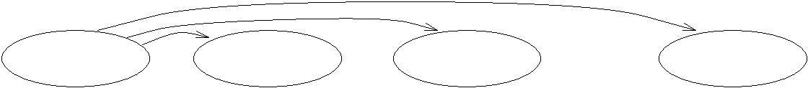
KEY
Nonkey attr1
Nonkey attr2
Nonkey attrk

FDs in a BCNF Relation

BCNF ensures that no redundancy can be detected using FD information alone. It is thus the most desirable normal form (from the point of view of redundancy) if we take into account only FD information. This point is illustrated in Figure 15.8.

X | Y | A
x | y1 | a
x | y2 | ?
Instance Illustrating BCNF

This figure shows (two tuples in) an instance of a relation with three attributes X, Y, and A. There are two tuples with the same value in the X column. Now suppose that we know that this instance satisfies an FD X ! A. We can see that one of the tuples has the value a in the A column. What can we infer about the value in the A column in the second tuple? Using the FD, we can conclude that the second tuple also has the value a in this column. (Note that this is really the only kind of inference we can make about values in the fields of tuples by using FDs.)

But isn't this situation an example of redundancy? We appear to have stored the value a twice. Can such a situation arise in a BCNF relation? No! If this relation is
in BCNF, because A is distinct from X it follows that X must be a key. (Otherwise, the FD
X ! A would violate BCNF.) If X is a key, then y1 = y2, which means that the two tuples are identical. Since a relation is defined to be a set of tuples, we cannot have two copies of the same tuple and the situation shown in Figure 15.8 cannot arise.

Thus, if a relation is in BCNF, every field of every tuple records a piece of information that cannot be inferred (using only FDs) from the values in all other elds in (all tuples of) the relation instance.

Third Normal Form
Let R be a relation schema, X be a subset of the attributes of R, and A be an attribute of R. R is in third normal form if for every FD X ! A that holds over R, one of

the following statements is true:

A 2 X; that is, it is a trivial FD, or
X is a super key, or
A is part of some key for R.

The de nition of 3NF is similar to that of BCNF, with the only difference being the third condition. Every BCNF relation is also in 3NF. To understand the third condition, recall that a key for a relation is a minimal set of attributes that uniquely determines all other attributes. A must be part of a key (any key, if there are several). It is not enough for A to be part of a super key, because the latter condition is satisfied by each and every attribute! Finding all keys of a relation schema is known to be an NP-complete problem, and so is the problem of determining whether a relation schema is in 3NF.

.

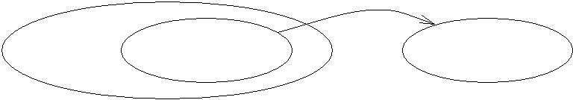
Partial dependencies are illustrated in Figure 15.9, and transitive dependencies are illustrated in Figure. Note that in Figure 15.10, the set X of attributes may or may not have some attributes in common with KEY; the diagram should be interpreted as indicating only that X is not a subset of KEY.

KEY | Attributes X | Attribute A | Case 1: A not in KEY
 | Figure 15.9 | Partial Dependencies
KEY | Attributes X | Attribute A | Case 1: A not in KEY

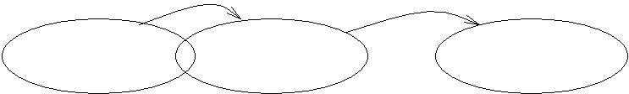
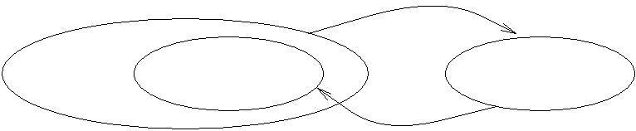
Case 2: A is in KEY
KEY
Attribute A
Attributes X

Transitive Dependencies

The motivation for 3NF is rather technical. By making an exception for certain de- pendencies involving key attributes, we can ensure that every relation schema can be decomposed into a collection of 3NF relations using only decompositions that have certain desirable properties (Section 15.6). Such a guarantee does not exist for BCNF relations; the 3NF definition weakens the BCNF requirements just enough to make this guarantee possible. We may therefore compromise by settling for a

3NF design. As we shall see in Chapter 16, we may sometimes accept this compromise (or even settle for a non-3NF schema) for other reasons as well.

DECOMPOSITIONS
As we have seen, a relation in BCNF is free of redundancy (to be precise, redundancy that can be detected using FD information), and a relation schema in 3NF comes close. If a relation schema is not in one of these normal forms, the FDs that cause a violation can give us insight into the potential problems. The main technique for addressing such redundancy-related problems is decomposing a relation schema into relation schemas with fewer attributes.

A decomposition of a relation schema R consists of replacing the relation schema by two (or more) relation schemas that each contain a subset of the attributes of R and together include all attributes in R. Intuitively, we want to store the information in any given instance of R by storing projections of the instance. This section examines the use of decompositions through several examples.

We begin with the Hourly Emps example from Section 15.3.1. This relation has at- tributes SNLRWH and two FDs: S ! SNLRWH and R ! W. Since R is not a key and W is not part of any key, the second dependency causes a violation of 3NF.

The alternative design consisted of replacing Hourly Emps with two relations having attributes SNLRH and RW. S ! SNLRH holds over SNLRH, and S is a key. R ! W holds over RW, and R is a key for RW. The only other dependencies that hold over these schemas are those obtained by augmentation. Thus both schemas are in BCNF.

Our decision to decompose SNLRWH into SNLRH and RW, rather than, say, SNLR and LRWH, was not just a good guess. It was guided by the observation that the dependency R ! W caused the violation of 3NF; the most natural way to deal with this violation is to remove the attribute W from this schema. To compensate for removing W from the main schema, we can add a relation RW, because each R value is associated with at most one W value according to the FD R ! W.
A very important question must be asked at this point: If we replace a legal instance r of relation schema SNLRWH with its projections on SNLRH (r1) and RW (r2), can we recover r from r1 and r2? The decision to decompose SNLRWH into SNLRH and RW is equivalent to saying that we will store instances r1 and r2 instead of r. However

it is the instance r that captures the intended entities or relationships. If we cannot
compute r from r1 and r2, our attempt to deal with redundancy has e ectively thrown out the baby with the bathwater. We consider this issue in more detail below.

Lossless-Join Decomposition
Let R be a relation schema and let F be a set of FDs over R. A decomposition of R into two schemas with attribute sets X and Y is said to be a lossless-join decomposition with respect to F if for every instance r of R that satis es the
dependencies in F, X (r) ./ Y (r) = r.

This de nition can easily be extended to cover a decomposition of R into more than
two relations. It is easy to see that r X (r) ./ Y (r) always holds. In general, though, the other direction does not hold. If we take projections of a relation and recombine them using natural join, we typically obtain some tuples that were not in the original relation. This situation is illustrated in Figure 15.11.
S | P | D
s1 | p1 | d1
s2 | p2 | d2
s3 | p1 | d3

S | P
s1 | p1
s2 | p2
s3 | p1

P | D
p1 | d1
p2 | d2
p1 | d3

S | P | D
s1 | p1 | d1
s2 | p2 | d2
s3 | p1 | d3
s1 | p1 | d3
s3 | p1 | d1

Instance r SP (r) P D(r) SP (r) ./ P D(r)

Instances Illustrating Lossy Decompositions

By replacing the instance r shown in Figure 15.11 with the instances SP (r) and P D(r), we lose some information. In particular, suppose that the tuples in r denote relationships. We can no longer tell that the relationships (s1; p1; d3) and (s3; p1;
d1) do not hold. The decomposition of schema SPD into SP and PD is therefore a
`lossy' decomposition if the instance r shown in the figure is legal, that is, if this instance could arise in the enterprise being modeled. (Observe the similarities between this example and the Contracts relationship set in Section 2.5.3.)

All decompositions used to eliminate redundancy must be lossless. The following simple test is very useful:
Let R be a relation and F be a set of FDs that hold over R. The decomposition of R into relations with attribute sets R1 and R2 is lossless if
+
and only if F contains either the FD R1 \ R2 ! R1 or the FD R1 \ R2 ! R2.

In other words, the attributes common to R1 and R2 must contain a key for either R1 or
R2. If a relation is decomposed into two relations, this test is a necessary and sufficient condition for the decomposition to be lossless-join.2 If a relation is
decomposed into more than two relations, an efficient (time polynomial in the size of the dependency set) algorithm is available to test whether or not the decomposition is lossless, but we will not discuss it.

Consider the Hourly Emps relation again. It has attributes SNLRWH, and the FD R ! W causes a violation of 3NF. We dealt with this violation by decomposing the relation into SNLRH and RW. Since R is common to both decomposed relations, and R ! W holds, this decomposition is lossless-join.
This example illustrates a general observation:

If an FD X ! Y holds over a relation R and X \Y is empty, the decomposition of R into R − Y and XY is lossless.
X appears in both R −Y (since X \ Y is empty) and XY, and it is a key for XY. Thus, the above observation follows from the test for a lossless-join decomposition.

Another important observation has to do with repeated decompositions. Suppose that a relation R is decomposed into R1 and R2 through a lossless-join decomposition, and that R1 is decomposed into R11 and R12 through another lossless-join decomposition. Then the decomposition of R into R11, R12, and R2 is lossless-join; by joining R11 and R12 we can recover R1, and by then joining R1 and R2, we can recover R.

Dependency-Preserving Decomposition
Consider the Contracts relation with attributes CSJDPQV from Section 15.4.1. The given FDs are C ! CSJDPQV, JP ! C, and SD ! P. Because SD is not a key the dependency SD ! P causes a violation of BCNF.
We can decompose Contracts into two relations with schemas CSJDQV and SDP to address this violation; the decomposition is lossless-join. There is one subtle problem, however. We can enforce the integrity constraint JP ! C easily when a tuple is inserted into Contracts by ensuring that no existing tuple has the same JP values (as the inserted tuple) but different C values. Once we decompose Contracts into CSJDQV and SDP, enforcing this constraint requires an expensive join of the two relations whenever a tuple is inserted into CSJDQV. We say that this decomposition is not dependency-preserving.

Intuitively, a dependency-preserving decomposition allows us to enforce all FDs by ex- amining a single relation instance on each insertion or modification of a tuple. (Note that deletions cannot cause violation of FDs.) To de ne dependency-preserving de- compositions precisely, we have to introduce the concept of a projection of FDs.

Let R be a relation schema that is decomposed into two schemas with attribute sets
X and Y, and let F be a set of FDs over R. The projection of F on X is the set of
FDs in the closure F + (not just F !) that involve only attributes in X. We will denote the projection of F on attributes X as FX . Note that a dependency U ! V in F + is in FX only if all the attributes in U and V are in X.
The decomposition of relation schema R with FDs F into schemas with attribute sets
X and Y is dependency-preserving if (FX [ FY )+ = F +. That is, if we take the
dependencies in FX and FY and compute the closure of their union, we get back all dependencies in the closure of F. Therefore, we need to enforce only the dependencies in FX and FY ; all FDs in F + are then sure to be satisfied. To enforce
FX , we need to examine only relation X (on inserts to that relation). To enforce FY , we need to examine only relation Y.

NORMALIZATION
Having covered the concepts needed to understand the role of normal forms and de-compositions in database design, we now consider algorithms for converting relations to BCNF or 3NF. If a relation schema is not in BCNF, it is possible to obtain a lossless-join decomposition into a collection of BCNF relation schemas. Unfortunately, there may not be any dependency-preserving decomposition into a collection of BCNF relation schemas

Decomposition into BCNF
We now present an algorithm for decomposing a relation schema R into a collection of BCNF relation schemas:

- Suppose that R is not in BCNF. Let X R, A be a single attribute in R, and X ! A be an FD that causes a violation of BCNF. Decompose R into R −> A and X→A.
- If either R −> A or X→A is not in BCNF, decompose them further by a recursive application of this algorithm.

R −> A denotes the set of attributes other than A in R, and X→A denotes the union of attributes in X and A. Since X ! A violates BCNF, it is not a trivial dependency; further, A is a single attribute. Therefore, A is not in X; that is, X \A is empty. Thus,

each decomposition carried out in Step is lossless-join.

The set of dependencies associated with R −> A and →XA is the projection of F onto their attributes. If one of the new relations is not in BCNF, we decompose it further in Step. Since a decomposition results in relations with strictly fewer attributes, this process will terminate, leaving us with a collection of relation schemas that are all in BCNF.

Consider the Contracts relation with attributes CSJDPQV and key C. We are given FDs JP ! C and SD ! P. By using the dependency SD ! P to guide the decomposition, we get the two schemas SDP and CSJDQV. SDP is in BCNF. Suppose that we also have the constraint that each project deals with a single supplier: J ! S. This means that the schema CSJDQV is not in BCNF. So we decompose it further into JS and CJDQV. C ! JDQV holds over CJDQV; the only other FDs that hold are those obtained from this FD by augmentation, and therefore all FDs contain a key in the left side. Thus, each of the schemas SDP, JS, and CJDQV is in BCNF, and this collection of schemas also represents a lossless-join decomposition of CSJDQV.

The steps in this decomposition process can be visualized as a tree, as shown in Figure. The root is the original relation CSJDPQV, and the leaves are the BCNF relations that are the result of the decomposition algorithm, namely, SDP, JS, and CSDQV. Intuitively, each internal node is replaced by its children through a single decomposition step that is guided by the FD shown just below the node.
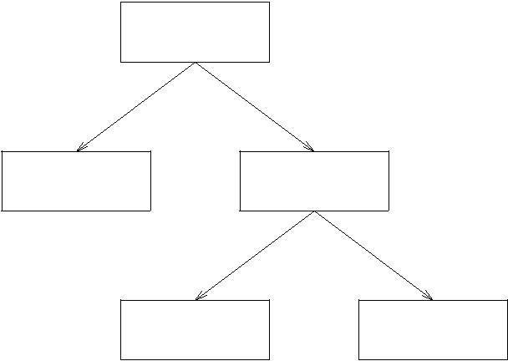
CSJDPQV
SD P
SDP
CSJDQV

J S
JS
CJDQV

Decomposition of CSJDQV into SDP, JS, and CJDQV

Redundancy in BCNF Revisited
The decomposition of CSJDQV into SDP, JS, and CJDQV is not dependency- preserving. Intuitively, dependency JP ! C cannot be enforced without a join. One way to deal with this situation is to add a relation with attributes CJP. In e ect, this solution amounts to storing some information redundantly in order to make the dependency enforcement cheaper.
This is a subtle point: Each of the schemas CJP, SDP, JS, and CJDQV is in BCNF, yet there is some redundancy that can be predicted by FD information. In particular, if we join the relation instances for SDP and CJDQV and project onto the attributes CJP, we must get exactly the instance stored in the relation with schema CJP. We saw in Section 15.5.1 that there is no such redundancy within a single BCNF relation. The current example shows that redundancy can still occur across relations, even though there is no redundancy within a relation.

Minimal Cover for a Set of FDs
A minimal cover for a set F of FDs is a set G of FDs such that:
1. Every dependency in G is of the form X ! A, where A is a single attribute.
+ +2. The closure F is equal to the closure G .

- If we obtain a set H of dependencies from G by deleting one or more dependencies,
+ +or by deleting attributes from a dependency in G, then F 6=
H .
Intuitively, a minimal cover for a set F of FDs is an equivalent set of dependencies that is minimal in two respects: (1) Every dependency is as small as possible; that is, each attribute on the left side is necessary and the right side is a single attribute.
+
(2) Every dependency in it is required in order for the closure to be equal to F . As an example, let F be the set of dependencies:
A ! B, ABCD ! E, EF ! G, EF ! H, and ACDF ! EG.

First, let us rewrite ACDF ! EG so that every right side is a single attribute:

ACDF ! E and ACDF ! G.

Next consider ACDF ! G. This dependency is implied by the following FDs:

A ! B, ABCD ! E, and EF ! G.

Therefore, we can delete it. Similarly, we can delete ACDF ! E. Next consider ABCD
! E. Since A ! B holds, we can replace it with ACD ! E. (At this point, the reader should verify that each remaining FD is minimal and required.) Thus, a minimal cover for F is the set:
A ! B, ACD ! E, EF ! G, and EF ! H.

The preceding example suggests a general algorithm for obtaining a minimal cover of a set F of FDs:

- Put the FDs in a standard form: Obtain a collection G of equivalent FDs with a single attribute on the right side (using the decomposition axiom).

- Minimize the left side of each FD: For each FD in G, check each attribute in
+
the left side to see if it can be deleted while preserving equivalence to F .
- Delete redundant FDs: Check each remaining FD in G to see if it can be
+
deleted while preserving equivalence to F .
Note that the order in which we consider FDs while applying these steps could produce different minimal covers; there could be several minimal covers for a given set of FDs.
More important, it is necessary to minimize the left sides of FDs before checking for redundant FDs. If these two steps are reversed, the nal set of FDs could still contain some redundant FDs (i.e., not be a minimal cover), as the following example illustrates. Let F be the set of dependencies, each of which is already in the standard form:

ABCD ! E, E ! D, A ! B, and AC ! D.

Observe that none of these FDs is redundant; if we checked for redundant FDs rst, we would get the same set of FDs F. The left side of ABCD ! E can be replaced by
+
AC while preserving equivalence to F , and we would stop here if we checked for
redundant FDs in F before minimizing the left sides. However, the set of FDs we have is not a minimal cover:

AC ! E, E ! D, A ! B, and AC ! D.

From transitivity, the first two FDs imply the last FD, which can therefore be deleted
+
while preserving equivalence to F . The important point to note is that AC ! D
becomes redundant only after we replace ABCD ! E with AC ! E. If we minimize left sides of FDs first and then check for redundant FDs, we are left with the rst three FDs in the preceding list, which is indeed a minimal cover for F.

Dependency-Preserving Decomposition into 3NF
Returning to the problem of obtaining a lossless-join, dependency-preserving decom-position into 3NF relations, let R be a relation with a set F of FDs that is a
minimal cover, and let R1; R2; : : : ; Rn be a lossless-join decomposition of R. For 1 i n, suppose that each Ri is in 3NF and let Fi denote the projection of F onto the attributes of Ri. Do the following:
Identify the set N of dependencies in F that are not preserved, that is, not included in the closure of the union of Fis.

For each FD X ! A in N , create a relation schema XA and add it to the decom- position of R.

Obviously, every dependency in F is preserved if we replace R by the Ris plus the
schemas of the form XA added in this step. The Ris are given to be in 3NF. We can show that each of the schemas XA is in 3NF as follows: Since X ! A is in the minimal cover F, Y ! A does not hold for any Y that is a strict subset of X. Therefore, X is a key for XA. Further, if any other dependencies hold over XA, the right side can involve only attributes in X because A is a single attribute (because X ! A is an FD in a minimal cover). Since X is a key for XA, none of these additional dependencies causes a violation of 3NF (although they might cause a violation of BCNF).

As an optimization, if the set N contains several FDs with the same left side, say, X ! A1; X ! A2; : : : ; X ! An, we can replace them with a single equivalent FD X ! A1 : : : An. Therefore, we produce one relation schema XA1 : : : An, instead of several schemas XA1; : : : ; XAn, which is generally preferable.

Consider the Contracts relation with attributes CSJDPQV and FDs JP ! C, SD ! P, and J
! S. If we decompose CSJDPQV into SDP and CSJDQV, then SDP is in BCNF, but
CSJDQV is not even in 3NF. So we decompose it further into JS and CJDQV.
The relation schemas SDP, JS, and CJDQV are in 3NF (in fact, in BCNF), and the decomposition is lossless-join. However, the dependency JP ! C is not preserved. This problem can be addressed by adding a relation schema CJP to the decomposition.

This set of FDs is not a minimal cover, and so we must nd one. We rst replace C
! CSJDPQV with the FDs:

C ! S, C ! J, C ! D, C ! P, C ! Q, and C ! V.

The FD C ! P is implied by C ! S, C ! D, and SD ! P; so we can delete it. The
FD C ! S is implied by C ! J and J ! S; so we can delete it. This leaves us with a minimal cover:

C ! J, C ! D, C ! Q, C ! V, JP ! C, SD ! P, and J ! S.

Using the algorithm for ensuring dependency-preservation, we obtain the relational schema CJ, CD, CQ, CV, CJP, SDP, and JS. We can improve this schema by combining relations for which C is the key into CDJPQV. In addition, we have SDP and JS in our decomposition. Since one of these relations (CDJPQV) is a super key, we are done.

Comparing this decomposition with the one that we obtained earlier in this section, we find that they are quite close, with the only difference being that one of them has CDJPQV instead of CJP and CJDQV. In general, however, there could be significant differences.

Database designers typically use a conceptual design methodology (e.g., ER design) to arrive at an initial database design. Given this, the approach of repeated decompositions to rectify instances of redundancy is likely to be the most natural use of FDs and normalization techniques. However, a designer can also consider the alternative designs suggested by the synthesis approach.

OTHER KINDS OF DEPENDENCIES *
FDs are probably the most common and important kind of constraint from the point of view of database design. However, there are several other kinds of dependencies. In particular, there is a well-developed theory for database design using multivalued dependencies and join dependencies. By taking such dependencies into account, we can identify potential redundancy problems that cannot be detected using FDs alone.

This section illustrates the kinds of redundancy that can be detected using multivalued dependencies. Our main observation, however, is that simple guidelines (which can be checked using only FD reasoning) can tell us whether we even need to worry about complex constraints such as multivalued and join dependencies. We also comment on the role of inclusion dependencies in database design.

Multivalued Dependencies
Suppose that we have a relation with attributes course, teacher, and book, which we denote as CTB. The meaning of a tuple is that teacher T can teach course C, and book B is a recommended text for the course. There are no FDs; the key is CTB. However, the recommended texts for a course are independent of the instructor. The instance shown in Figure 15.13 illustrates this situation.

course | teacher | book
Physics101 | Green | Mechanics
Physics101 | Green | Optics
Physics101 | Brown | Mechanics
Physics101 | Brown | Optics
Math301 | Green | Mechanics
Math301 | Green | Vectors
Math301 | Green | Geometry

BCNF Relation with Redundancy That Is Revealed by MVDs

There are three points to note here:

The relation schema CTB is in BCNF; thus we would not consider decomposing

it further if we looked only at the FDs that hold over CTB.
There is redundancy. The fact that Green can teach Physics101 is recorded once per recommended text for the course. Similarly, the fact that Optics is a text for Physics101 is recorded once per potential teacher.
The redundancy can be eliminated by decomposing CTB into CT and CB.

The redundancy in this example is due to the constraint that the texts for a course are independent of the instructors, which cannot be expressed in terms of FDs. This con- strait is an example of a multivalued dependency, or MVD. Ideally, we should model this situation using two binary relationship sets, Instructors with attributes CT and Text with attributes CB. Because these are two essentially independent relationships, modeling them with a single ternary relationship set with attributes CTB is inappropriate. (See Section 2.5.3 for a further discussion of ternary versus binary relationships.) Given the subjectivity of ER design, however, we might create a ternary relationship. A careful analysis of the MVD information would then reveal the problem.

Let R be a relation schema and let X and Y be subsets of the attributes of R. Intuitively, the multivalued dependency X !! Y is said to hold over R if, in every legal
instance r of R, each X value is associated with a set of Y values and this set is independent of the values in the other attributes.
Formally, if the MVD X !! Y holds over R and Z = R − XY , the following must be true for every legal instance r of R:

If t1 2 r, t2 2 r and t1:X = t2:X, then there must be some t3 2 r such that
t1:XY = t3:XY and t2:Z = t3:Z.

Figure illustrates this de nition. If we are given the first two tuples and told that the MVD X !! Y holds over this relation, we can infer that the relation instance must also contain the third tuple. Indeed, by interchanging the roles of the rst two tuples
treating the first tuple as t2 and the second tuple as t1|we can deduce that the tuple
t4 must also be in the relation instance.

X | Y | Z
a | b1 | c1 | | tuple t1
a | b2 | c2 | | tuple t2
a | b1 | c2 | | tuple t3
a | b2 | c1 | | tuple t4

This table suggests another way to think about MVDs: If X !! Y holds over R, then Y
Z ( X=x(R)) = Y ( X=x(R)) Z ( X=x(R)) in every legal instance of R, for any value x that appears in the X column of R. In other words, consider groups of tuples in R with the same X-value, for each X-value. In each such group consider the projection onto the attributes YZ. This projection must be equal to the cross-product of the projections onto Y and Z. That is, for a given X-value, the Y-values and Z-values are independent. (From this de nition it is easy to see that X !! Y must hold whenever X ! Y holds. If the FD X ! Y holds, there is exactly one Y-value for a given X-value, and the conditions in the MVD de nition hold trivially. The converse does not hold, as Figure 15.14 illustrates.)

Returning to our CTB example, the constraint that course texts are independent of instructors can be expressed as C !! T. In terms of the de nition of MVDs, this constraint can be read as follows:

\If (there is a tuple showing that) C is taught by teacher T, and (there is a tuple showing that) C has book B as text,
then (there is a tuple showing that) C is taught by T and has text B.

Given a set of FDs and MVDs, in general we can infer that several additional FDs and MVDs hold. A sound and complete set of inference rules consists of the three Armstrong Axioms plus ve additional rules. Three of the additional rules involve only MVDs:
MVD Complementation: If X !! Y, then X !! R − XY .
MVD Augmentation: If X !! Y and W Z, then WX !! YZ. MVD Transitivity: If X !! Y and Y !! Z, then X !! (Z − Y ).
As an example of the use of these rules, since we have C !! T over CTB, MVD complementation allows us to infer that C !! CT B − CT as well, that is, C !! B. The remaining two rules relate FDs and MVDs:
Replication: If X ! Y, then X !! Y.
Coalescence: If X !! Y and there is a W such that W \ Y is empty, W ! Z, and Y Z, then X ! Z.
Observe that replication states that every FD is also an MVD.

Fourth Normal Form
Fourth normal form is a direct generalization of BCNF. Let R be a relation schema, X and Y be nonempty subsets of the attributes of R, and F be a set of dependencies that includes both FDs and MVDs. R is said to be in fourth normal form (4NF) if for every MVD X !! Y that holds over R, one of the following statements is true:
Y X or XY = R, or
X is a Superkey.

In reading this definition, it is important to understand that the de nition of a key has not changed the key must uniquely determine all attributes through FDs alone. X !! Y is a trivial MVD if Y X R or XY = R; such MVDs always hold.
The relation CTB is not in 4NF because C !! T is a nontrivial MVD and C is not a key. We can eliminate the resulting redundancy by decomposing CTB into CT and CB; each of these relations is then in 4NF.

To use MVD information fully, we must understand the theory of MVDs. However, the following result due to Date and Fagin identifies conditions detected using only FD information!|under which we can safely ignore MVD information. That is, using MVD information in addition to the FD information will not reveal any redundancy. Therefore, if these conditions hold, we do not even need to identify all MVDs.

If a relation schema is in BCNF, and at least one of its keys consists of a single attribute, it is also in 4NF.

An important assumption is implicit in any application of the preceding result: The set of FDs identified thus far is indeed the set of all FDs that hold over the relation. This assumption is important because the result relies on the relation being in BCNF, which in turn depends on the set of FDs that hold over the relation.

Figure shows three tuples from an instance of ABCD that satisfies the given MVD B
!! C. From the definition of an MVD, given tuples t1 and t2, it follows

B | C | A | D
b | c1 | a1 | d1 | | tuple t1
b | c2 | a2 | d2 | | tuple t2
b | c1 | a2 | d2 | | tuple t3

Three Tuples from a Legal Instance of ABCD

that tuple t3 must also be included in the instance. Consider tuples t2 and t3. From the given FD A ! BCD and the fact that these tuples have the same A-value,
deduce that c1 = c2. Thus, we see that the FD B ! C must hold over ABCD whenever the FD A ! BCD and the MVD B !! C hold. If B ! C holds, the relation ABCD is not in BCNF (unless additional FDs hold that make B a key)!

Join Dependencies
A join dependency is a further generalization of MVDs. A join dependency (JD)
./ fR1; : : : ; Rng is said to hold over a relation R if R1; : : : ; Rn is a lossless-join decomposition of R.

An MVD X !! Y over a relation R can be expressed as the join dependency ./ fXY, X(R−Y)g. As an example, in the CTB relation, the MVD C !! T can be expressed as the join dependency ./ fCT, CBg.
Unlike FDs and MVDs, there is no set of sound and complete inference rules for JDs.

Fifth Normal Form
A relation schema R is said to be in fth normal form (5NF) if for every JD
./ fR1; : : : ; Rng that holds over R, one of the following statements is true:
Ri = R for some i, or
The JD is implied by the set of those FDs over R in which the left side is a key for R.

The second condition deserves some explanation, since we have not presented inference rules for FDs and JDs taken together. Intuitively, we must be able to show
that the decomposition of R into fR1; : : : ; Rng is lossless-join whenever the key dependencies (FDs in which the left side is a key for R) hold. ./ fR1; : : : ; Rng is a trivial JD if Ri = R for some i; such a JD always holds.
The following result, also due to Date and Fagin, identifies conditions again, detected using only FD information under which we can safely ignore JD information.

If a relation schema is in 3NF and each of its keys consists of a single attribute, it is also in 5NF.

The conditions identified in this result are sufficient for a relation to be in 5NF, but not necessary. The result can be very useful in practice because it allows us to conclude that a relation is in 5NF without ever identifying the MVDs and JDs that may hold over

