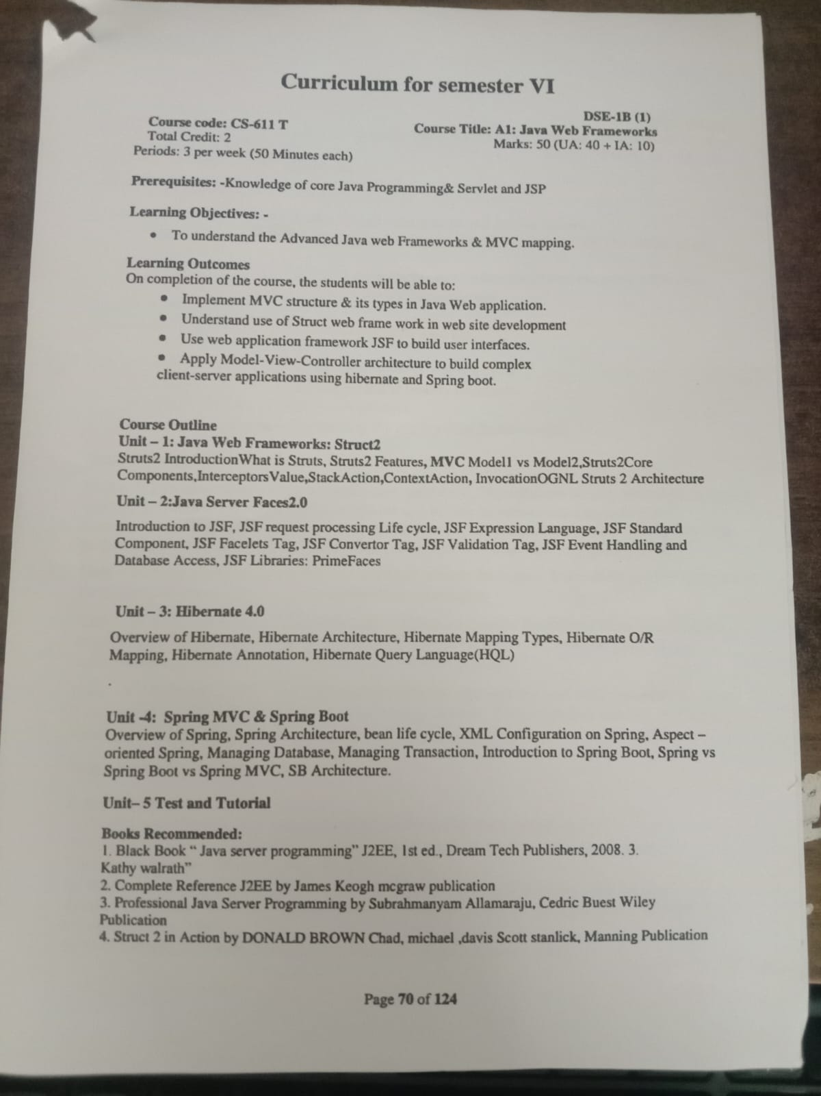
Java web frameworks

Introduction what is strut
UNIT-1

Struts is an open-source web application framework developed by Apache Software Foundation, it is used to create a web application based on servlet and JSP. It depends on the MVC (Model View Controller) framework. Struts are thoroughly useful in building J2EE (Java 2 Platform, Enterprise Edition) applications because struts take advantage of J2EE design patterns. Struts follows these J2EE design patterns including MVC and JSP custom tag libraries. In struts, the composite view manages the layout of its sub-views and can implement a template, making persistent look and feel easier to achieve and customize across the entire application. A composite view is made up by using other reusable sub-views such that a small change that happens in a sub-view is automatically updated in every composite view. Struts consist of a set of custom tag libraries. Struts also support utility classes.
The main purpose of the struts framework is to provision separation of concerns between the business logic and the presentation logic (view), making it easier to manage and develop large-scale web applications.

Features of Struts
Struts have the following features:
- Struts encourages good design practices and modeling because the framework is designed with "time-proven" design patterns.
- Struts is almost simple, so easy to learn and use.
- It supports many convenient features such as input validation and internationalization.
- It takes much of the complexity out as instead of building your own MVC framework, you can use struts.
- Struts is very well integrated with J2EE.
- Struts has large user community.
- It is flexible and extensible; it is easy for the existing web applications to adapt the struts framework.
- Struts provide good tag libraries.
- It allows capturing input form data into JavaBean objects called Action forms.
- It also hands over standard error handling both programmatically and declaratively.

Working of Struts:
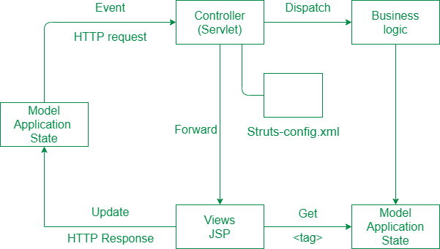

Step-by-Step Implementation of Struts
Step 1: Initialization Phase
- In initial phase, the controller rectifies a configuration file.
- This configuration file is like the manual for initialization and is used to deploy the controller layer objects.
Step 2: Composition of Configuration file
- Config file's core is formed by all the objects defined inside it.
- These objects include action mapping which plays in defining the behavior of application.
- Furthermore, it also contains the definition of these action mappings.
- Action mappings are the key aspects in instructing the servlet controllers for handling the HTTP Requests.
Step 3: Routing of HTTP Requests & process flow
- Initially, the requests are directed towards the action and then JSP.
- JSP does further processing and rendering the view page.
Step 4: Action object request handling
- Action objects handle all the requests of client.
- These objects have access to the servlet controller of our application, and they can execute specific actions defined inside controllers.
The action object can indirectly forward one or more shared objects, these shared objects can be JavaBeans, and are typically shared in shared context which is established using Java

Struts is a popular open-source framework of Java for developing large scale web-applications. It provides a framework for implementing MVC-architecture applications promoting the separation of concerns between business and presentation logic. Struts is an essential framework for building J2EE (Enterprise Edition) based web apps.
Struts 2 comes with a complete cycle development framework, from design to deployment and maintenance of the application, Struts 2 has full support for everything. It was originally known as "web work 2".
In this article, we'll look at the features of Struts 2.
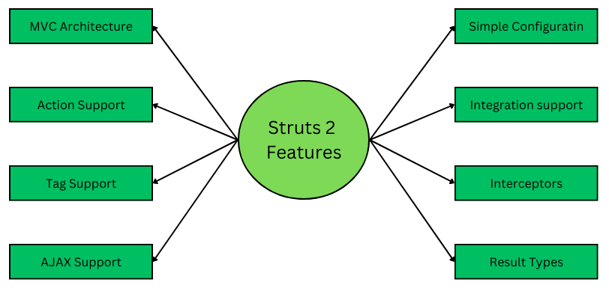

Features of Struts 2
There are certain Features of Struts 2 mentioned below:

1. MVC Architecture Support
Struts 2 is built on developing applications based on the MVC architecture, providing a separation of concerns between the business logic and presentation logic. Business logic is contained inside the component called - 'Controller' or the 'Action Servlet', and the Presentation logic can be defined flexibly inside any view-related file such as HTML or JSP.

2. Action Support
Actions are special Java classes just like REST APIs, that provide the business logic to handle all the incoming requests and generate appropriate responses. These actions are called when a specific URL is hit. In struts 2, the Action class is the POJO (Plain-old-Java-Object) and you do not have to mandatorily implement an action interface.

3. Tag Support
Struts 2 has custom tag support that simplifies the process of writing dynamic web pages in less code. These tags also help in integrating the business logic alongside the presentation layer. Ex: Form tags, UI Tags, Data Tags, Control Tags, Template tags, etc.

4. Ajax Support
Struts 2 comes occupied with AJAX (Asynchronous JavaScript & XML) support, which is more efficient for developing dynamic and interactive applications without writing extensive JavaScript code. It is facilitated by a powerful library - Dojo Toolkit for a rich and responsive user interface. Some of the most common tags: are <sx: autocomplete>, <sx: div>, etc.

5. Simplified Configuration
Struts 2 provides a deployment descriptor file for simplifying initial configuration and reducing boilerplate code. It initializes the resources in XML format, which is done by scanning Java packages. On the other hand, you can also take control of the configuration file by providing an external application-config file. This simplified procedure for configuration allows the developer to focus on the business logic rather than configuring everything in detail.

6. Integration
It has a well-defined control on integrating with other Java frameworks such as Spring, Hibernate, JPA, etc. This enables the developers to leverage the strength of other robust frameworks.

7. Interceptors
Interceptors are additional (and optional) components that can be added to the application to intercept requests & responses for pre-post processing purposes. Intercepting is done mainly for logging, authentication & authorization, monitoring, debugging, and troubleshooting related work.

8. Result Types
Result types represent the responses. Responses can be generated in different formats like XML, JSON, and HTML. This allows the developer to use the appropriate technology and implement the view in any language.

.

What is MVC1?
In the context of software development, the term "MVC1" was not widely recognized or commonly used. The standard and widely known terminology is just "MVC" (Model-View-Controller).
Model-View-Controller (MVC) is a software development architectural pattern that is often used to build and structure applications. It seeks to divide an application's concerns into three interconnected components, making maintenance, scalability, and flexibility easier.

Model
The Model is a representation of the application's data and business logic. It is in charge of managing the data, performing operations on that data, and preserving the application's state. The model does not rely on the view or controller components. Instead, it can alert the view or the controller about changes in the data using various techniques (e.g., callbacks or events).

View
The View is in charge of the user interface and the presentation logic. It displays model data to the user and collects user input. The view has no business logic, instead delegating user actions to the controller. When the model is changed, the view is updated to reflect the changes in the data.

Controller
The Controller serves as a bridge between the model and the view. It receives user input from the view, processes it, and interacts with the model to update the state of the program. Based on user input, the controller determines which actions to take and alters the model or the view (or both).

Separation of Concerns
The MVC architecture separates data management (Model), user interface (View), and application functionality (Controller), resulting in a more organized and maintained codebase.

Reusability
MVC1 components can be reused in various parts of the application or even in other projects, increasing code efficiency.

What is MVC2?

MVC2, also known as Model 2 or Web MVC, is an update of the standard Model-View-Controller (MVC) model that aims to address some of the limits and issues encountered with the original MVC1 approach. MVC2 is extensively used in web development and offers a more refined and efficient approach to creating web applications. Let's get into the details of MVC2 ?

Model
The Model component is unchanged from the typical MVC pattern. It represents the data and business logic of the program, managing the data, performing operations on it, and preserving the application's state. The Model is not dependent on the View or the Controller.

View
Like in MVC1, the View component is in charge of the user interface and presentation logic. In MVC2, however, the View is intended to be more passive and unaware of the other components. The View monitors or responds to changes in the Model rather than directly engaging with the Controller. When the data in the Model changes, the View immediately adjusts to reflect those changes.
In MVC2, the passive nature of the View helps in greater separation of concerns and makes the program more maintainable and testable. Views are easily reusable because they do not rely on specific Controllers.

Controller
Like in the original MVC design, the Controller's primary purpose in MVC2 is to handle user input, process it, and control the application's flow. The major difference is that the Controller does not directly update the View. Instead, the Controller interacts with the Model to update the state of the application. When the Model's data changes, the Model informs registered Views, and they immediately update themselves.
The Controller serves as an interface between the Model and the View, responding to user input and initiating necessary Model activities. It is still in charge of deciding which Model methods to invoke based on user input and business logic.

Improved Separation of Concerns
The passive View in MVC2 improves the separation of user interface logic and application logic, resulting in a cleaner and easier-to-maintain codebase.

Testability
MVC2's passive View and separation of concerns facilitate unit testing by allowing each component to be tested independently.

Difference between MVC1 and MVC2
The following table highlights the major differences between MVC1 and MVC2 ?
Characteristics | MVC1 | MVC2
Dependency | View and Controller have direct dependencies on each other, leading to potential tight coupling. | View and Model have no direct dependency on each other. The Controller acts as an intermediary between them.
View Responsibilities | View is actively involved in updating the Model and Controller. | View is passive and observes changes in the Model. It automatically updates itself when the Model changes.
Code Maintainability | As the application grows, the tight coupling between View and Controller can lead to less maintainable code. | The separation of concerns and passive View lead to cleaner and more maintainable code.
Model Interaction | The Controller directly interacts with both the Model and View. | The Controller interacts with the Model but doesn't directly update the View. The View observes the Model for changes.
Code Reusability | View and Controller might be tightly bound, making it challenging to reuse View components in different contexts. | Passive View and better separation of concerns enable easier reusability of View components.
Testability | Due to the direct interaction between View and Controller, unit testing can be more complicated. | Passive View and clearer separation of concerns make unit testing easier for individual components.
Common Use | Historically used in traditional desktop applications.

Struts 2 Core Components
In this article, I am going to discuss the Struts 2 Core Components. Please read our previous article where we discussed How to Create Struts 2 Application in MyEclipse. At the end of this article, you will understand the following pointers in detail.
- Struts 2 Interceptors
- Advantage of interceptors
- Struts 2 default interceptors
- Struts 2 ValueStack
- ValueStack Interface
- Methods of ValueStack interface
- Struts 2 ActionContext
- Struts 2 ActionInvocation
- ActionInvocation Interface
- Methods of ActionInvocation Interface
- Struts 2 OGNL

What is an Interceptor?
At the time of preprocessing and postprocessing of a request, the interceptor object is called. Many features are implemented in Struts 2 using interceptors such as – validation, exception handling, file uploading, etc.

How to use an Interceptor?
In our “Hello World” program we are using already existing interceptors. Those are –
- Timer interceptor – it will calculate the accurate time of execution of an action method.
- Params interceptor – it will send the request parameters to the action.
If you don’t use these interceptors, then you will encounter the problem of that stating the name property is not set because the parameter is unable to reach the action.
In the previous chapter, we built an application. The files which are used there (HelloWorldAction.java, web.xml, HelloWorld.jsp, and index.jsp), among them we will modify only the struts.xml file to add an interceptor.
<?xml version = "1.0" Encoding = "UTF-8"?>
<!DOCTYPE struts PUBLIC
"-//Apache Software Foundation//DTD Struts Configuration 2.0//EN"
"http://struts.apache.org/dtds/struts-2.0.dtd">
<struts>
<constant name = "struts.devMode" value = "true" />
<package name = "helloworld" extends = "struts-default">
<action name = "hello"
class = "com.info.struts2.HelloWorldAction"
method = "execute">
<interceptor-ref name = "params"/>
<interceptor-ref name = "timer" />
<result name = "success">/HelloWorld.jsp</result>
</action>
</package>
</struts>
To create a War file right click on the project name and go to Export -> WAR File. In the Tomcat’s webapps directory deploy that WAR file. Now start the Tomcat server and access the URL http://localhost:8080/HelloWorldStruts2/index.jsp.It will display the following screen.
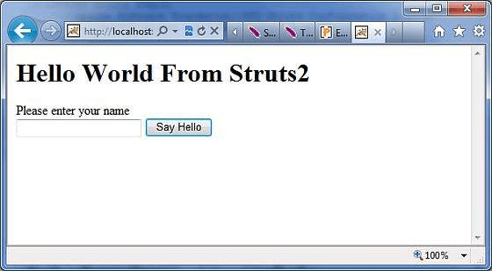
Enter any word as per your choice in the blank text box and click on the Say Hello button to execute the defined action. The log is generated and you will find the below text –
INFO: Server startup in 3539 ms PM
com.opensymphony.xwork2.util.logging.commons.CommonsLogger info
INFO: Executed action [//hello!execute] took 109 ms.

Advantages of Interceptors
To delete any concern like validation, exception handling, logging, etc. from the application, there is no need for the redeployment of the application, what we need to do is that just eliminate the entry from the struts.xml file.

Struts 2 Default Interceptors
- alias – converts similar types of parameters that have disparate names between requests.
- chain – makes the properties of preceding action that are available in the current action and also used with chain result type.
- checkbox – used to handle the checkboxes in the sequence manner. And through this, we can easily identify the unchecked checkboxes.
- cookie – used to add a cookie to the current action.
- conversionError – used to add conversion errors to the action’s field errors.
- createSession – used to create the HttpSession object if it doesn’t exist.
- clearSession – releases the HttpSession object.
- debugging – used to provide support for debugging.
- execAndWait – used to send an intervening waiting page for the result.
- exception – used to guide an exception to a result.
- fileUpload – used to provide support to file upload in struts 2.
- i18n – used to provide support to internationalization and localization.
- jsonValidation – provides support to asynchronous support.
- logger – used to find out the action name.
- store – used to store and repossess action messages, action errors for action that implements the ValidationAware interface.
- modelDriven – used to make other model objects as the default object of valuestack.
- scopedModelDriven – same as ModelDriven but works only for action that implements ScopedModelDriven.
- params – colonizes the action properties with the request parameters.
- prepare – used to perform preparation logic if action implements a Preparable interface.
- profiling – used to support action profiling.
- roles – used to support role-based action.
- scope – used to store the action state in the session or application scope.
- servletConfig – used to provide access to maps that represent HttpServletRequest and HttpServletResponse.
- staticParams – pointing the static properties to action properties.
- timer – gives the output to the time that needed to execute an action.
- token – prevents imitation submission of the request.
- tokenSession – prevents imitation submission of the request.
- validation – used to provide support to input validation.
- workflow – can call the validate method of action class if any action class implements Validateable interface.

Struts 2 ValueStack
A Value Stack is simply a stack that contains application-specific objects such as Action object, Model object, Named objects, and Temporary objects. Though the action is placed at the top of the stack during the execution time.

ValueStack Interface
To deal with valuestack an interface is provided by the Struts framework. It consists of many useful methods.

Methods of ValueStack Interface
findValue(String expr): To find a value for a specific expression
Syntax: public Object findValue(String expr)
findString(String expr): To find a string for a specified expression.
Syntax: public String findString(String expr)
peek(): It returns the object which is at the top of the stack without removing it
Syntax: public Object peek()
pop(): It returns the object which is at the top of the stack and removes it from the stack
Syntax: public Object pop()
push(Object o): On the top of the stack it put the particular object.
Syntax: public void push(Object o)
set(String key, Object value): Sets an object on the stack with the specified key, which can be retrieved using findValue(key).
Syntax: public void set(String key, Object value)
size(): It gives the no. of objects in the stack.
Syntax: public int size()

What is ActionContext?
It is basically a container that stores the objects that are related to the current request-response of a web application. When a session or application or locale etc is going on it is created during a complete client-server interaction.
The objects are stored in a particular manner such as Temporary Objects -> Model Object -> Action Object -> Named Object. All the objects of ValueStack and also other objects that are relatable to the current interaction of web applications to the client.
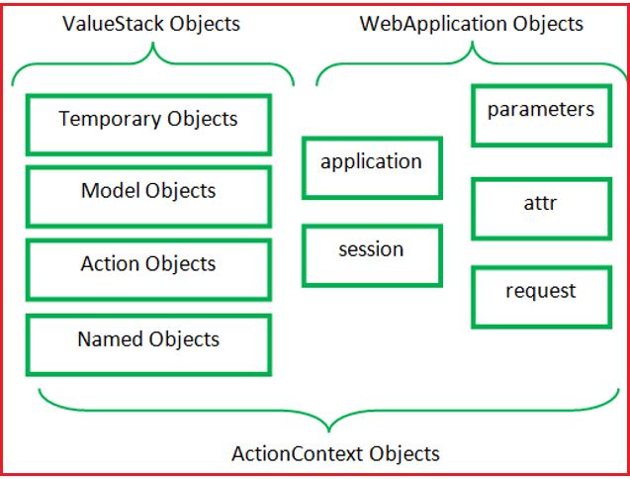
The context map of an ActionContext has the following objects –
- Application
- Session
- ValueStack
- Action
- Request
- Parameters
- Attr
To make our ActionContext thread-safe, in every context the object that is stored is distinguishable. Thus, we don’t need to declare the objects as synchronized.
We can refer the current ActionContext by calling the getContext() method of the ActionContext class. Hence, for referring the current ActionContext the following method is used:
ActionContext context = ActionContext.getContext();
// to access objects from ValueStack we should use:
ActionContext context = ActionContext.getContext().getValueStack();
Syntax: public class ActionContext extends Object implements Serializable

ActionContext Methods:
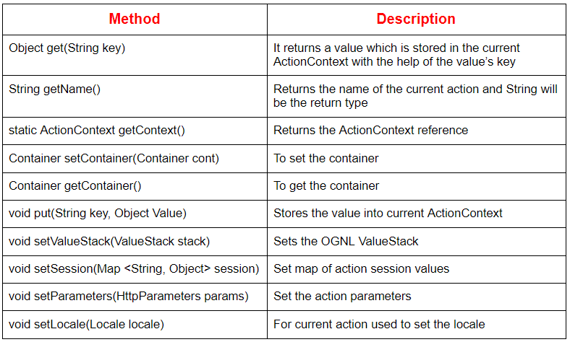

ActionInvocation
It represents the execution state of an activity. The action and interceptor objects are in hold of it.
Syntax: public interface ActionInvocation extends Serializable

ActionInvocation Interface
An ActionInvocation Interface is provided by the struts framework to deal with the ActionInvocation. It has many methods, among them some help to get the instance of ActionProxy, ActionContext, ValueStack, Result, etc.

Methods of ActionInvocation Interface
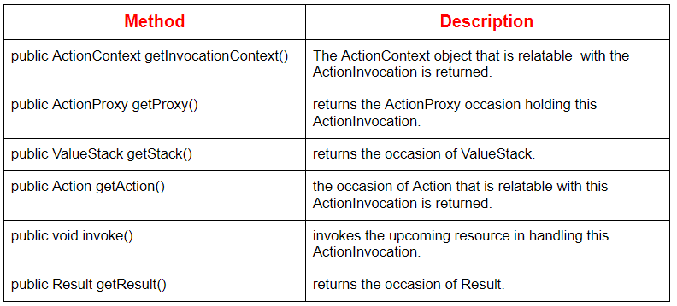

What is OGNL?
Object Graph Navigational Language (OGNL) is an open-source framework used to get properties from Java Beans. In Struts 2 –
- It is used to reference and manipulate data on the ValueStack.
- performs two important tasks – data transfer and type conversion.

What are the features of OGNL?
- type conversion
- calling methods
- collection manipulation and generation
- projection across collections
- expression evaluation
- lambda expressions
Syntax: Accessing the action property
<s:property value=”propertyName”/>
Syntax: Accessing the property from a scope (request, session or application)
<s:property name=”#scopeName. propertyName “/>

OGNL Example

test.jsp
<%@ taglib uri="/struts-tags" prefix="s"%>
<html>
<head>
<title>Struts 2 OGNL example</title>
</head>
<body>
<h3>This is a OGNL example.</h3>
<h4><a href="welcome">Click here </a>
to see the list values by using OGNL.</h4>
</body>
</html>

web.xml
<?xml version="1.0" encoding="UTF-8"?>
<web-app version="2.5"
xmlns="http://java.sun.com/xml/ns/javaee"
xmlns:xsi="http://www.w3.org/2001/XMLSchema-instance"
xsi:schemaLocation="http://java.sun.com/xml/ns/javaee
http://java.sun.com/xml/ns/javaee/web-app_2_5.xsd">
<filter>
<filter-name>struts2</filter-name>
<filter-class>
org.apache.struts2.dispatcher.ng.
filter.StrutsPrepareAndExecuteFilter
</filter-class>
</filter>
<filter-mapping>
<filter-name>struts2</filter-name>
<url-pattern>/*</url-pattern>
</filter-mapping>
<welcome-file-list>
<welcome-file>test.jsp</welcome-file>
</welcome-file-list>
</web-app>

struts.xml
<!DOCTYPE struts PUBLIC
"-//Apache Software Foundation//DTD Struts Configuration 2.0//EN"
"http://struts.apache.org/dtds/struts-2.0.dtd">
<struts>
<package name="user" extends="struts-default">
<action name="welcome"
class="com.info.action.Test">
<result name="success">/welcome.jsp</result>
</action>
</package>
</struts>

Test.java
import java.util.ArrayList;
import java.util.List;
public class Test
{
//data members
private List < String > myList = new ArrayList < String > ();
//business logic
public String execute ()
{
myList.add ("Bharat");
myList.add ("Richi");
myList.add ("Sahdev");
myList.add ("Rajesh");
myList.add ("Himanshu");
myList.add ("Vivek");
myList.add ("Shveta");
myList.add ("Bharti");
return "success";
}
public List < String > getMyList ()
{
return myList;
}
public void setMyList (List < String > myList)
{
this.myList = myList;
}
}

welcome.jsp
<%@ taglib uri="/struts-tags" prefix="s"%>
<html>
<head>
<title>Struts 2 OGNL example</title>
</head>
<body>
<h3>This is a OGNL example.</h3>
<h5> All list items: <s:property value="myList" /> </h5>
<h5> Second list item: <s:property value="myList[1]" /> </h5>
<h5> List size: <s:property value="myList.size" /> </h5>
</body>
</html>
Output:
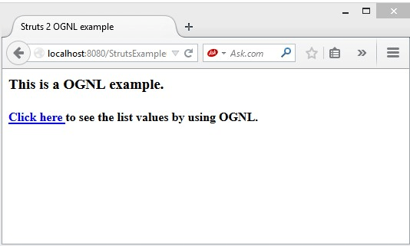
Stack action
The term "stack action" in a Java web framework generally refers to one of two concepts: the Action class (or similar controller mechanism) in frameworks like Apache Struts, or the use of the Stack data structure within application logic.
1. Action Class in Java Web Frameworks (e.g., Apache Struts)
In MVC (Model-View-Controller) based Java web frameworks like Apache Struts, an Action is a core component that handles user requests.
- Role: When a user interacts with the web application (e.g., submits a form), the front controller routes the HTTP request to a specific Action class.
- Functionality: The Action typically interacts with the application's business logic (the Model) and prepares data. It then determines which view (e.g., a JSP page) should be displayed to the user as a response.
- Methods: Developers override a specific method (e.g., execute() in Struts) to implement the request handling logic.
- Configuration: The mapping between URLs/requests and specific Action classes is defined in configuration files (like struts-config.xml in older versions or annotations in modern ones).
2. Using the Stack Data Structure in Java
In general Java programming, including web application development, a Stack is a linear data structure based on the Last-In-First-Out (LIFO) principle.
- Core Operations:
  - push(): Adds an element to the top of the stack.
  - pop(): Removes and returns the top element from the stack.
  - peek(): Returns the top element without removing it.
  - empty(): Checks if the stack is empty.
  - search(): Returns the 1-based position of an element from the top.
- Implementation: Java provides a built-in Stack class (java.util.Stack). However, it is a legacy class extending Vector, which has performance overhead due to synchronization.
- Modern alternative: It is recommended to use the Deque interface and its implementations like ArrayDeque when stack functionality is needed in modern Java applications, as it provides a more efficient and consistent set of LIFO operations.
- Applications in web development: Stacks are used in various algorithms within web applications, such as managing undo/redo functionality, expression evaluation, syntax parsing, and implementing backtracking algorithms like depth-first search.
In summary, the specific meaning of "stack action" depends on the context: in framework terms, it's a controller logic component; in data structure terms, it refers to the push() and pop() operations on a LIFO collection
Java web frameworks, a "context" is an object or interface that provides access to the surrounding execution environment, shared resources, and the current application state. It acts as a container for information that various components, including "actions" or controllers, need to function within the larger application, allowing for communication and resource sharing across different parts of the system.
Key Context Types in Java Web Development
Different levels of context exist in Java web development, typically following a hierarchy:
- ServletContext: This is the lowest-level context in a standard Java web application (Servlet API). It is created by the web container (e.g., Apache Tomcat) when the application is deployed and remains active until the application is shut down.
  - Purpose: It provides application-wide configuration parameters, logging capabilities, and a shared space to store objects (attributes) that are accessible by all servlets, filters, and listeners within that specific web application.
  - Access: It can be accessed via the getServletContext() method from a servlet or by using a ServletContextListener for lifecycle events.
- ApplicationContext (Spring Framework): In the Spring framework, the ApplicationContext is a core container that manages the application's beans (objects) and their dependencies. It extends the basic BeanFactory and offers advanced enterprise capabilities like internationalization and event propagation.
  - Hierarchy: A Spring web application typically has a root ApplicationContext shared by the entire application, and potentially multiple child WebApplicationContexts specific to individual servlets (like the DispatcherServlet in Spring MVC).
  - Access: It can be accessed programmatically using WebApplicationContextUtils or, more commonly, components (like controllers/actions) are dependency-injected directly from the context.
- ActionContext (Struts Framework): In the Apache Struts web framework, the ActionContext is a ThreadLocal container for objects relevant to the current HTTP request and response cycle, such as parameters, session data, and the locale.
  - Purpose: This provides a convenient way for action objects to access request-specific data without having to explicitly pass HttpServletRequest and HttpServletResponse objects everywhere, and it helps manage thread safety because each thread has its own context.
The Role of Context in Actions
In the context of a Java web framework:
- State Management: It manages the current operational "state" of the application or the specific request, allowing components to interact with their environment reliably.
- Resource Access: It provides a unified interface (facade pattern) to access resources such as databases (via JNDI DataSources), configuration files, and other application components.
- Decoupling: By abstracting environmental details, the context helps decouple business logic from low-level web infrastructure details.
Ultimately, the context and the "actions" that utilize it work together to process requests, manage data, and generate responses within a structured environment.

struts 2 is a Java web application framework that utilizes a Model-View-Controller (MVC) architecture. Its core components include Actions, Interceptors, the Value Stack, and Results, with the Object-Graph Navigation Language (OGNL) serving as the expression language to link data between them.
Struts 2 Architecture Components
The main components work together to process a user request through a series of steps:
- Filter Dispatcher (Controller): The entry point for every request. It determines the appropriate action to invoke and manages the request's lifecycle.
- Interceptors (Controller Helper): These are invoked before and after the action execution, handling cross-cutting concerns such as validation, file uploads, and internationalization. They are the backbone of the framework's processing chain.
- Actions (Model/Controller Logic): Plain Old Java Objects (POJOs) where the main business logic of the application resides. They are instantiated per request, making them thread-safe, and define methods (like execute()) that return a string result.
- Value Stack / ActionContext: The central storage area for all data related to a request. The Action object, along with its properties and other relevant data, is pushed onto the Value Stack. The ActionContext is a thread-local map that holds the Value Stack.
- Results (View Preparation): Based on the string returned by the Action, a corresponding result type is selected. The result is responsible for preparing the view (e.g., a JSP, FreeMarker, or Velocity template) to be rendered and returned to the user.
- View Technologies (View): The presentation layer, often implemented using JSP, which uses Struts 2 tags and OGNL to access data from the Value Stack and display it to the user.
The Role of Invocation and OGNL
ActionInvocation is a key internal component that manages the execution flow. It encapsulates the Action and the interceptor stack and is responsible for invoking each interceptor in the defined order and finally the action itself.
Object-Graph Navigation Language (OGNL) is the powerful expression language tightly integrated with Struts 2.
- Data Transfer: OGNL is used to seamlessly transfer data between the view (e.g., form input) and the Action properties, automatically handling type conversion in the process.
- Data Access: In the view layer (e.g., a JSP page using Struts tags), OGNL expressions are used to retrieve properties and invoke methods on the objects stored in the Value Stack.
- Linking Components: OGNL acts as the "common thread" that links and enables integration between the Action (model) and the View components, by providing a simplified syntax to reference Java objects in the Value Stack.

Introduction to JavaServer Faces 2.x
JavaServer Faces (JSF) is a user interface (UI) framework for Java web applications. It is designed to significantly ease the burden of writing and maintaining applications that run on a Java application server and render their UIs back to a target client. JSF provides ease-of-use in the following ways:
- Makes it easy to construct a UI from a set of reusable UI components
- Simplifies migration of application data to and from the UI
- Helps manage UI state across server requests
- Provides a simple model for wiring client-generated events to server-side application code
- Allows custom UI components to be easily built and re-used
This tutorial demonstrates how you can apply JSF 2.x support to a web application using the NetBeans IDE. You begin by adding JSF 2.x framework support to a basic web application, and then proceed to perform the following tasks:
- create a JSF managed bean to handle request data,
- wire the managed bean to the application’s web pages, and
- convert the web pages into Facelets template files.
The NetBeans IDE has provided long-standing support for JavaServer Faces. Starting with the release of JSF 2.0 and Java EE 6, NetBeans IDE has provided support for JSF 2.0 and JSF 2.1. For more information, see JSF 2.x Support in NetBeans IDE.
To complete this tutorial, you need the following software and resources.
Software or Resource | Version Required
NetBeans IDE | 7.2, 7.3, 7.4, 8.0, Java EE bundle
Java Development Kit (JDK) | 7 or 8
GlassFish server | Open Source Edition 3.x or 4
`jsfDemo` web application project | n/a

- The NetBeans IDE Java Bundle also includes the GlassFish server, a Java EE-compliant server, which you require for this tutorial.
- To compare your project with a working solution, download the completed sample project.

Adding JSF 2.x Support to a Web Application
Begin by opening the jsfDemo web application project in the IDE. Once you have the project opened in the IDE, you can add framework support to it using the project’s Properties window.
The IDE also allows you to create new projects with JSF 2.x support. For more information, see Creating a New Project with JSF 2.x Support.
- Click the Open Project ( images:./open-project-btn.png[] ) button in the IDE’s main toolbar, or press Ctrl-Shift-O (⌘-Shift-O on Mac).
- In the Open Project dialog, navigate to the location on your computer where you stored the unzipped tutorial project. Select it, then click Open Project to open it in the IDE.
Note. You might be prompted to resolve the reference to the JUnit libraries when you open the NetBeans project if you did not install the JUnit plugin when you installed the IDE.
- Run the project to see what it looks like in a browser. Either right-click the jsfDemo project node in the Projects window and choose Run, or click the Run Project ( images:./run-project-btn.png[] ) button in the main toolbar. The project is packaged and deployed to the GlassFish server, and your browser opens to display the welcome page (index.xhtml).

JSF technology includes a set of APIs, which represent different UI components and helps in managing their states. These APIs further help in handling events on the UI components and validate user inputs through the UI components. JSF framework provides the flexibility of creating simple as well as complex applications as this technology uses the most popular Java server technologies (Servlet and Java Server Page) and does not limit a developer to a specific markup language or client device. The UI component classes bundled with JSF APIs contain logic implementation for various component functionalities and do not have any client-specific presentation logic therefore, the JSF UI components can be rendered for different client devices. Currently, SF provides a custom renderer and Java Server Page(JSP) custom tag for rendering UI components for an HTML client.
JSF is robust Web application framework that implements an event programming model to handle different events and actions performed by the client on different UI components. To handle each event, a listener should be registered on server side. While developing a Web application, a developer has to write navigation rules inside the source code to navigate from one Web page to another. JSF provides a simple way to define navigation rules in a configuration file and display different error messages showing the real cause of errors to clients. These messages are generated while validating user inputs against some validation rule and can be displayed on the same page that contains the UI components.
There are different Web application frameworks that implement one or more of MVC design pattern. JSF is based on MVC2 pattern and this pattern is based on component type development. In this pattern, the developers have to concentrate only on their respective component introduces separate layers, such as model view and controller and helps the developer to concentrate on a single type of component by making a Web application easy to maintain. The different categories of components, such as model view, and controller are created for different functionalities, such as use of Text Field, Dialog Box Simple Label and Color Chooser and can be used separately

Explaining the Features of JSF
Java technology provides various frameworks to develop a Web application Some of these frameworks, such as Struts, are more popular than JSF, but the rich yet simple features of JSF make it one of the preferred choices for designing and managing UI components in a Web application.
The following are the various features of JSF:
- Provides an easy to use environment that is integrated Development Environment (IDE) for developing Web applications with JSF UI components. It has extensive tool support from the companies, such as Sun, IBM, and Oracle.
- Facilitates creating complex UI components in a Web page through its own set of tags which are provided as JSP custom tag library. Designing a UI component is easy with JSF as it is based on MVC design pattern, which clearly separates presentation and business logic.
- Provides a way to manage all UI components in a Web page. Managing UI components includes validation of user input, state of component, page navigation and event handling.
- Provides extensible architecture, which means that you can add other functionalities over JSF and can easily customize and reuse JSF UI components.
- Supports multiple client devices. There are different renderers to make similar UI components to be rendered or displayed for different client devices. Various component classes can be extended to create custom component tag libraries to support a particular type of client.
- Contains components that support internationalization and enable displaying localized messages according to the specified Locale.
- Supports a standard Rapid Application Development (RAD) Java Web application framework which enables fast development of a powerful application with a set of reusable components
- Provides the developer with a way to link visual components to the controller or model components without breaking the layer.
- Provides Expression Language (EL) for a JSF page. As JSF pages use JSP tags, it is difficult to embed separate ELs into one JSF page. One of the key concerns of Java EE specification is to keep its different Web tier technologies, such as ISP, JSF, and JSP Standard Tag Library(JSTL) aligned. This alignment resulted in the creation of a Unified EL, which integrates JSP 2.0 EL and JSF 1.1 EL. JSP 2.1 and JSF 1.2 support this Unified EL. In other words, you can use the JSTL tags with JSF components.
- Helps in building Web 20 applications that use Asynchronous JavaScript and XML technology (AJAX) and further reduces the complexities involved in creating UI components.
- Allows the configuration of application wide ResourceBundle to EL using <resource-bundle> element in the faces-config.xml file.

JSF Lifecycle - Execute and Render Stage
Last Updated : 30 Dec, 2021

JavaServer Faces application system oversees lifecycle stages consequently for straightforward applications and furthermore permits you to deal with that physically. The lifecycle of a JavaServer Faces application starts when the customer makes an HTTP demand for a page and closures when the worker reacts with the page.
The JSF lifecycle is partitioned into two fundamental stages:
- Execute Stage
- Render Stage

1) Execute Stage
In execute stage, when the first solicitation is made, the application sees is fabricated or reestablished. For other resulting demands different activities are performed like solicitation boundary esteems are applied, transformations and approvals are performed for part esteems, overseen beans are refreshed with segment esteems and application rationale is conjured.
The execute stage is additionally partitioned into following subphases.
- Restore View Stage
- Apply request values Stage
- process Approvals Stage
- Update Model Qualities Stage
- invoke Application Stage
- Render Reaction Stage

Restore View Stage :
At the point when a customer demands a JavaServer Faces page, the JavaServer Faces usage starts the reestablish see stage. In this stage, JSF fabricates the perspective on the mentioned page, wires occasion overseers and validators to segments in the view, and saves the view in the FacesContext example.
In the event that the solicitation for the page is a postback, a view relating to this page as of now exists in the FacesContext example. During this stage, the JavaServer Faces execution reestablishes the view by utilizing the state data saved money on the customer or the worker.

Apply request values Stage :
In this stage, the segment tree is reestablished during a postback demand. A segment tree is an assortment of structure elements. Each segment in the tree removes its new incentive from the solicitation boundaries by utilizing its disentangle (processDecodes()) strategy. After that worth is put away locally on every segment.
On the off chance that any decipher techniques or occasion audience members have called the renderResponse strategy on the current FacesContext example, the JavaServer Faces usage jumps to the Render Reaction stage.
On the off chance that any occasions have been lined during this stage, the JavaServer Faces usage communicates the occasions to intrigued audience members.
In the event that the application needs to divert to an alternate web application asset or create a reaction that doesn't contain any JavaServer Faces segments, it can call the FacesContext.responseComplete() strategy.
In the event that the current solicitation is recognized as a halfway solicitation, the incomplete setting is recovered from the FacesContext, and the fractional handling technique is applied.

Process Approvals Stage :
In this stage, the JavaServer Faces measures all validators enrolled on the segments by utilizing its approve () strategy. It looks at the segment ascribes that indicate the guidelines for the approval and thinks about these standards to the nearby worth put away for the segment. The JavaServer Faces additionally finishes changes for input segments that don't have the prompt trait set to valid.
if that any approved strategies or occasion audience members have called the renderResponse technique on the current FacesContext, the JavaServer Faces execution jumps to the Render Reaction stage.
if that the application needs to divert to an alternate web application asset or produce a reaction that doesn't contain any JavaServer Faces segments, it can call the FacesContext.responseComplete strategy.
if those occasions have been lined during this stage, the JavaServer Faces execution communicates them to intrigued audience members.
In the event that the current solicitation is distinguished as a fractional solicitation, the halfway setting is recovered from the FacesContext, and the incomplete handling strategy is applied.

Update Model Qualities Stage :
Subsequent to guaranteeing that the information is legitimate, it navigates the part tree and sets the comparing worker side article properties to the segments' neighborhood esteems. The JavaServer Faces usage refreshes just the bean properties pointed at by an information part's worth trait. On the off chance that the nearby information can't be changed over to the sorts indicated by the bean properties, the lifecycle propels straightforwardly to the Render Reaction stage so the page is re-delivered with blunders shown.
if the chance that any update Models techniques or any audience members have called the render Response() strategy on the current Faces Context occurrence, the Java Server Faces usage jumps to the Render Reaction stage.
In the event that the application needs to divert to an alternate web application asset or create a reaction that doesn't contain any Java Server Faces segments, it can call the Faces Context .response Complete() technique.
if that any occasions have been lined during this stage, the Java Server Faces execution communicates them to intrigued audience members.
If the current solicitation is distinguished as a fractional solicitation, the incomplete setting is recovered from the Faces Context, and the halfway handling technique is applied.

Invoke Application Stage :
In this stage, JSF handles application-level occasions, for example, presenting a structure or connecting to another page.
Presently, if the application needs to divert to an alternate web application asset or produce a reaction that doesn't contain any JSF segments, it can call the FacesContext.responseComplete() technique.
From that point forward, the JavaServer Faces execution moves control to the Render Reaction stage.

Render Reaction Stage:
- This is last period of JSF life cycle. In this stage, JSF assembles the view and delegates power to the suitable asset for delivering the pages.
- On the off chance that this is an underlying solicitation, the segments that are spoken to on the page will be added to the part tree.
- On the off chance that this is certainly not an underlying solicitation, the parts are now added to the tree and need not to be added once more.
- In the event that the solicitation is a postback and blunders were experienced during the Apply Solicitation Esteems stage, Cycle Approvals stage, or Update Model Qualities stage, the first page is delivered again during this stage.
- In the event that the pages contain h:message or h:messages labels, any lined mistake messages are shown on the page.
- In the wake of delivering the substance of the view, the condition of the reaction is saved so ensuing solicitations can get to it. The saved state is accessible to the Reestablish View stage.

2) Render :
In this stage, the mentioned see is delivered as a reaction to the customer program. View delivering is a cycle in which output is produced as HTML or XHTML. In this way, the client can see it in the program.
- The accompanying advances are taken during the render cycle.
- Application is accumulated, when a customer asks for the index.xhtml page.
- Application executes after arrangement and another segment tree is built for the application and put in a FacesContext.
- The segment tree is populated with the segment and the oversaw bean property related with it, spoken to by the EL articulation.
- In view of the segment tree. Another view is assembled.
- The view is delivered to the mentioning customer as a reaction.
- The segment tree is pulverized consequently.
- On ensuing solicitations, the segment tree is revamped, and the saved state is applied.

JSF provides a rich expression language. We can write normal operations using #{operation-expression} notation. Following are some of the advantages of JSF Expression languages.
- Can reference bean properties where bean can be an object stored in request, session or application scope or is a managed bean.
- Provides easy access to elements of a collection which can be a list, map or an array.
- Provides easy access to predefined objects such as a request.
- Arithmetic, logical and relational operations can be done using expression language.
- Automatic type conversion.
- Shows missing values as empty strings instead of NullPointerException.

Example Application
Let us create a test JSF application to test expression language.
Step | Description
1 | Create a project with a name helloworld under a package com.tutorialspoint.test as explained in the JSF - First Application chapter.
2 | Modify UserData.java under package com.tutorialspoint.test as explained below.
3 | Modify home.xhtml as explained below. Keep the rest of the files unchanged.
4 | Compile and run the application to make sure the business logic is working as per the requirements.
5 | Finally, build the application in the form of war file and deploy it in Apache Tomcat Webserver.
6 | Launch your web application using appropriate URL as explained below in the last step.

UserData.java
package com.tutorialspoint.test;

import java.io.Serializable;
import java.util.Date;

import javax.faces.bean.ManagedBean;
import javax.faces.bean.SessionScoped;

@ManagedBean(name = "userData", eager = true)
@SessionScoped
public class UserData implements Serializable {
private static final long serialVersionUID = 1L;
private Date createTime = new Date();
private String message = "Hello World!";

public Date getCreateTime() {
return(createTime);
}

public String getMessage() {
return(message);
}
}

home.xhtml
<?xml version = "1.0" encoding = "UTF-8"?>
<!DOCTYPE html PUBLIC "-//W3C//DTD XHTML 1.0 Transitional//EN"
"http://www.w3.org/TR/xhtml1/DTD/xhtml1-transitional.dtd">

<html xmlns = "http://www.w3.org/1999/xhtml"
xmlns:f = "http://java.sun.com/jsf/core"
xmlns:h = "http://java.sun.com/jsf/html">

<h:head>
<title>JSF Tutorial!</title>
</h:head>

<h:body>
<h2>Expression Language Example</h2>
Creation time:
<h:outputText value = "#{userData.createTime}"/>
<br/><br/>
Message:
<h:outputText value = "#{userData.message}"/>
</h:body>
</html>
Once you are ready with all the changes done, let us compile and run the application as we did in JSF - First Application chapter. If everything is fine with your application, this will produce the following result.
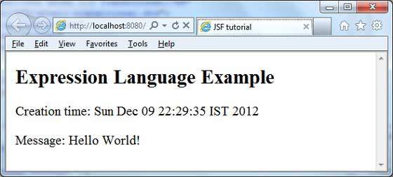
Jsf standars components

Chapter 1. Standard JSF Components
The components and examples covered in this chapter have been selected to introduce a number of important concepts for developing JSF user interfaces. It is necessary to understand the basic JSF components because they are the building blocks from which other components and component libraries are derived.
We will begin by looking at a number of common web application development tasks and how they can be implemented using standard JSF components. In the process, we will learn how to use other JSF artifacts, such as managed beans, converters, validators, and more.

An introduction to JSF
While the main focus of this book is learning how to use JSF UI components, and not to cover the JSF framework in complete detail, a basic understanding of fundamental JSF concepts is required before we can proceed. Therefore, by way of introduction, let's look at a few of the building blocks of JSF applications: the Model-View-Controller architecture, managed beans, EL expressions, converters, and validators.

The Model-View-Controller architecture
JSF is based on the Model-View-Controller (MVC) architecture. The Model in MVC represents the data of the application, and is typically implemented using Plain Old Java Objects (POJOs) based on the JavaBeans API. The View in MVC represents the user interface of the application and is responsible for rendering data and user interface controls to the user. The Controller in MVC represents an object that responds to user interface events and deals with querying or modifying the Model.

Managed beans
Managed beans are the Controllers of a JSF application, handling events in the user interface and updating the Model in response to user interaction. A managed bean is simply a Java class with instance variables and methods that are coupled to the application's domain model and to JSF's event handling API.

The JSF Expression Language (JSF EL)
The JSF Expression Language (JSF EL) is a simple, powerful, object-oriented, and typesafe scripting language used to bind UI components to managed bean properties and methods. The following example shows how to display a customized welcome message that references a backing bean property using the JSF EL:
<h:outputText value="Hello, #{backingBean.username}" />

Converters and validators
JSF includes standard converters for common data types such as numbers, Boolean values, and dates, and also supports custom converters for handling user-defined data types. Additionally, JSF includes standard validators for typical input validation scenarios such as checking required fields and numbers, and also supports custom validators. We will see a number of both, standard converters and validators and custom convertors and validators, throughout this book.
JSF provides special tags to create common layout for a web application called facelets tags. These tags provide flexibility to manage common parts of multiple pages at one place.
For these tags, you need to use the following namespaces of URI in html node.
<html
xmlns = "http://www.w3.org/1999/xhtml"
xmlns:ui = "http://java.sun.com/jsf/facelets">
Following are important Facelets Tags in JSF 2.0.
S.No | Tag & Description
1 | Templates  We'll demonstrate how to use templates using the following tags  - <ui:insert>  - <ui:define>  - <ui:include>  - <ui:composition>
2 | Parameters  We'll demonstrate how to pass parameters to a template file using the following tag  - <ui:param>

SF Validation - Declarative Validator
The validations that are fired using JSF standard validators or Bean validators fall under declarative type. Examples for JSF standard validators are Length validator, Required validator etc… Consider an example for standard validator. Create mobile.xhtml as mobile.xhtml
<?xml version='1.0' encoding='UTF-8' ?>
<!DOCTYPE html PUBLIC "-//W3C//DTD XHTML 1.0 Transitional//EN" "https://www.w3.org/TR/xhtml1/DTD/xhtml1-transitional.dtd">
<html xmlns="https://www.w3.org/1999/xhtml"
xmlns:h="https://java.sun.com/jsf/html">
<h:head>
</h:head>
<h:body>
<h3>Add Mobile Details</h3>
<h:form>
<h:panelGrid columns="3">
<h:outputLabel for="mname">Mobile Name:</h:outputLabel>
<h:inputText id="mname" required="true"
requiredMessage="Mobile Name is mandatory"></h:inputText>
<br>
<br>

<h:outputLabel for="color">Color:</h:outputLabel>
<h:inputText id="color" required="true"></h:inputText>
<br>
<br>

<h:outputLabel for="model">Model Number:</h:outputLabel>
<h:inputText id="model"></h:inputText>
<br>
<br>

<h:commandButton value="Submit"></h:commandButton>
</h:panelGrid>
</h:form>
</h:body>
</html>
Here we are setting the required attribute to true which makes the field mandatory and fires the custom message “value is required” for color field and user defined message for mobile name field as the message is specified in the requiredmessage attribute. Run the application and you will see the below output on pressing submit button.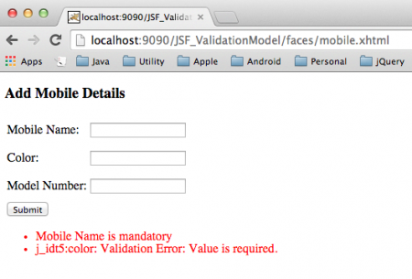

JSF Imperative validation
The standard validation messages would not be sufficient in all the cases and sometimes may require complex validations.Imperative validation allows users to do this by
- Firing the validation from the Bean method
- Use annotation @FacesValidator in the class during runtime
Firing the validation from the Bean method In this type of validation we write a method in the bean to validate the UIComponents and invoke this method from the jsf page through a validator attribute in the inputText tag. Now lets see consider an example of firing a validation from the Bean. mob.xhtml
<?xml version='1.0' encoding='UTF-8' ?>
<!DOCTYPE html PUBLIC "-//W3C//DTD XHTML 1.0 Transitional//EN" "https://www.w3.org/TR/xhtml1/DTD/xhtml1-transitional.dtd">
<html xmlns="https://www.w3.org/1999/xhtml"
xmlns:h="https://java.sun.com/jsf/html">
<h:head>
</h:head>
<h:body>
<h3>Add Mobile Details</h3>
<h:form>
<h:outputLabel for="mno">Model Number:</h:outputLabel>
<h:inputText id="mno" value="#{mobile.mno}" required="true" size="4"
disabled="#{mobile.mno}" validator="#{mobile.validateModelNo}">
</h:inputText>
<h:commandButton value="Submit"></h:commandButton>
</h:form>
</h:body>
</html>
In this page we are invoking the validateModelno method of the java bean in the validator tag attribute. Create Mobile.java as
package com.journaldev.jsf.bean;

import java.io.Serializable;
import javax.faces.application.FacesMessage;
import javax.faces.bean.ManagedBean;
import javax.faces.bean.SessionScoped;
import javax.faces.component.UIComponent;
import javax.faces.component.UIInput;
import javax.faces.context.FacesContext;

@ManagedBean
@SessionScoped
public class Mobile implements Serializable {

private static final long serialVersionUID = -7250065889869767422L;

// @NotNull(message="Please enter the model number")
private String mno;

public String getMno() {
return mno;
}

public void setMno(String mno) {
this.mno = mno;
}

public void validateModelNo(FacesContext context, UIComponent comp,
Object value) {

System.out.println("inside validate method");

String mno = (String) value;

if (mno.length() < 4) {
((UIInput) comp).setValid(false);

FacesMessage message = new FacesMessage(
"Minimum length of model number is 4");
context.addMessage(comp.getClientId(context), message);

}

}

}
Here we are checking for the length of the model no and if the length is less than 4 we are specifying the message as “Minimum length of model number is 4”. Now Run the application which produces the following output.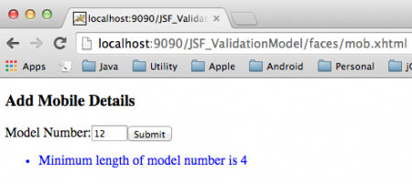

Using @FacesValidator in the Bean - Custom JSF Validator
In this method we use @FacesValidator annotation, specify the name for the validator and implement the Validator by overriding the validate method. mobvalidator.xhtml
<?xml version='1.0' encoding='UTF-8' ?>
<!DOCTYPE html PUBLIC "-//W3C//DTD XHTML 1.0 Transitional//EN" "https://www.w3.org/TR/xhtml1/DTD/xhtml1-transitional.dtd">
<html xmlns="https://www.w3.org/1999/xhtml"
xmlns:h="https://xmlns.jcp.org/jsf/html"
xmlns:f="https://java.sun.com/jsf/core">
<h:head>
</h:head>
<h:body>
<h:form>
<h3>Validation using Faces validator</h3>
<h:outputLabel for="mno" value="Model Number: " />
<h:inputText id="mno" value="#{mobileValidator.mno}">
<f:validator validatorId="mobileValidator" />
</h:inputText>
<h:message for="mno" style="color:blue" />
<p></p>
<h:commandButton value="Submit"></h:commandButton>
</h:form>
</h:body>
</html>
In this we are calling the custom validator named “mobileValidator” in the validatorId attribute of the <f:validator> tag. Create MobileValidator.java as
package com.journaldev.jsf.bean;

import javax.faces.application.FacesMessage;
import javax.faces.bean.ManagedBean;
import javax.faces.bean.SessionScoped;
import javax.faces.component.UIComponent;
import javax.faces.context.FacesContext;
import javax.faces.validator.FacesValidator;
import javax.faces.validator.Validator;
import javax.faces.validator.ValidatorException;

@ManagedBean
@SessionScoped
@FacesValidator("mobileValidator")
public class MobileValidator implements Validator {

private String mno;

public String getMno() {
return mno;
}

public void setMno(String mno) {
this.mno = mno;
}

int maximumlength = 6;

public MobileValidator() {
}

@Override
public void validate(FacesContext fc, UIComponent uic, Object obj)
throws ValidatorException {

String model = (String) obj;

if (model.length() > 6) {
FacesMessage msg = new FacesMessage(
" Maximum Length of 6 is exceeded.Please enter values within range");
msg.setSeverity(FacesMessage.SEVERITY_ERROR);

throw new ValidatorException(msg);
}

}

}
Here we override the standard validate method and implement our own logic for validating the input fields. Run the application and see the output as shown JSF event handling and database acess 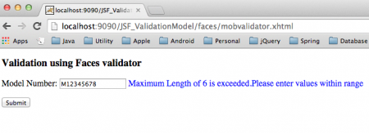

Event handling and database Access
JSF Event Handling
Events in JSF are signals triggered by user actions (like button clicks or value changes) or during the JSF lifecycle.
- Server-Side Events: These are the primary means of interaction in traditional JSF and are handled on the server.
  - Action Events: Fired by components like <h:commandButton> or <h:commandLink> when activated. Handled by methods referenced in the actionListener attribute (or the action attribute, for navigation and implicit action handling).
  - Value Change Events: Fired by input components like <h:inputText> or <h:selectOneMenu> when their local value changes. Handled by methods referenced in the valueChangeListener attribute.
  - Phase Events: System-level events that occur at specific stages of the JSF lifecycle, allowing developers to execute logic at points like Restore View or before rendering.
- Client-Side Events: Modern JSF (2.0+) also supports client-side events using JavaScript and the <f:ajax> tag, which can perform partial page rendering (PPR) without a full page refresh. These events can be configured to propagate to the server when needed.
Handling Mechanism:
- A user action occurs in the UI component.
- The component creates an event object and adds it to an event queue.
- During the appropriate phase of the JSF lifecycle, the framework notifies registered listener methods in the backend Java code (managed beans) to process the event.
Database Access within the Framework
Database access is typically handled in the backend logic, invoked by the event handler methods within the managed beans.
- Managed Beans (Backing Beans): These are regular Java classes (annotated with @ManagedBean, @Named, etc.) that are bound to the UI components via Expression Language (EL). Event listener methods reside here.
- Business Logic Layer: The managed bean methods then call services or data access objects (DAOs) which contain the logic for interacting with the database.
- Persistence Frameworks: JSF itself does not provide an ORM (Object-Relational Mapping) solution, but is designed to integrate seamlessly with standard Java persistence technologies such as:
  - Java Persistence API (JPA) / Hibernate: The most common approach, using entity managers and annotations to map Java objects to database tables.
  - Spring Framework: Many enterprise applications integrate JSF with the Spring framework, using Spring for dependency injection and transaction management, which simplifies database operations.
  - Raw JDBC: Less common in modern frameworks but still an option.
In summary, user events trigger methods in managed beans, and these methods contain or delegate the logic for data retrieval, insertion, or updates using established persistence frameworks. This follows the Model-View-Controller (MVC) pattern, separating the UI (View) from the data and business logic (Model/Controller).

JavaServer Faces (JSF) is a standard Java framework for building web application user interfaces. It is not a single library but a specification with an API, a reference implementation, and a component model that supports various built-in and third-party libraries.
Core Components and Libraries
The JSF specification itself includes core components and tag libraries within its reference implementation:
- html library: A set of components that largely mirrors standard HTML input elements (e.g., h:inputText, h:commandButton).
- core library: A set of tags used for core functionalities like event handling, validation, and internationalization (e.g., f:view, f:selectItem).
Third-Party Component Libraries
A key feature of the JSF framework is its extensible architecture, which allows developers and vendors to create custom UI component libraries. These libraries provide rich, pre-built components that enhance productivity and functionality:
- PrimeFaces: A very popular, feature-rich open-source library that offers a wide range of advanced components, including data tables, charts, and menus.
- Apache MyFaces: An open-source project that serves as an alternative implementation and also provides additional component libraries and extensions.
- Oracle ADF Faces: A commercial library from Oracle that offers an extensive set of enhanced UI components, such as color and date pickers, advanced tables, and progress meters.
- IBM JSF Widget Library (JWL): A library of components available for use within IBM development environments.
- Liferay Faces: An effort to bridge JSF and the Liferay Portal platform.
- BootsFaces/ButterFaces: These libraries integrate popular front-end frameworks like Bootstrap with JSF components.
Framework Features
JSF is based on the Model-View-Controller (MVC) design pattern, using a central FacesServlet as the front controller to manage the request processing lifecycle. It provides numerous features that simplify web development:
- Component-Based Architecture: Developers build UIs by assembling reusable components.
- State Management: Automatically manages the UI component state between requests on the server or client side.
- Event Handling and Validation: Allows wiring client-generated events to server-side handlers and directly binding validators to components.
- Expression Language (EL): Used to link UI components with server-side application data and logic (managed beans).
- Facelets: The preferred View Description Language (VDL) for JSF 2.x and later, using XHTML templates to provide consistent look and feel across an application. ..
JavaServer Faces (JSF) is a standard Java framework for building web application user interfaces. It is not a single library but a specification with an API, a reference implementation, and a component model that supports various built-in and third-party libraries.
Core Components and Libraries
The JSF specification itself includes core components and tag libraries within its reference implementation:
- html library: A set of components that largely mirrors standard HTML input elements (e.g., h:inputText, h:commandButton).
- core library: A set of tags used for core functionalities like event handling, validation, and internationalization (e.g., f:view, f:selectItem).
PrimeFaces is a popular open-source user interface (UI) component library used within the JavaServer Faces (JSF) framework. It is not a standalone framework itself, but rather an add-on that enhances the capabilities of the core JSF framework.
Relationship between JSF and PrimeFaces
- JSF (JavaServer Faces) is a standardized, component-based, Model-View-Controller (MVC) web application framework for building user interfaces for Java applications. It provides the underlying lifecycle, architecture, and a basic set of standard components (like simple input fields and buttons).
- prime Faces extends JSF by providing a rich suite of over 100 sophisticated, pre-built UI components (e.g., advanced data tables, charts, dialogs, calendars, etc.) that have a professional look and feel and are ready for enterprise use.
Key Features of Prime Faces within JSF
- Rich Component Set: Offers a wide variety of components that go beyond the basic HTML elements wrapped by standard JSF, allowing developers to build complex, modern web interfaces quickly.
- AJAX Support: Built-in, standardized AJAX capabilities enable partial page rendering and processing, which improves application responsiveness and user experience.
- Ease of Use: It is designed to be lightweight, with zero configuration required to get started (single JAR file dependency), which simplifies development.
- Theming: Includes a powerful theme engine with numerous built-in themes and a visual designer tool to customize the application's appearance.
- Mobile Support: Offers a mobile kit for developing responsive applications optimized for various devices.
In summary, you use the JSF framework as the foundation for your web application, and then leverage the Prime Faces library to rapidly develop rich, interactive user interfaces.
You can find more information and explore the available components on the official

UNIT 3 HIBERNATE 4.0

Introduction to Hibernate Framework
Last Updated : 4 Sep, 2025

Hibernate is an open-source Object Relational Mapping (ORM) framework for Java. It simplifies database connection by mapping Java classes (objects) to database tables and Java data types to SQL data types. Instead of writing long SQL queries, developers can use Hibernate APIs or HQL (Hibernate Query Language) to perform CRUD operations.
Hibernate acts as a bridge between Java objects and relational databases, thereby reducing the need for boilerplate JDBC code.
ORM Framework

Why Use Hibernate?
When working with JDBC, several challenges often arise:
- Database Portability Issues: Changing the database in the middle of a project is costly because JDBC code is not portable across different database systems.
- Mandatory Exception Handling: JDBC requires explicit handling of exceptions for every database operation, which increases code complexity.
- Lack of Object-Level Relationships: JDBC works at the table level, so there is no direct support for managing object relationships.
- Boilerplate Code: For every project, repetitive code is needed for tasks like establishing connections, executing queries and handling results. This increases code length and reduces readability.
To overcome the above problems we use ORM tool i.e. nothing but Hibernate framework. By using Hibernate we can avoid all the above problems and we can enjoy some additional set of functionalities.

Key Features of Hibernate
- ORM (Object-Relational Mapping): Maps Java classes to database tables and Java objects to rows, enabling object-oriented database interaction.
- Database Independence: Hibernate applications can run on multiple databases with minimal changes, providing portability.
- HQL (Hibernate Query Language): Supports database-independent, object-oriented queries for fetching and manipulating data.
- Transaction Management: Integrates with JDBC or JTA to provide reliable and consistent transaction handling.
- Caching: Improves performance with first-level (session) and optional second-level caching across sessions.
- Relationship Mapping: Supports mapping of object relationships like one-to-one, one-to-many, many-to-one and many-to-many.

Hibernate Architecture
The architecture of Hibernate is layered and consists of several key components working together.
Architecture

Key Components of Hibernate Architecture

1. Configuration
Configuration is a class which is present in org.hibernate.cfg package. It activates Hibernate framework. It reads both configuration file and mapping files.
Example:
Configuration cfg = new Configuration();
cfg.configure(); // Reads and validates hibernate.cfg.xml
Key Points:
- Activates Hibernate framework.
- Reads configuration (hibernate.cfg.xml) and mapping files.
- Throws an exception if the configuration is invalid.
- Creates in-memory metadata representing the configuration.

2. SessionFactory
The SessionFactory interface creates Session objects and maintains a second-level cache. It is heavyweight and thread-safe, so usually one per application.
SessionFactory factory = cfg.buildSessionFactory();
Key Points:
- Factory for Session objects.
- Thread-safe and heavy-weight.
- One per database is sufficient.

3. Session
The Session interface interacts with the database and provides CRUD operations. It maintains a first-level cache (session-level).
Session session = factory.openSession();

4. Transaction
The Transaction interface handles atomic database operations, ensuring data integrity through commit or rollback.
Transaction tx = session.beginTransaction();
tx.commit(); // or tx.rollback();

5. Query
The Query interface executes HQL, Criteria API or native SQL queries to fetch or manipulate data.
Query<Student> query = session.createQuery("from Student");
List<Student> students = query.list();

6. Persistent Classes (Entities)
Java classes annotated with @Entity represent database tables. Each object maps to a row.
@Entity
class Student {
@Id
private Long id;
private String name;
}
Key Points:
- Represents database tables.
- Mapped via annotations or XML.
- Enables object-oriented access to data.

7. Mapping
Defines the relationship between Java classes and database tables. Can be done via annotations or XML files.
@Entity
@Table(name="student")
class Student { ... }
Key Points:
- Maps classes to tables and fields to columns.
- Supports relationships: One-to-One, One-to-Many, Many-to-One, Many-to-Many.

8. JDBC Layer
Handles low-level database communication. Hibernate internally uses JDBC to execute SQL and retrieve results.
Key Points:
- Connects to database using JDBC API.
- Executes SQL queries generated by Hibernate.
- Manages connection pooling and result fetching.

Hibernate Workflow
1. Application loads configuration (hibernate.cfg.xml).
2. Hibernate builds a SessionFactory.
3. Application requests a Session from SessionFactory.
4. Inside a Session:
- Begin Transaction
- Perform CRUD operations
- Commit or Rollback transaction
5. Hibernate translates operations -> SQL-> executes via JDBC.
6. Results are returned as Java objects

Step-by-Step Implementation of Hibernate Setup

Step 1 Create a Hibernate Project
- Open IntelliJ IDEA ->New Project-> Maven.
- Set GroupId ->com.example
- Set ArtifactId-> HibernateDemo.
- Select JDK 17+.
- Finish
Project Structure:
Structure

Step 2: Add Dependencies
<project xmlns="http://maven.apache.org/POM/4.0.0"
xmlns:xsi="http://www.w3.org/2001/XMLSchema-instance"
xsi:schemaLocation="http://maven.apache.org/POM/4.0.0
http://maven.apache.org/maven-v4_0_0.xsd">

<modelVersion>4.0.0</modelVersion>

<groupId>com.example</groupId>
<artifactId>HibernateDemo</artifactId>
<version>1.0-SNAPSHOT</version>
<packaging>jar</packaging>

<name>HibernateDemo</name>

<properties>
<project.build.sourceEncoding>UTF-8</project.build.sourceEncoding>
<maven.compiler.source>17</maven.compiler.source>
<maven.compiler.target>17</maven.compiler.target>
</properties>

<dependencies>
<!-- Hibernate Core -->
<dependency>
<groupId>org.hibernate.orm</groupId>
<artifactId>hibernate-core</artifactId>
<version>6.2.7.Final</version>
</dependency>

<!-- JPA API -->
<dependency>
<groupId>jakarta.persistence</groupId>
<artifactId>jakarta.persistence-api</artifactId>
<version>3.1.0</version>
</dependency>

<!-- MySQL Connector/J -->
<dependency>
<groupId>com.mysql</groupId>
<artifactId>mysql-connector-j</artifactId>
<version>8.0.33</version>
</dependency>

<!-- Optional: Logging (Hibernate requires slf4j) -->
<dependency>
<groupId>org.slf4j</groupId>
<artifactId>slf4j-api</artifactId>
<version>2.0.9</version>
</dependency>
<dependency>
<groupId>org.slf4j</groupId>
<artifactId>slf4j-simple</artifactId>
<version>2.0.9</version>
</dependency>
</dependencies>

<build>
<plugins>
<!-- Maven Compiler Plugin -->
<plugin>
<groupId>org.apache.maven.plugins</groupId>
<artifactId>maven-compiler-plugin</artifactId>
<version>3.11.0</version>
<configuration>
<source>17</source>
<target>17</target>
</configuration>
</plugin>
</plugins>
</build>

</project>

Step 3: Add Hibernate Configuration File
- Go to src/main/resources.
- Create hibernate.cfg.xml:
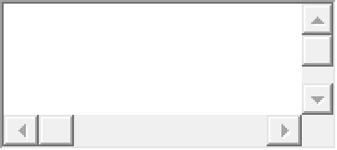
<!DOCTYPE hibernate-configuration PUBLIC
"-//Hibernate/Hibernate Configuration DTD 3.0//EN"
"http://hibernate.sourceforge.net/hibernate-configuration-3.0.dtd">
​
<hibernate-configuration>
<session-factory>
<property name="hibernate.connection.driver_class">com.mysql.cj.jdbc.Driver</property>
<property name="hibernate.connection.url">jdbc:mysql://localhost:3306/hibernate_db</property>
<property name="hibernate.connection.username">root</property>
<property name="hibernate.connection.password">password</property>
​
<property name="hibernate.dialect">org.hibernate.dialect.MySQL8Dialect</property>
<property name="hibernate.show_sql">true</property>
<property name="hibernate.hbm2ddl.auto">update</property>
​
<!-- Entities mapping will be added later -->
<!-- <mapping class="com.example.Student"/> -->
</session-factory>
</hibernate-configuration>

Step 4: Test Hibernate Setup
Open main class and run the application
import org.hibernate.SessionFactory;
import org.hibernate.cfg.Configuration;

public class HibernateSetupTest {
public static void main(String[] args) {
try {
SessionFactory sessionFactory = new Configuration().configure().buildSessionFactory();
System.out.println("Hibernate setup successful!");
} catch (Exception e) {
e.printStackTrace();
}
}
}
If you see the message Hibernate setup successful! in the console, your Hibernate database connection is correctly configured and ready to use.
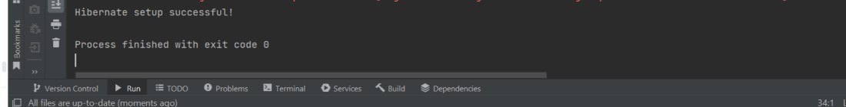

Prerequisites: Introduction of Hibernate
Hibernate is a framework which is used to develop persistence logic which is independent of Database software. In JDBC to develop persistence logic we deal with primitive types. Whereas Hibernate framework we use Objects to develop persistence logic which are independent of database software. Hibernate Architecture: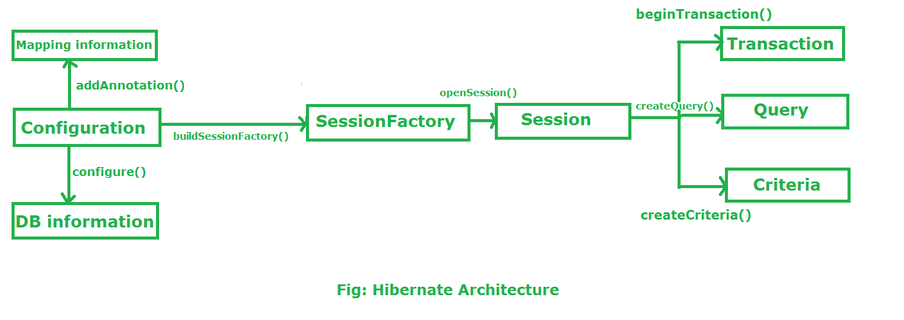Configuration:
- Configuration is a class which is present in org.hibernate.cfg package. It activates Hibernate framework. It reads both configuration file and mapping files.
It activate Hibernate Framework
Configuration cfg=new Configuration();
It read both cfg file and mapping files
cfg.configure();
- It checks whether the config file is syntactically correct or not.
- If the config file is not valid then it will throw an exception. If it is valid then it creates a meta-data in memory and returns the meta-data to object to represent the config file.
SessionFactory:
- SessionFactory is an Interface which is present in org.hibernate package and it is used to create Session Object.
- It is immutable and thread-safe in nature.
buildSessionFactory() method gathers the meta-data which is in the cfg Object.
From cfg object it takes the JDBC information and create a JDBC Connection.
SessionFactory factory=cfg.buildSessionFactory();
Session:
- Session is an interface which is present in org.hibernate package. Session object is created based upon SessionFactory object i.e. factory.
- It opens the Connection/Session with Database software through Hibernate Framework.
- It is a light-weight object and it is not thread-safe.
- Session object is used to perform CRUD operations.
Session session = factory.openSession();
openSession() is a method provided by the SessionFactory that creates and returns a new Session instance. This session is not bound to any transaction or context and is independent of any ongoing transactions in the application.
We can also use getCurrentSession, that returns a Session bound to the current context, which is usually managed by a transaction manager or a framework like Spring.
Session session = sessionFactory.getCurrentSession();
Transaction:
- Transaction object is used whenever we perform any operation and based upon that operation there is some change in database.
- Transaction object is used to give the instruction to the database to make the changes that happen because of operation as a permanent by using commit() method.
Transaction tx=session.beginTransaction();
tx.commit();
Query:
- Query is an interface that present inside org.hibernate package.
- A Query instance is obtained by calling Session.createQuery().
- This interface exposes some extra functionality beyond that provided by Session.iterate() and Session.find():
  - A particular page of the result set may be selected by calling setMaxResults(), setFirstResult().
  - Named query parameters may be used.
Criteria:
- Criteria is a simplified API for retrieving entities by composing Criterion objects.
- The Session is a factory for Criteria. Criterion instances are usually obtained via the factory methods on Restrictions.
Flow of working during operation in Hibernate Framework: Suppose We want to insert an Object to the database. Here Object is nothing but persistence logic which we write on java program and create an object of that program. If we want to insert that object in the database or we want to retrieve the object from the database. Now the question is that how hibernate save the Object to the database or retrieve the object from the database. There are several layers through which Hibernate framework go to achieve the above task. Let us understand the layers/flow of Hibernate framework during performing operations: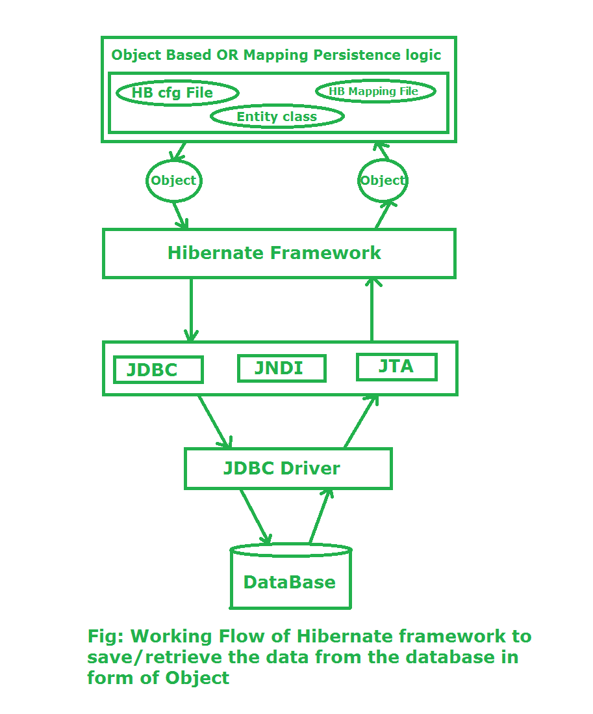
Stage I: In first stage, we will write the persistence logic to perform some specific operations to the database with the help of Hibernate Configuration file and Hibernate mapping file. And after that we create an object of the particular class on which we wrote the persistence logic. Stage II:In second stage, our class which contains the persistence logic will interact with the hibernate framework where hibernate framework gives some abstraction do perform some task. Now here the picture of java class is over. Now Hibernate is responsible to perform the persistence logic with the help of layers which is below of Hibernate framework or we can say that the layers which are the internal implementation of Hibernate. Stage III:In third stage, our hibernate framework interact which JDBC, JNDI, JTA etc to go to the database to perform that persistence logic. Stage IV & V:In fourth & fifth stage, hibernate is interact with Database with the help of JDBC driver. Now here hibernate perform that persistence logic which is nothing but CRUD operation. If our persistence logic is to retrieve an record then in the reverse order it will display on the console of our java program in terms of Object

Hibernate - Types of Mapping
Last Updated : 16 Jan, 2026

Hibernate is an open-source, lightweight ORM (Object Relational Mapping) framework that simplifies database interactions in Java applications. It implements the JPA (Java Persistence API) specification and allows developers to map Java classes to database tables and class fields to table columns. One of Hibernate’s core features is mapping, which defines how Java objects are persisted in relational databases.
Hibernate mappings are broadly classified into two categories:
1. Value / Basic Types Mapping
2. Association / Relationship Mapping

Value/Basic Types Mapping
Basic type mapping is used to map Java data types directly to database column types.

1. Primitive Types Mapping
Hibernate provides built-in support for mapping Java primitive and wrapper types to SQL types.
Java Type | Wrapper Class | ANSI SQL Type
int | Integer | INTEGER
char / String | String | CHAR(1)
float | Float | FLOAT
String | String | VARCHAR
double | Double | DOUBLE
boolean | Boolean | BIT
short | Short | SMALLINT
long | Long | BIGINT
byte | Byte | TINYINT
BigDecimal | BigDecimal | NUMERIC
Example: This code maps the Student Java class to a students database table using Hibernate annotations.
@Entity
@Table(name = "students")
public class Student {
@Id
@GeneratedValue(strategy = GenerationType.IDENTITY)
private int id;

private String name;
private int age;
private boolean active;

// Getters & Setters
}
Explanation:
- @Entity: Makes the class a Hibernate entity.
- @Table(name = "students"): Maps the class to the students table.
- @Id: Marks id as the primary key.
- @GeneratedValue: Auto-generates the primary key value.
- name, age, active: Map to VARCHAR, INTEGER, and BOOLEAN columns.
- Getters & Setters: Allow Hibernate to access and manage field values.

2. Date and Time
Hibernate supports Java date and time classes for handling temporal data.
Mapping type | Java type | ANSI SQL Type
date | java.util.Date or java.sql.Date | DATE
time | java.util.Date or java.sql.Time | TIME
calendar | java.util.Calendar | TIMESTAMP
timestamp | java.util.Date or java.sql.Timestamp | TIMESTAMP
calendar_date | java.util.Calendar | DATE
Example: This code shows how an Employee entity is mapped to a database table with date and time fields using Hibernate.
@Entity
@Table(name = "employees")
public class Employee {
@Id
@GeneratedValue(strategy = GenerationType.IDENTITY)
private int id;
private String name;
@Temporal(TemporalType.DATE)
private Date joiningDate;

private LocalDateTime lastUpdated;
}
Explanation:
- name: Mapped to a VARCHAR column.
- @Temporal(TemporalType.DATE): Stores only the date part of joiningDate.
- LocalDateTime lastUpdated: Automatically mapped to a TIMESTAMP column (Java 8+ date/time support).

3. Binary and large objects
Used to store large data such as images, documents, or videos.
Java type | Wrapper Class | ANSI SQL Type
clob | java.sql.Clob | CLOB
blob | java.sql.Blob | BLOB
binary | byte[] | VARBINARY (or BLOB)
text | java.lang.String | CLOB
serializable | Serializable | VARBINARY (or BLOB)
Example: This code demonstrates how to store large binary and text data in a database using Hibernate.
@Entity
@Table(name = "files")
public class FileData {
@Id
@GeneratedValue(strategy = GenerationType.IDENTITY)
private int id;
private String fileName;
@Lob
private byte[] fileData; // Stored as BLOB
@Lob
private String description; // Stored as CLOB
}
Explanation:
- fileName: Mapped to a VARCHAR column.
- @Lob byte[] fileData: Stores binary data (like files/images) as a BLOB.
- @Lob String description: Stores large text content as a CLOB.

4. JDK linked
Hibernate also supports mappings for certain Java utility classes.
Java type | Wrapper Class | ANSI SQL Type
class | java.lang.Class | VARCHAR
locale | java.util.Locale | VARCHAR
currency | java.util.Currency | VARCHAR
timezone | java.util.TimeZone | VARCHAR
Example: This code shows how to map a Java enum to a database column using Hibernate.
public enum Role {
ADMIN, USER, GUEST
}
@Entity
@Table(name = "users")
public class User {
@Id
@GeneratedValue(strategy = GenerationType.IDENTITY)
private int id;
private String username;
@Enumerated(EnumType.STRING)
private Role role; // Stored as VARCHAR
}
Explanation:
- enum Role: Defines a fixed set of constants (ADMIN, USER, GUEST).
- @Entity: Marks User as a Hibernate entity.
- @Table(name = "users"): Maps the class to the users table.
- @Id: Declares id as the primary key.
- @GeneratedValue: Automatically generates the primary key.
- username: Stored as a VARCHAR column.
- @Enumerated(EnumType.STRING): Stores the enum value as a readable VARCHAR instead of an ordinal number.
- role: Persists the user’s role safely and clearly in the database.

Association / Relationship Mapping
In real-world applications, entities often relate to one another. Hibernate provides annotations to map these relationships.

1. One-to-One
Each instance of an entity is associated with exactly one instance of another entity
@OneToOne
@JoinColumn(name = "profile_id")
private Profile profile;
Use Case: User ↔ Profile

2. One-to-Many
One entity is associated with multiple instances of another entity.
@OneToMany(mappedBy = "department")
private List<Employee> employees;
Use Case: Department → Employees

3. Many-to-One
Multiple entities are associated with a single entity.
@ManyToOne @JoinColumn(name = "department_id")
private Department department;
Use Case: Employees → Department

4. Many-to-Many Mapping
Multiple entities are associated with multiple entities using a join table.
@ManyToMany
@JoinTable(
name = "student_course",
joinColumns = @JoinColumn(name = "student_id"),
inverseJoinColumns = @JoinColumn(name = "course_id")
)
private Set<Course> courses;
Use Case: Students ↔ Courses

Hibernate mapping

ollections Mappings
If an entity or class has collection of values for a particular variable, then we can map those values using any one of the collection interfaces available in java. Hibernate can persist instances of java.util.Map, java.util.Set, java.util.SortedMap, java.util.SortedSet, java.util.List, and any array of persistent entities or values.
Sr.No. | Collection type & Mapping Description
1 | java.util.Set  This is mapped with a <set> element and initialized with java.util.HashSet
2 | java.util.SortedSet  This is mapped with a <set> element and initialized with java.util.TreeSet. The sort attribute can be set to either a comparator or natural ordering.
3 | java.util.List  This is mapped with a <list> element and initialized with java.util.ArrayList
4 | java.util.Collection  This is mapped with a <bag> or <ibag> element and initialized with java.util.ArrayList
5 | java.util.Map  This is mapped with a <map> element and initialized with java.util.HashMap
6 | java.util.SortedMap  This is mapped with a <map> element and initialized with java.util.TreeMap. The sort attribute can be set to either a comparator or natural ordering.
Arrays are supported by Hibernate with <primitive-array> for Java primitive value types and <array> for everything else. However, they are rarely used, so I am not going to discuss them in this tutorial.
If you want to map a user defined collection interfaces, which is not directly supported by Hibernate, you need to tell Hibernate about the semantics of your custom collections, which is not very easy and not recommend to be used.

Association Mappings
The mapping of associations between entity classes and the relationships between tables is the soul of ORM. Following are the four ways in which the cardinality of the relationship between the objects can be expressed. An association mapping can be unidirectional as well as bidirectional.
Sr.No. | Mapping type & Description
1 | Many-to-One  Mapping many-to-one relationship using Hibernate
2 | One-to-One  Mapping one-to-one relationship using Hibernate
3 | One-to-Many  Mapping one-to-many relationship using Hibernate
4 | Many-to-Many  Mapping many-to-many relationship using Hibernate

Component Mappings
It is very much possible that an Entity class can have a reference to another class as a member variable. If the referred class does not have its own life cycle and completely depends on the life cycle of the owning entity class, then the referred class hence therefore is called as the Component class.
The mapping of Collection of Components is also possible in a similar way just as the mapping of regular Collections with minor configuration differences. We will see these two mappings in detail with examples.
Sr.No. | Mapping type & Description
1 | Component Mappings  Mapping for a class having a reference to another class as a member variable.

Hibernate Query language (HQL)

Hibernate - Query Language
Last Updated : 26 Aug, 2025

Hibernate Query Language (HQL) is an object-oriented query language used in Hibernate to interact with the database. Unlike SQL, which works directly with tables and columns, HQL works with persistent objects (entities) and their properties. HQL is database-independent, meaning queries are written in terms of entity classes and attributes and Hibernate automatically translates them into the appropriate SQL for the underlying database.

Key Features of HQL
- Object-Oriented: Operates on entity objects instead of database tables.
- Portable: Database-independent same HQL query works on different databases.
- Powerful Queries: Supports joins, aggregations, grouping, ordering, subqueries, etc.
- Polymorphic Queries: Supports inheritance queries can work on parent classes and include child class entities.
- Automatic Mapping: Properties in HQL map directly to Java class fields, not column names.
The Query interface provides object-oriented methods and capabilities for representing and manipulating HQL queries.
Note:
- Keywords like FROM, SELECT and WHERE are not case-sensitive in HQL.
- Table and Column names are case-sensitive in HQL.

Hibernate Query Language (HQL) Clauses
There are many HQL clauses available to interact with relational databases and several of them are listed below:
- FROM Clause
- SELECT Clause
- WHERE Clause
- ORDER BY Clause
- UPDATE Clause
- DELETE Clause
- INSERT Clause
For details and examples regarding each clause is mentioned below.

1. FROM Clause
To load a whole persistent object into memory, the FROM clause is used.
String hib = "FROM Student";
Query query = session.createQuery(hib);
List results = query.list();

2. SELECT Clause
The SELECT clause is used when only a few attributes of an object are required rather than the entire object.
String hib = "SELECT S.roll FROM Student S";
Query query = session.createQuery(hib);
List results = query.list();

3. WHERE Clause
Filtering records is done with the WHERE clause. It's used to retrieve only the records that meet a set of criteria.
String hib = "FROM Student S WHERE S.id = 5";
Query query = session.createQuery(hib);
List results = query.list();

4. ORDER BY Clause
The ORDER BY clause is used to sort the results of an HQL query.
String hib = "FROM Student S WHERE S.id > 5 ORDER BY S.id DESC";
Query query = session.createQuery(hib);
List results = query.list();
NOTE:
- Order By - DESC will sort in descending order
- Order By - ASC will sort in ascending order

5. UPDATE Clause
The UPDATE clause is required to update the value of an attribute.
String hib = "UPDATE Student set name=:n WHERE roll=:i";
Query q=session.createQuery(hib);
q.setParameter("n","John");
q.setParameter("i",23);
int status=q.executeUpdate();
System.out.println(status);

6. DELETE Clause
It is required to delete a value of an attribute.
String hib = "DELETE FROM Student WHERE id=10";
Query query=session.createQuery(hib);
query.executeUpdate();

7. INSERT Clause
It is required to Insert values into the relation.
String hib = "INSERT INTO Student(first_name, last_name)" +
"SELECT first_name, last_name FROM backup_student";
Query query = session.createQuery(hib);
int result = query.executeUpdate();

Pagination using Query
For pagination using query we have two methods available for it, below table contains the methods and its description.
- Query setMaxResults(int max): Instructs Hibernate to get a specific number of items.
- Query setFirstResult(int starting_no): Takes an integer as an argument that represents the first row in your result set, beginning with row 0.

Example for pagination using HQL
To fetch the few row data at a time we can use pagination using HQL. For this example we are fetching the rows 5 to 10.
String hib = "FROM Student"
Query query=session.createQuery(hib);
query.setFirstResult(5);
query.setMaxResult(10);
List list=query.list();
The above example returns the list of records from 5 to 10.

Aggregate Methods
Similar to SQL, HQL has several aggregation techniques, some of them are mentioned below-
- Average
- Max
- Min
- Count
- Sum
For details and examples regarding each aggregate method is mentioned below.

Average
To find the average of marks
String hib = "SELECT AVG(marks) FROM Student";
Query q=session.createQuery(hib);

Max
To find the maximum mark among all the available marks.
String hib = "SELECT MAX(marks) FROM Student";
Query q=session.createQuery(hib);

Min
To find the minimum mark among all the available marks.
String hib = "SELECT MIN(marks) FROM Student";
Query q=session.createQuery(hib);

Count
To find the count of id present.
String hib = "SELECT COUNT(id) FROM Student";
Query q=session.createQuery(hib);

Sum
To find the sum of all the marks of Student.
String hib = "SELECT SUM(marks) FROM Student";
Query q=session.createQuery(hib);
List<Integer> list=q.list();
System.out.println(list.get(0));

Spring - MVC Framework
Last Updated : 6 Oct, 2025

Spring MVC follows the Model-View-Controller pattern centered around the Front Controller, DispatcherServlet, which routes all HTTP requests to the appropriate controller. The @Controller annotation marks a class as a controller, and @RequestMapping maps web requests to specific controller methods.
The terms model, view, and controller are defined as follows:
- Model: The Model encapsulates the application data.
- View: The View renders the model data and generates HTML output that the client's browser can interpret.
- Controller: The Controller processes the user requests and passes them to the view for rendering.

Dispatcher Servlet
The DispatcherServlet is the central component of Spring MVC:
- Acts as the Front Controller for all HTTP requests.
- Determines the appropriate controller to handle a request.
- Dispatches the request to the selected controller.
- Resolves the view using the View Resolver and renders the response.

Spring MVC Flow Diagram
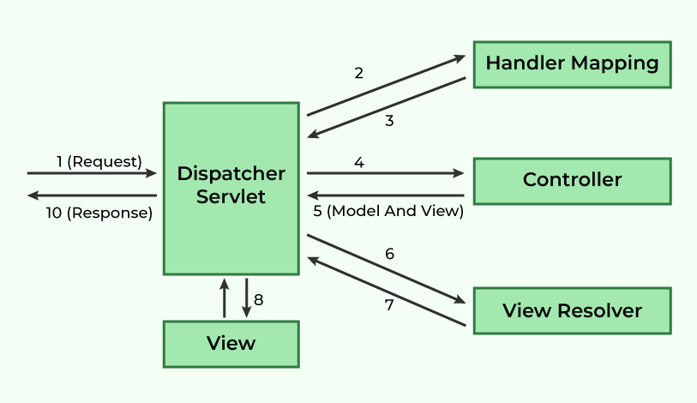
- DispatcherServlet intercepts incoming requests.
- Retrieves the handler mapping and forwards the request to the controller.
- The controller processes the request and returns a ModelAndView object.
- DispatcherServlet uses the view resolver to render the appropriate view.

Steps to Create a Spring MVC Application

Step 0: Set Up the Project
Create a Maven-based Spring MVC project. Ensure the required folder structure and server configuration are in place.

Step 1: Add dependencies in pom.xml
Include the following dependencies
pom.xml:
<dependencies>
<!-- Spring Web MVC -->
<dependency>
<groupId>org.springframework</groupId>
<artifactId>spring-webmvc</artifactId>
<version>5.3.30</version>
</dependency>

<!-- Jakarta Servlet API -->
<dependency>
<groupId>jakarta.servlet</groupId>
<artifactId>jakarta.servlet-api</artifactId>
<version>5.0.0</version>
<scope>provided</scope>
</dependency>
</dependencies>

Step 2: Define the Controller
Create a controller class to handle requests.
HelloGeek.java:
@Controller
public class HelloGeek {

@RequestMapping("/")
public String display(Model model) {
model.addAttribute("message", "Spring MVC Tutorial!!");
return "index";
}
}

Step 3: Configure web.xml
Specify the DispatcherServlet in the web.xml file:
web.xml:
<web-app xmlns="http://xmlns.jcp.org/xml/ns/javaee"
xmlns:xsi="http://www.w3.org/2001/XMLSchema-instance"
xsi:schemaLocation="http://xmlns.jcp.org/xml/ns/javaee
http://xmlns.jcp.org/xml/ns/javaee/web-app_3_0.xsd"
version="3.0">

<display-name>SpringMVC</display-name>

<servlet>
<servlet-name>spring</servlet-name>
<servlet-class>org.springframework.web.servlet.DispatcherServlet</servlet-class>
<load-on-startup>1</load-on-startup>
</servlet>

<servlet-mapping>
<servlet-name>spring</servlet-name>
<url-pattern>/</url-pattern>
</servlet-mapping>

</web-app>

Step 4: Define Bean Configuration (spring-servlet.xml)
Place the configuration in WEB-INF to enable component scanning and view resolution:
spring-servlet.xml:
<beans xmlns="http://www.springframework.org/schema/beans"
xmlns:context="http://www.springframework.org/schema/context"
xmlns:mvc="http://www.springframework.org/schema/mvc"
xmlns:xsi="http://www.w3.org/2001/XMLSchema-instance"
xsi:schemaLocation="http://www.springframework.org/schema/beans
http://www.springframework.org/schema/beans/spring-beans.xsd
http://www.springframework.org/schema/context
http://www.springframework.org/schema/context/spring-context.xsd
http://www.springframework.org/schema/mvc
http://www.springframework.org/schema/mvc/spring-mvc.xsd">

<context:component-scan base-package="com.geeksforgeeks.controller"/>
<mvc:annotation-driven/>

<bean class="org.springframework.web.servlet.view.InternalResourceViewResolver">
<property name="prefix" value="/WEB-INF/views/"/>
<property name="suffix" value=".jsp"/>
</bean>

</beans>
In this configuration,
- We have added the necessary XML namespaces and schema locations.
- <context:component-scan> tells Spring where to look for annotated components.
- <mvc:annotation-driven> enables Spring MVC annotations.
- The InternalResourceViewResolver bean is defined to resolve view names. It looks for JSP files in the /WEB-INF/views/ directory and appends .jsp to the view name.

Step 5: Create a JSP File
We will now create a JSP file to display the message.
index.jsp in /WEB-INF/views/:
<%@ page contentType="text/html; charset=UTF-8" language="java" %>
<!DOCTYPE html>
<html>
<head>
<title>Spring MVC Example</title>
</head>
<body>
<h2>${message}</h2>
</body>
</html>
This JSP file will display the message passed from the controller.

Step 6: Run the Application
Start the server and access the application:
http://localhost:8080/
Output:
Spring MVC Tutorial!!

Advantages of Spring MVC Framework
- Uses a lightweight servlet container for the development and deployment of applications.
- Enables rapid and parallel development.
- Facilitates fast application development.
- Allows multiple developers to work together efficiently.
- Makes updating the application easier

Spring

Introduction to Spring Boot
Last Updated : 28 Aug, 2025

Spring is one of the most popular frameworks for building enterprise applications, but traditional Spring projects require heavy XML configuration, making them complex for beginners.
Spring Boot solves this problem by providing a ready-to-use, production-grade framework on top of Spring. It eliminates boilerplate configuration, comes with an embedded server and focuses on rapid development.

Features of Spring Boot
Spring Boot is built on top of the conventional Spring framework, providing all the features of Spring while being significantly easier to use. Here are its key features:
1. Auto-Configuration: Automatically configures components (like Hibernate, JPA) based on dependencies. No need for manual XML setup.
2. Easy Maintenance and Creation of REST Endpoints: With annotations like @RestController, @GetMapping and @PostMapping, creating REST endpoints is straightforward.
Example:
@RestController
@RequestMapping("/api")
public class MyController {
@GetMapping("/hello")
public String sayHello() {
return "Hello, World!";
}
}
3. Embedded Tomcat Server: Embedded Servers: Spring Boot includes an embedded Tomcat server, eliminating the need for manual setup. It also supports Jetty and Undertow, offering flexibility for different application needs.
4. Easy Deployment: Spring Boot applications can be packaged as JAR or WAR files and deployed directly to servers or cloud environments. By 2025, it offers seamless integration with Docker and Kubernetes for easier cloud-native deployment and scaling.
5. Microservice-Based Architecture: Spring Boot is well-suited for microservice architecture, where applications are split into independent, modular services. Unlike monolithic systems, this approach improves scalability, maintainability and deployment flexibility.

Evolution of Spring Boot
Spring Boot was introduced in 2013 following a JIRA request by Mike Youngstrom to simplify Spring bootstrapping.

Major Spring Boot Versions
- Spring Boot 1.0 (April 2014)
- Spring Boot 2.0 (March 2018)
- Spring Boot 3.0 (November 2022) (Introduced Jakarta EE 9+, GraalVM support)
- Latest Version (2025): Spring Boot 3.x (Enhancements in observability, native images and containerization)

Applications of Spring Boot
Spring Boot is widely used in modern software development because of its simplicity, scalability and production-ready features. Here are some of its major applications:
1. Enterprise Applications: Build complex applications such as Hospital Management Systems, Banking Systems or ERP solutions with minimal configuration.
2. Cloud-Native Applications: Seamless integration with Docker, Kubernetes and cloud platforms (AWS, Azure, GCP) for deployment and scaling.
3. Real-Time Applications: Supports Reactive Programming for chat applications, streaming platforms, IoT systems and event-driven systems.
4. Batch Processing Applications: With Spring Batch, Spring Boot is used for ETL (Extract, Transform, Load), report generation and large data processing.

Spring Boot Architecture
To understand the architecture of Spring Boot, let’s examine its different layers and components.
Spring Boot Flow Architecture

1. Client Layer
- This represents the external system or user that interacts with the application by sending HTTPS requests.

2. Controller Layer (Presentation Layer)
- Handles incoming HTTP requests from the client.
- Processes the request and sends a response.
- Delegates business logic processing to the Service Layer.

3. Service Layer (Business Logic Layer)
- Contains business logic and service classes.
- Communicates with the Repository Layer to fetch or update data.
- Uses Dependency Injection to get required repository services.

4. Repository Layer (Data Access Layer)
- Handles CRUD (Create, Read, Update, Delete) operations on the database.
- Extends Spring Data JPA or other persistence mechanisms.

5. Model Layer (Entity Layer)
- Represents database entities and domain models.
- Maps to tables in the database using JPA/Spring Data.

6. Database Layer
- The actual database that stores application data.
- Spring Boot interacts with it through JPA/Spring Data.

Request Flow in Spring Boot
Client ->Controller ->Service ->Repository ->Database ->Response
- A Client makes an HTTPS request (GET/POST/PUT/DELETE).
- The request is handled by the Controller, which is mapped to the corresponding route.
- If business logic is required, the Controller calls the Service Layer.
- The Service Layer processes the logic and interacts with the Repository Layer to retrieve or modify data in the Database.
- The data is mapped using JPA with the corresponding Model/Entity class.
- The response is sent back to the client. If using Spring MVC with JSP, a JSP page may

